ReLEAF registry staging pack
All 33 GEMS-Taiwan parts, pulled live from the registry on 19 October 2026, with bracketed placeholders resolved where the wiki confirms the value and every figure matched to its slot.

How to read this
Each part has its sections in registry order. The grey monospace block under each heading is the exact Markdown to paste into that documentation entry — it is what the registry holds now, with resolutions applied. Under it, Resolved lists what changed and why; Open questions lists what is still in brackets and must be decided before pasting. Figures appear at the slot they belong to, with the file name to upload from the upload/ folder.

What is not in this pack
The two collection documents are not written yet. Until they exist, the shared cloning block still sits on every composite part, which the Registry Rules say should not be duplicated. Four slots have no image: BBa_26XVQ3FS characterisation, and three captions that want sequencing traces rather than gels. Five parts have no documentation at all.

The 33 parts
Part | Title | Group | Tier | Sections | Open
BBa_2654HAF3 | ccaSR-Csn-AcdS-Histag | hybrid | A | desig, exper, chara, appli, discu
BBa_26U8UTMH | ccaSR-SamyQ-AcdS 2.1-Histag | hybrid | A | desig, exper, chara, appli, discu
BBa_26CXI09X | Pveg-EEBD-RBS0-Csn-AcdS-Histag-B0015 | protectant | A | desig, exper, chara, appli, discu | 6
BBa_261XH2RS | PliaG-RBS0-ccaS-m3-B0015 | light-sensing | A | desig, exper, appli | 6
BBa_269A97I7 | Pveg-EEBD-RBS0-SamyQ-BoPep4 2.1-Histag-B0015 | protectant | A | desig, exper, appli | 3
BBa_26BDO8AQ | Pveg-RBS0-ccaR-B0015 | light-sensing | A | desig, exper, appli | 4
BBa_26D5AX7S | Pveg-EEBD-RBS0-SamyQ-LEA14 2.1-Histag-B0015 | protectant | A | desig, exper, appli | 3
BBa_26DE5E2Q | PcpcG2-veg-EEBD-RBS0-SamyQ-AcdS 2.1-Histag-B0015 | hybrid | A | desig, exper, appli | 4
BBa_26IA55UY | Pveg-EEBD-RBS0-SamyQ-BoPep4 2.2-Histag-B0015 | protectant | A | desig, exper | 3
BBa_26Q3LKZU | PcpcG2-veg-EEBD-RBS0-Csn-AcdS-Histag-B0015 | hybrid | A | desig, exper, appli | 3
BBa_26SG0NQQ | Pveg-EEBD-RBS0-Csn-LEA14-Histag-B0015 | protectant | A | desig, exper, appli | 3
BBa_26XVQ3FS | Pveg-EEBD-RBS0-SamyQ-AcdS 2.1-Histag-B0015 | protectant | A | desig, exper, chara, appli | 2
BBa_26XZYM10 | PtagC+RBS-Ho1:pcyA-L3S2P21 | light-sensing | A | desig, exper, appli | 5
BBa_262YYNPV | AcdS 2.1 | protectant | B | desig, appli
BBa_265CD14Z | BoPep4 | protectant | B | desig, appli
BBa_267B69E3 | SamyQ-BoPep4 2.2-Histag | protectant | B | desig, exper, appli | 4
BBa_26ERHWWI | Bopep4 2.2 | protectant | B | desig, appli
BBa_26FSZTWM | Pveg-EEBD-RBS0-SamyQ-BoPep4-Histag-B0015 | protectant | B | desig, exper, appli | 2
BBa_26ILD3SO | SamyQ-BoPep4-Histag | protectant | B | desig, exper, appli
BBa_26IN6G1D | LEA14 2.1 | protectant | B | desig, appli
BBa_26J0GJGZ | SamyQ-LEA14 2.1-Histag | protectant | B | desig, exper, appli | 4
BBa_26LTB0W1 | LEA14 | protectant | B | desig, appli
BBa_26LYCBW0 | BoPep4 2.1 | protectant | B | desig, appli
BBa_26MA70QI | AcdS | protectant | B | desig, appli | 1
BBa_26NXOP7S | Csn-AcdS-Histag | protectant | B | desig, exper, appli | 5
BBa_26PX0UGH | SamyQ-BoPep4 2.1-Histag | protectant | B | desig, exper, appli | 4
BBa_26TOGLX3 | SamyQ-AcdS 2.1-Histag | protectant | B | desig, exper, appli | 4
BBa_26ZQ1T72 | Csn-LEA14-Histag | protectant | B | desig, exper, appli | 4
BBa_26A4MT29 | PtagC+RBS | light-sensing | C | none
BBa_26OSLRE4 | RBS0 | shared infrastructure | C | none
BBa_26V6CPEV | EEBD-RBS0 | shared infrastructure | C | none
BBa_26YHOQCL | Bopep4 (15-23) | protectant | C | none
BBa_26Z8FHTR | Pveg-EEBD-RBS0-SamyQ-Bopep4-Histag (9-23)-B0015 | protectant | C | none

BBa_2654HAF3 — ccaSR-Csn-AcdS-Histag
hybrid · tier A · published · 6929 bp · registry.igem.org/parts/bba-2654haf3

Design
## Overview

This is the assembled Level 2 construct of our stress-responsive optogenetic bioreactor. It carries four Level 1 transcriptional units on a single plasmid, so that *Bacillus subtilis* can sense and respond to light signals on its own. The first module makes the chromophore PCB, the second expresses the sensor kinase CcaSm3, and the third expresses the response regulator CcaR. The fourth is the output, which secretes ACC deaminase (AcdS) when green light is present - specifically, CcasR-Csn-AcdS-Histag (Bba\_2654HAF3), the wildtype output with the Csn signal peptide.

The part is a composite of four transcriptional units in this order:

1. PCB production ([BBa\_26XZYM10](https://registry.igem.org/parts/bba-26xzym10)): PtagC + RBS ([<u>**BBa\_26A4MT29**</u>](https://registry.igem.org/parts/bba-26a4mt29))-ho1:pcyA ([<u>**BBa\_K4354012**</u>](https://registry.igem.org/parts/bba-k4354012) )-L3S2P21 ([<u>**BBa\_K2675031**</u>](https://share.google/pocPiJukHq9mm39e5)). Ho1 converts heme to biliverdin IXa, and PcyA subsequently reduces it to PCB. Fusing the two enzymes raises PCB production about 80 fold (Castillo-Hair et al. 2019). We used the shorter PtagC+RBS instead of Pveg and RBS0 to cut down repeated sequences and make Level 2 assembly easier .
2. Light Sensing ([BBa\_261XH2RS](https://registry.igem.org/parts/bba-261xh2rs)): PliaG (BBa\_K823000)-RBS0 (BBa\_26OSLRE4)- ccaS-m3 ([BBa\_26OSLRE4](https://registry.igem.org/parts/bba-26oslre4))- B0015 (BBa\_B0015). This module expresses CcaSm3, the light sensor. Green light switches CcaS to an active state that passes a phosphate to CcaR, and red light switches it back.
3. Transduction ([BBa\_26BDO8AQ](https://registry.igem.org/parts/bba-26bdo8aq)): Pveg (BBa\_K143012) – RBS0 – ccaR (BBa\_K5431017) – B0015. When CcaS phosphorylates it under green light, CcaR binds the PcpcG2 promoter and activates transcription, and under red light it is likely dephosphorylated so that output switches off. Pveg keeps CcaR constitutively expressed, so light is the only input to the circuit.
4. Light responsive ([BBa\_26Q3LKZU](https://registry.igem.org/parts/bba-26q3lkzu)): PcpcG2-veg – EEBD – RBS0 – Csn– AcdS – 6xHis ([BBa\_26NXOP7S](https://registry.igem.org/parts/bba-26nxop7s)) – B0015. PcpcG2-veg is a strong promoter derived from Castillo-Hair et al. 2019, the Csn signal peptide directs ACC deaminase through the Sec pathway for secretion, where it degrades ACC, and the C-terminal 6xHis tag enables detection of the protein.

This complete construct was assembled by Golden gate assembly into the Level 2 vector pSTK-EXP2 with BsmBI enzyme

## About

* Biosafety level: S1
* Target organism: *Bacillus subtilis* WB800
* Main purpose of use: light controlled expression and secretion of ACC deaminase in the host *B. subtilis*
* Potential application: controlling the release of plant growth promoting protectants with green and red light. Users can set stress thresholds for each crop through a microcontroller based sensor without redesigning the entire genetic circuit

## Literature

**How the circuit works:** CcaS binds PCB through its GAF domain and is made in a green-light sensitive ground state. Absorbing green light switches it to an active state that autophosphorylates and passes the phosphate to CcaR. Phosphorylated CcaR activates the PcpcG2 output promoter. Red light returns CcaS to the ground state and probably causes CcaS to dephosphorylate CcaR, which turns output off (Castillo-Hair et al., 2019; Hirose et al., 2008). Because *B. subtilis* does not make PCB, the circuit needs all four modules on the same plasmid to work.

**Why optogenetic:** Our original plan was to release engineered rhizobacteria that sensed stress themselves, which limits the usable stressors, and crops also differ in their thresholds. For example, heat stress in *Arabidopsis* starts at about 30–37 °C, whereas peanut tolerates about 35–40 °C. Using light as the only input lets the user program thresholds per crop without redesigning the circuit.

**Differences from the published system:** Castillo-Hair et al. (2019) drove *ccaS* from the xylose-inducible PxylA and *ccaR* from the IPTG-inducible Phy-spank. We replaced both with constitutive promoters (PliaG and Pveg) so that light is the only input and no inducer dosing is needed.

**Output module:** PcpcG2-veg is promoter from Castillo-Hair et al. (2019), in which the sequence after the −10 hexamer comes from the strong Pveg promoter while the CcaR binding site stays intact. In the original study this gave much higher output than PcpcG2-172. The EEBD (*E. coli* expression-blocking device) sits upstream of the RBS to stop leaky expression of the output gene in *E. coli* during cloning, before the construct is moved into *B. subtilis*. The output gene is a fusion of a Sec signal peptide, *P. putida acdS*, and a 6xHis tag. In the SamyQ version, 12 of the first 15 *acdS* codons were recoded to open up the mRNA structure around the start codon.

## References

1. Castillo-Hair, S. M., Baerman, E. A., Fujita, M., Igoshin, O. A., & Tabor, J. J. (2019). Optogenetic control of *Bacillus subtilis* gene expression. *Nature Communications*, 10, 3099.
2. Hirose, Y., Shimada, T., Narikawa, R., Katayama, M., & Ikeuchi, M. (2008). Cyanobacteriochrome CcaS is the green light receptor that induces the expression of phycobilisome linker protein. *PNAS*, 105(28), 9528–9533.
3. Caro-Astorga, J., Rogan, M., Malcı, K., Ming, H., Debenedictis, E., James, P., & Ellis, T. (2025). SubtiToolKit: A bioengineering kit for *Bacillus subtilis* and Gram-positive bacteria. *Trends in Biotechnology*, 43(6), 1446–1469.
4. Fernández, S., Ayora, S., & Alonso, J. C. (2000). *Bacillus subtilis* homologous recombination: Genes and products. *Research in Microbiology*, 151(6), 481–486.
5. Chen, Y.-J., et al. (2013). Characterization of 582 natural and synthetic terminators and quantification of their design constraints. *Nature Methods*, 10(7), 659–664.
6. Haller, D. J., Castillo-Hair, S. M., & Tabor, J. J. (2025). Optogenetic control of *B. subtilis* gene expression using the CcaSR system. *Methods in Molecular Biology*, 2840, 1–17.
7. Radeck, J., et al. (2013). The Bacillus BioBrick Box. *Journal of Biological Engineering*, 7, 29.

Resolved: [168/WB800] → WB800 (strain settled 7 Oct)

Experiment
## Construction/assembly (wet lab)

Each module was first built and sequence verified as a Level 1 transcription unit in the SubtiToolKit pSTK-1A, -1B, -1C, and -1D vectors (Caro-Astorga et al. 2025). The four sequence verified Level 1 units were then combined in a single Golden Gate reaction into the pSTK-EXP2 Level 2 vector, in the order Module 1-Module 2-Module 3-Module 4. We tested two vectors to insert ratios, 1:5 and 1:7. The reaction was transformed into *E. coli* DH5α, and clones were screened by colony PCR with primers specific to each module and sequence verified. The verified plasmid was then electroporated into *B. subtilis* 168 and WB800 at 2.1-2.3 kV

Construct details:

* Composite insert: pSTK-EXP2-sfGFP-PtagC+RBS-Ho1:pcyA-L3S2P21-PliaG-RBS0-CcaSm3-B0015-Pveg-RBS0-CcaR-B0015-PcpcG2-veg-EEBD-RBS0-Csn:AcdS-Histag-B0015
* Vector: pSTK-EXP2 (Level 2 vector)
* Assembly method: Golden Gate Assembly (BsmbI)
* Vector:insert ratios tested: 1:5 and 1:7
* Thermal cycle

| Temperature | Time | Cycles |
| ------------------- | ------- | ---------- |
| 42 degrees Celcius | 5 min | 45 cycles |
| 16 degrees Celcius | 5 min | |
| 55 degrees celsius | 10 min | 1 cycle |
| 80 degrees Celcius | 20 min | 1 cycle |

## Verification (wet lab)

Colonies from the Level 2 transformation were screened by colony PCR, with primers specific to each module, and products were run on an agarose gel alongside a DNA ladder. A colony was a positive candidate only if it gave a band of the expected size for the modules . Positive candidates were then sequenced to confirm that all four modules are correct and in the right order. We checked every module because one module being positive doesn’t necessarily verify the state of the others. Constructs that were confirmed were then electroporated into *B. subtilis* and grown into liquid culture to initiate full functional runs in the LPA.

| Primer | Sequence |
| ----------- | ------------------------------ |
| L2-pcyA-F | GCG AAG CAT GGG CAG AAA GA |
| L2-ccaSm3 R | GCG TTC TTG GTT TTG TCT GTG CC |
| L2-ccaSm3 F | GGG AAC AGG ACT CGG TTT AAT GG |
| L2-ccaR R | CCA GCG GCA AAT CAT CCT CC |
| L2-ccaR F | GGT CCA TGG CAT TGG GTA TCG |
| L2-SamyQ R | GAA CGA AAC TGT CCG CTT TCG TT |

## Results (wet lab)

![](https://registry.igem.wiki/documentation/e093103b-ab92-4883-9ac7-8f4160e8e942/ba762e02cb85ba4902ecfa6ff18b66b651548425f2a458b6af9b20c0fe8a7f08.avif)

**Fig. 1. Colony PCR verification of the ccaSR-Csn-AcdS-Histag construct.** Lane M contains the DNA ladder, and lanes 2 through 5 represent individual colonies screened using ccaSm3 F and ccaR R primers. The electrophoresis results indicate that lanes 3, 4 and 5 yield a band migrating between the 500 and 750 basepair markers, consistent with the expected size of 632 basepairs, while lane 2 yields no product. The bright band near 250 basepairs and the faint higher-molecular-weight bands in lanes 3 through 5 are non-specific amplifications.

![](https://registry.igem.wiki/documentation/e093103b-ab92-4883-9ac7-8f4160e8e942/1bb1bfecc9e21bdbf44520b10b23a3f8ee398d68e02016aa9958e874bdd453ed.avif)

**Fig. 2. Colony PCR verification of the ccaSR-Csn-AcdS-Histag construct.** The gel indicates that both clones have correct bands across all 4 modules, confirming successful assembly.

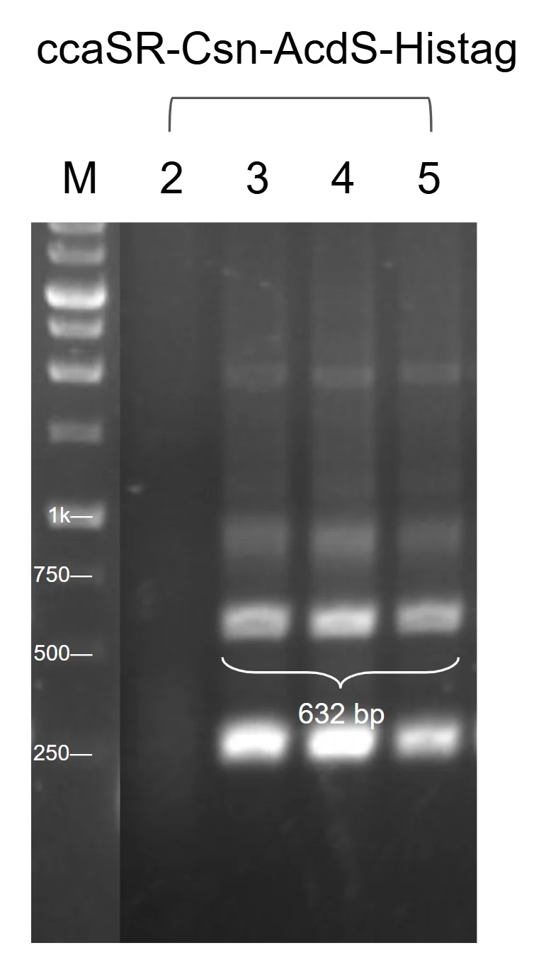
Figure 1. Colony PCR for ccaSR–Csn–AcdS–Histag. Three of three colonies gave a band at 632 bp. Clones 3 and 5 went forward for the cross-module check.
upload/02_BBa_2654HAF3_EXPE_fig1_pp-gel-sys-csn.png (778x1380, 158 KB)

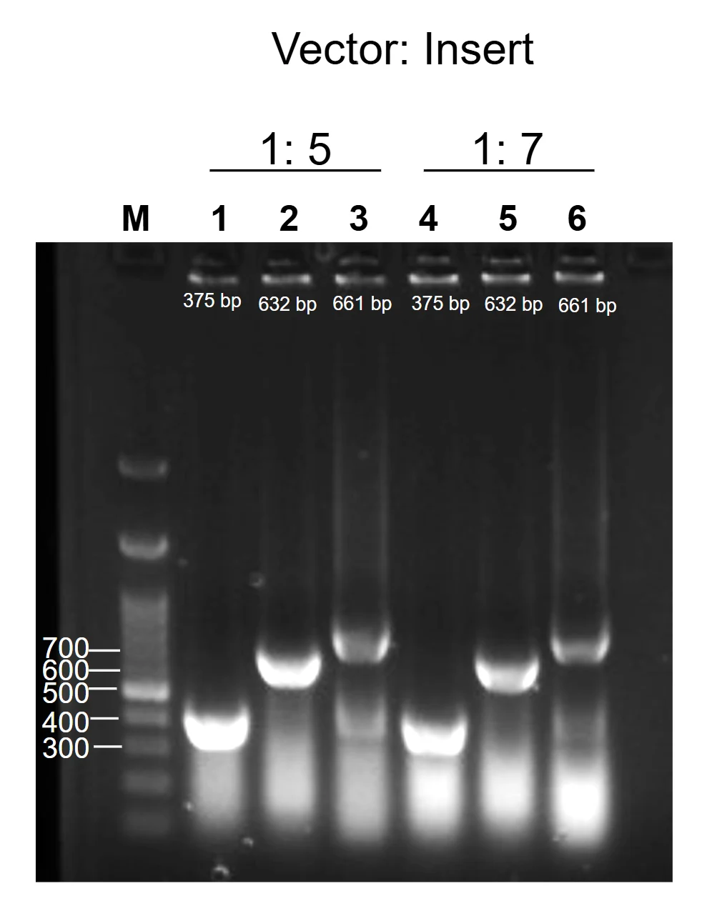
Figure 2. Cross-module PCR for ccaSR–Csn–AcdS–Histag. Two of two clones gave a band at the expected size across all three junctions. Clone 2, at a vector to insert ratio of 1:7, was selected for sequencing.
upload/03_BBa_2654HAF3_EXPE_fig2_pp-pcr-sys-csn.png (996x1282, 239 KB)

Characterisation
**Fig.1. Western blot of wild-type ACCD in *Bacillus subtilis* WB800 carrying CcaSR under different light intensities in the LPA (ABDI).** Samples were collected before light exposure (0 h) and at 2, 4, 6, and 8 h. (A) Green 100% and green 12%. (B) Green 2% and red 100%. Lane M is the molecular weight marker (kDa). Signals increased over time under green 100%, 12%, and 2%, but not in a clear order across intensities: green 2% stayed faint until 6 h, while green 12% at 8 h gave the strongest signal of the green lanes. ACCD is about 35 kDa as a monomer, yet the bands ran at roughly 63 to 75 kDa. Since ACCD can also form a homodimer of about 70 kDa, these bands may be the dimer, though this is only a possibility that we plan to test in future experiments.

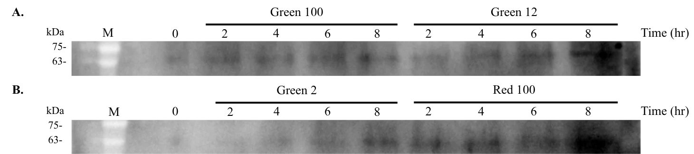
Figure 1. Wild-type ACCD, construct ABDI, in B. subtilis WB800 carrying CcaSR under different light intensities. (A) Green 100% and green 12%. (B) Green 2% and red 100%. M, molecular weight marker in kDa. Signals rose with time in green 100%, green 12% and green 2%, but not in an ordered way across intensities: green 2% was faint until 6 h, while green 12% at 8 h was the strongest of the green lanes. ACCD is about 35 kDa as a monomer and the bands ran near the 63 to 75 kDa markers; ACCD can also exist as a homodimer at about 70 kDa, so these bands may be the dimer. This is only a possibility, and we plan to validate it in future experiments.
upload/04_BBa_2654HAF3_CHAR_fig1_lpa-wb-timecourse.png (1461x327, 116 KB)

Application
The Level 2 construct ccaSR-Csn-AcdS-Histag (BBa\_2654HAF3) shows that *Bacillus subtilis* can sense light and respond to it on its own. All four modules sit on a single plasmid. The first makes the chromophore PCB, the second expresses the sensor kinase CcaS-m3, the third expresses the response regulator CcaR, and the fourth secretes ACC deaminase (AcdS) when green light is present. Because *B. subtilis* does not make PCB, the circuit only works with all four modules together.

We tested this in *B. subtilis* WB800 in the LPA (light plate apparatus) under green and red light at different intensities. Western blots showed ACCD signal increasing over time under green light, but not under red light. This is the proof of concept for the whole design: light is the only input, and no inducer needs to be added.

Discussion
#### Use in plant protection

The aim is to release plant-protective proteins only when and where they are needed. A secreted ACC deaminase lowers stress ethylene around roots, so it could be used as part of a plant-growth-promoting bioprotectant. Light as the only input offers a practical advantage over circuits that sense stress themselves. Crops differ in their stress thresholds (for example, heat stress starts at about 30 to 37 °C in *Arabidopsis* but about 35 to 40 °C in peanut), and a self-sensing strain would have to be redesigned for each stressor and each crop. With light control, a user can set thresholds for each crop through a microcontroller-based sensor that switches the light, without redesigning the genetic circuit. This is the role the circuit plays in our bioreactor system.

#### A modular platform for other protectants

Modules 1 to 3 form a reusable light-sensing chassis, and only Module 4 defines the output. Any of our protectant cassettes can in principle be placed behind PcpcG2-veg:

* **AcdS** lowers ethylene levels. This is the version built and tested in the full circuit.
* **LEA14** protects cellular structures under environmental stress. We did not build the light-responsive Module 4 with LEA14. Instead, we characterized the constitutive LEA14 version to see how it would behave in the whole system, and it also protects plants facing salinity stress. This avoids repeating the same assembly, since ccaSR-AcdS already demonstrates that the concept works.
* **BoPep4**, a broccoli plant elicitor peptide, activates plant defense responses.

Our constitutive constructs, which use Pveg in place of the light switch, give the maximal secretion and production of each protectant. They also serve as a benchmark for the light-controlled version.

#### Beyond our project

Replacing the xylose-inducible and IPTG-inducible promoters of the published CcaSR system (Castillo-Hair et al., 2019) with constitutive ones means no inducer dosing is required. Other teams can reuse the four-module Level 2 plasmid for any secreted protein, simply by exchanging the output cassette. This makes light-controlled secretion in *B. subtilis* usable beyond plant protection, for example for other enzymes or peptides that should be produced on demand.

BBa_26U8UTMH — ccaSR-SamyQ-AcdS 2.1-Histag
hybrid · tier A · published · 6914 bp · registry.igem.org/parts/bba-26u8utmh

Design
## Overview

This is the assembled Level 2 construct of our stress-responsive optogenetic bioreactor. It carries four Level 1 transcriptional units on a single plasmid, so that *Bacillus subtilis* can sense and respond to light signals on its own. The first module makes the chromophore PCB, the second expresses the sensor kinase CcaSm3, and the third expresses the response regulator CcaR. The fourth is the output, which secretes ACC deaminase (AcdS) when green light is present - specifically, CcasR-Csn-AcdS-Histag (Bba\_2654HAF3), the wildtype output with the Csn signal peptide.

The part is a composite of four transcriptional units in this order:

1. PCB production ([BBa\_26XZYM10](https://registry.igem.org/parts/bba-26xzym10)): PtagC + RBS ([<u>**BBa\_26A4MT29**</u>](https://registry.igem.org/parts/bba-26a4mt29))-ho1:pcyA ([<u>**BBa\_K4354012**</u>](https://registry.igem.org/parts/bba-k4354012) )-L3S2P21 ([<u>**BBa\_K2675031**</u>](https://share.google/pocPiJukHq9mm39e5)). Ho1 converts heme to biliverdin IXa, and PcyA subsequently reduces it to PCB. Fusing the two enzymes raises PCB production about 80 fold (Castillo-Hair et al. 2019). We used the shorter PtagC+RBS instead of Pveg and RBS0 to cut down repeated sequences and make Level 2 assembly easier .
2. Light Sensing ([BBa\_261XH2RS](https://registry.igem.org/parts/bba-261xh2rs)): PliaG (BBa\_K823000)-RBS0 (BBa\_26OSLRE4)- ccaS-m3 ([BBa\_26OSLRE4](https://registry.igem.org/parts/bba-26oslre4))- B0015 (BBa\_B0015). This module expresses CcaSm3, the light sensor. Green light switches CcaS to an active state that passes a phosphate to CcaR, and red light switches it back.
3. Transduction ([BBa\_26BDO8AQ](https://registry.igem.org/parts/bba-26bdo8aq)): Pveg (BBa\_K143012) – RBS0 – ccaR (BBa\_K5431017) – B0015. When CcaS phosphorylates it under green light, CcaR binds the PcpcG2 promoter and activates transcription, and under red light it is likely dephosphorylated so that output switches off. Pveg keeps CcaR constitutively expressed, so light is the only input to the circuit.
4. Light responsive ([BBa\_26DE5E2Q](https://registry.igem.org/parts/bba-26de5e2q)): PcpcG2-veg – EEBD – RBS0 – SamyQ– AcdS 2.1– 6xHis ([BBa\_26TOGLX3](https://registry.igem.org/parts/bba-26toglx3)) – B0015. PcpcG2-veg is a strong promoter derived from Castillo-Hair et al. 2019, the Csn signal peptide directs ACC deaminase through the Sec pathway for secretion, where it degrades ACC, and the C-terminal 6xHis tag enables detection of the protein.

This complete construct was assembled by Golden gate assembly into the Level 2 vector pSTK-EXP2 with BsmBI enzyme

## About

* Biosafety level: S1
* Target organism: *Bacillus subtilis* WB800
* Main purpose of use: light controlled expression and secretion of ACC deaminase in the host *B. subtilis*
* Potential application: controlling the release of plant growth promoting protectants with green and red light. Users can set stress thresholds for each crop through a microcontroller based sensor without redesigning the entire genetic circuit

## Literature

**How the circuit works:** CcaS binds PCB through its GAF domain and is made in a green-light sensitive ground state. Absorbing green light switches it to an active state that autophosphorylates and passes the phosphate to CcaR. Phosphorylated CcaR activates the PcpcG2 output promoter. Red light returns CcaS to the ground state and probably causes CcaS to dephosphorylate CcaR, which turns output off (Castillo-Hair et al., 2019; Hirose et al., 2008). Because *B. subtilis* does not make PCB, the circuit needs all four modules on the same plasmid to work.

**Why optogenetic:** Our original plan was to release engineered rhizobacteria that sensed stress themselves, which limits the usable stressors, and crops also differ in their thresholds. For example, heat stress in *Arabidopsis* starts at about 30–37 °C, whereas peanut tolerates about 35–40 °C. Using light as the only input lets the user program thresholds per crop without redesigning the circuit.

**Differences from the published system:** Castillo-Hair et al. (2019) drove *ccaS* from the xylose-inducible PxylA and *ccaR* from the IPTG-inducible Phy-spank. We replaced both with constitutive promoters (PliaG and Pveg) so that light is the only input and no inducer dosing is needed.

**Output module:** PcpcG2-veg is promoter from Castillo-Hair et al. (2019), in which the sequence after the −10 hexamer comes from the strong Pveg promoter while the CcaR binding site stays intact. In the original study this gave much higher output than PcpcG2-172. The EEBD (*E. coli* expression-blocking device) sits upstream of the RBS to stop leaky expression of the output gene in *E. coli* during cloning, before the construct is moved into *B. subtilis*. The output gene is a fusion of a Sec signal peptide, *P. putida acdS*, and a 6xHis tag. In the SamyQ version, 12 of the first 15 *acdS* codons were recoded to open up the mRNA structure around the start codon.

## References

1. Castillo-Hair, S. M., Baerman, E. A., Fujita, M., Igoshin, O. A., & Tabor, J. J. (2019). Optogenetic control of *Bacillus subtilis* gene expression. *Nature Communications*, 10, 3099.
2. Hirose, Y., Shimada, T., Narikawa, R., Katayama, M., & Ikeuchi, M. (2008). Cyanobacteriochrome CcaS is the green light receptor that induces the expression of phycobilisome linker protein. *PNAS*, 105(28), 9528–9533.
3. Caro-Astorga, J., Rogan, M., Malcı, K., Ming, H., Debenedictis, E., James, P., & Ellis, T. (2025). SubtiToolKit: A bioengineering kit for *Bacillus subtilis* and Gram-positive bacteria. *Trends in Biotechnology*, 43(6), 1446–1469.
4. Fernández, S., Ayora, S., & Alonso, J. C. (2000). *Bacillus subtilis* homologous recombination: Genes and products. *Research in Microbiology*, 151(6), 481–486.
5. Chen, Y.-J., et al. (2013). Characterization of 582 natural and synthetic terminators and quantification of their design constraints. *Nature Methods*, 10(7), 659–664.
6. Haller, D. J., Castillo-Hair, S. M., & Tabor, J. J. (2025). Optogenetic control of *B. subtilis* gene expression using the CcaSR system. *Methods in Molecular Biology*, 2840, 1–17.
7. Radeck, J., et al. (2013). The Bacillus BioBrick Box. *Journal of Biological Engineering*, 7, 29.

Resolved: [168/WB800] → WB800 (strain settled 7 Oct)

Experiment
## Construction/assembly (wet lab)

Each module was first built and sequence verified as a Level 1 transcription unit in the SubtiToolKit pSTK-1A, -1B, -1C, and -1D vectors (Caro-Astorga et al. 2025). The four sequence verified Level 1 units were then combined in a single Golden Gate reaction into the pSTK-EXP2 Level 2 vector, in the order Module 1-Module 2-Module 3-Module 4. We tested two vectors to insert ratios, 1:5 and 1:7. The reaction was transformed into *E. coli* DH5α, and clones were screened by colony PCR with primers specific to each module and sequence verified. The verified plasmid was then electroporated into *B. subtilis* 168 and WB800 at 2.1-2.3 kV

Construct details:

* Composite insert: pSTK-EXP2-sfGFP-PtagC+RBS-Ho1:pcyA-L3S2P21-PliaG-RBS0-CcaSm3-B0015-Pveg-RBS0-CcaR-B0015-PcpcG2-veg-EEBD-RBS0-SamyQ:AcdS 2.1-Histag-B0015
* Vector: pSTK-EXP2 (Level 2 vector)
* Assembly method: Golden Gate Assembly (BsmbI)
* Vector:insert ratios tested: 1:5 and 1:7
* Thermal cycle

| Temperature | Time | Cycles |
| ------------------- | ------- | ---------- |
| 42 degrees Celcius | 5 min | 45 cycles |
| 16 degrees Celcius | 5 min | |
| 55 degrees celsius | 10 min | 1 cycle |
| 80 degrees Celcius | 20 min | 1 cycle |

## Verification (wet lab)

Colonies from the Level 2 transformation were screened by colony PCR, with primers specific to each module, and products were run on an agarose gel alongside a DNA ladder. A colony was a positive candidate only if it gave a band of the expected size for the modules . Positive candidates were then sequenced to confirm that all four modules are correct and in the right order. We checked every module because one module being positive doesn’t necessarily verify the state of the others. Constructs that were confirmed were then electroporated into *B. subtilis* and grown into liquid culture to initiate full functional runs in the LPA.

| Primer | Sequence |
| ----------- | ------------------------------ |
| L2-pcyA-F | GCG AAG CAT GGG CAG AAA GA |
| L2-ccaSm3 R | GCG TTC TTG GTT TTG TCT GTG CC |
| L2-ccaSm3 F | GGG AAC AGG ACT CGG TTT AAT GG |
| L2-ccaR R | CCA GCG GCA AAT CAT CCT CC |
| L2-ccaR F | GGT CCA TGG CAT TGG GTA TCG |
| L2-SamyQ R | GAA CGA AAC TGT CCG CTT TCG TT |

## Results

![](https://registry.igem.wiki/documentation/ceb2e430-3a0a-4a10-8496-5d6acb63c0ea/c00e095c212cd17717dc7c38297ccb986edb743ff6d766157cd99588f240c246.avif)

**Fig. 1. Colony PCR verification of the Level 2 CcasR-SamyQ-AcdS 2.1-Histag construct.** Lanes 1 through 11 represent individual colonies screened using CcaSm3 fw and CcaR rv primers. The electrophoresis results highlight that lanes 1 through 11 yield a band around the expected size of 632 basepairs.

![](https://registry.igem.wiki/documentation/ceb2e430-3a0a-4a10-8496-5d6acb63c0ea/68787dec5c522066ab3a008b06d1c5a2581dfda420e14af37e40128647249b32.avif)

**Fig. 2. Colony PCR verification of the Level 2 CcasR-SamyQ-AcdS 2.1-Histag construct.** Lanes 1 represent individual colonies screened using Ho1:pcyA fw and Ccasm3 rv primers; Lanes 2 represent individual colonies screened using CcaSm3 fw and CcaR rv primers; and Lanes 3 represent colonies screened using CcaR fw and ACCD rv primers. The electrophoresis results indicate that lanes 1, 2 and 3 yield a single band around the expected sizes of 375, 632, and 441 basepairs accordingly.

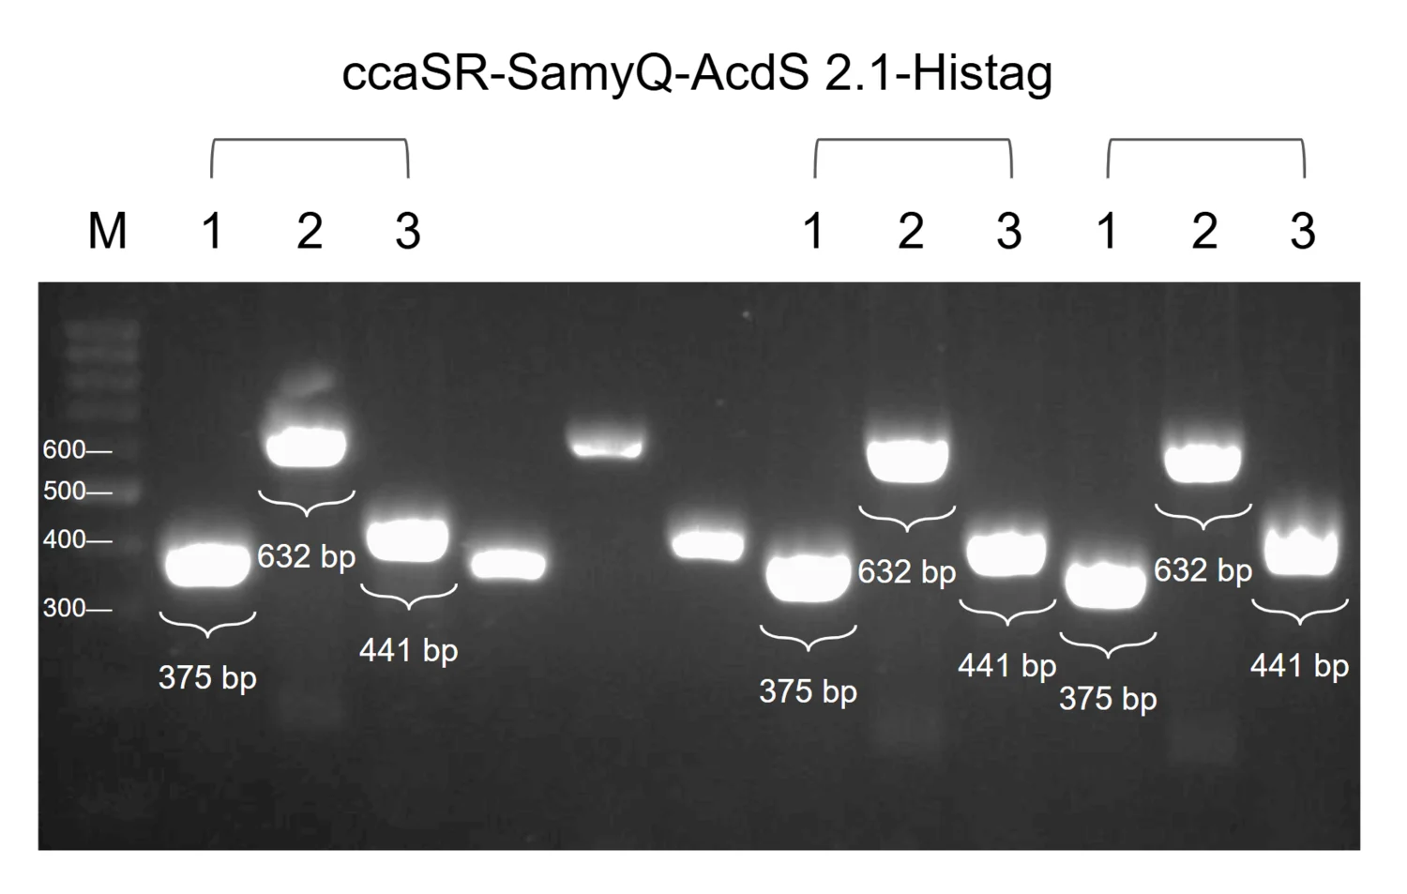
Figure 1. Cross-module PCR for ccaSR–SamyQ–AcdS 2.1–Histag. Three of three clones gave a band at the expected size across all modules. Clone 1 was selected for sequencing.
upload/14_BBa_26U8UTMH_EXPE_fig1_pp-pcr-sys-samyq.png (1500x953, 323 KB)

Characterisation
**Fig.1. Level 2 optogenetic control of His-tagged ACC deaminase expression (ABDQ).** Cells were grown under green light (G), which is expected to activate ACCD expression, or red light (R), which served as the repressing control. Samples were collected 13 h and 16 h after light exposure and probed with an anti-His primary antibody. Lane M is the protein marker ladder. Band intensities were similar across all lanes, so ACCD was produced steadily and at comparable levels under both wavelengths under the conditions tested.

**Fig.2. Optogenetic induced time-course of ACC deaminase expression under secondary regulation (ABDQ).** Western blot of His-tagged ACCD in *B. subtilis* cultures that were kept in the dark overnight (16 h) and then exposed to green light for 3, 6, or 8 h (O8). Lane M is the protein molecular weight marker. Probing with an anti-His primary antibody showed ACCD at all time points, with similar levels throughout.

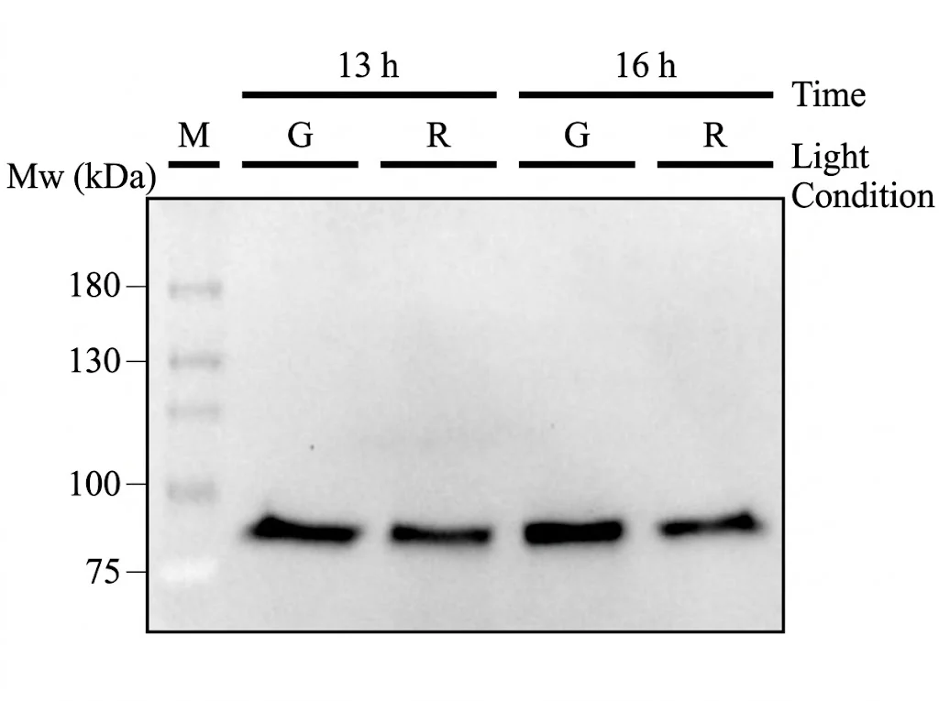
Figure 1. ACCD V2T1, construct ABDQ, after 13 and 16 h in the plate. G, green light; R, red light, both at 100%. A single band ran between the 75 and 100 kDa markers in all four lanes. The green lanes looked somewhat stronger than the red lanes at both times. Anti-His ELISA on these same four samples puts that difference at 12.9 against 11.8 µg/mL at 13 h and 12.5 against 12.1 µg/mL at 16 h: green is higher each time, with two samples a side and ranges that overlap.
upload/15_BBa_26U8UTMH_CHAR_fig1_lpa-wb-13-16h.png (1024x765, 140 KB)

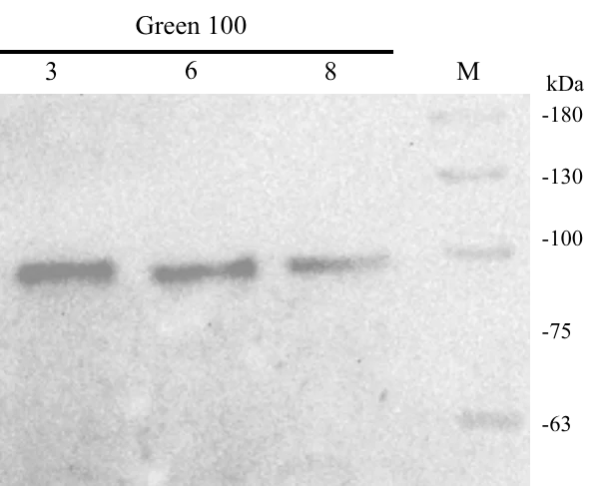
Figure 2. ACCD V2T1 after an overnight culture of 16 h was moved into the plate under green light at 100%, sampled after 3, 6 and 8 h. A band ran just below the 100 kDa marker all three times. It was strong at 3 and 6 h and weaker at 8 h.
upload/16_BBa_26U8UTMH_CHAR_fig2_lpa-wb-overnight.png (599x487, 126 KB)

Application
The Level 2 construct ccaSR-SamyQ-AcdS 2.1-Histag (BBa\_2654HAF3) shows that *Bacillus subtilis* can sense light and respond to it on its own. All four modules sit on a single plasmid. The first makes the chromophore PCB, the second expresses the sensor kinase CcaS-m3, the third expresses the response regulator CcaR, and the fourth secretes ACC deaminase (AcdS 2.1) when green light is present. Because *B. subtilis* does not make PCB, the circuit only works with all four modules together.

We tested this in *B. subtilis* WB800 in the LPA (light plate apparatus) under green and red light at different intensities. Western blots showed ACCD signal increasing over time under green light, but not under red light. This is the proof of concept for the whole design: light is the only input, and no inducer needs to be added.

Discussion
#### Use in plant protection

The aim is to release plant-protective proteins only when and where they are needed. A secreted ACC deaminase lowers stress ethylene around roots, so it could be used as part of a plant-growth-promoting bioprotectant. Light as the only input offers a practical advantage over circuits that sense stress themselves. Crops differ in their stress thresholds (for example, heat stress starts at about 30 to 37 °C in *Arabidopsis* but about 35 to 40 °C in peanut), and a self-sensing strain would have to be redesigned for each stressor and each crop. With light control, a user can set thresholds for each crop through a microcontroller-based sensor that switches the light, without redesigning the genetic circuit. This is the role the circuit plays in our bioreactor system.

#### A modular platform for other protectants

Modules 1 to 3 form a reusable light-sensing chassis, and only Module 4 defines the output. Any of our protectant cassettes can in principle be placed behind PcpcG2-veg:

* **AcdS** lowers ethylene levels. This is the version built and tested in the full circuit.
* **LEA14** protects cellular structures under environmental stress. We did not build the light-responsive Module 4 with LEA14. Instead, we characterized the constitutive LEA14 version to see how it would behave in the whole system, and it also protects plants facing salinity stress. This avoids repeating the same assembly, since ccaSR-AcdS already demonstrates that the concept works.
* **BoPep4**, a broccoli plant elicitor peptide, activates plant defense responses.

Our constitutive constructs, which use Pveg in place of the light switch, give the maximal secretion and production of each protectant. They also serve as a benchmark for the light-controlled version.

#### Beyond our project

Replacing the xylose-inducible and IPTG-inducible promoters of the published CcaSR system (Castillo-Hair et al., 2019) with constitutive ones means no inducer dosing is required. Other teams can reuse the four-module Level 2 plasmid for any secreted protein, simply by exchanging the output cassette. This makes light-controlled secretion in *B. subtilis* usable beyond plant protection, for example for other enzymes or peptides that should be produced on demand.

BBa_26CXI09X — Pveg-EEBD-RBS0-Csn-AcdS-Histag-B0015
protectant · tier A · published · 1669 bp · registry.igem.org/parts/bba-26cxi09x

Design
## Overview

This part encodes 1-aminocyclopropane-1-carboxylate (ACC) deaminase (AcdS: [BBa\_26MA70QI](https://registry.igem.org/parts/bba-26ma70qi)) from *Pseudomonas putida* (Arthrobacter siderocapsulatus) strain UW4.

The part is a composite transcription unit with three elements, in this order:

* **Pveg (**&#x42;ba\_K14301&#x32;**):** a constitutive bacterial promoter originally derived from *Bacillus subtilis* that drives continuous gene transcription without requiring external induction.
* **EEBD-RBS0 (**[BBa\_26V6CPEV](https://registry.igem.org/parts/bba-26v6cpev)**):** A composite ribosome binding site element containing a synthetic RBS sequence and expression-enhancing nucleotide context to improve translation initiation efficiency. EEBD is a blocking device, consisting of a B0015 terminator between two recombination sites to prevent unwanted gene expression or the production of toxic proteins while cloning DNA constructs inside *Escherichia coli*
* **Csn-AcdS-Histag (**[BBa\_26NXOP7S](https://registry.igem.org/parts/bba-26nxop7s)**):** a translational fusion of three elements:
* **Csn signal peptide:** the N-terminal Sec-dependent signal peptide of *B. subtilis* chitosanase (gene *csn*), which directs the protein to the secretion pathway and is cleaved off during export.
* **AcdS** ([<u>**BBa\_26MA70QI**</u>](https://registry.igem.org/parts/bba-26ma70qi)): the ACC deaminase coding sequence from *Pseudomonas putida*, with its native start and stop codons removed.
* **6x Histag:** fused at the C-terminus followed by a stop codon, allowing protein detection and purification.
* **B0015** (BBa\_B0015): A high-efficiency double transcriptional terminator that stops RNA polymerase from continuing transcription past the CDS protectant, preventing transcriptional read-through into downstream modules.

The complete module was assembled by Golden gate assembly with BsaI-HFv2.

## About

* **Biosafety level:** S1
* **Target organism:** *Bacillus subtilis* (168 / WB800)
* **Main purpose of use:** Constitutive expression and secretion of ACC deaminase
* **Potential application:** Lowering plant ethylene levels under stress, as a component of plant-growth-promoting bioprotectants.

## Literature

**Rationale.** ACC deaminase degrades ACC, the precursor of ethylene, and so can lower the ethylene levels that inhibit plant growth under stress (Hontzeas et al., 2004; Shah et al., 1998). The Csn signal peptide exports the enzyme from the cell, and the C-terminal 6x Histag allows detection and purification. The AcdS sequence comes from Q5PWZ8 (UniProt Consortium, n.d.; GenBank CP053102.1).

**Why a constitutive version.** We used the constitutive Pveg version in addition to the whole light-sensing construct because it lets us see the maximal secretion and protein production rate without the light switch. This version can be applied to plants and characterized directly by Western blot, which shows whether our constructs work under the most optimal conditions.

**Why Pveg and EEBD-RBS0.** Pveg gives high, continuous expression, so differences between protectants and signal peptides reflect the cargo rather than promoter strength. RBS0 sets translation initiation, and the EEBD protects *E. coli* during cloning. These are standard SubtiToolKit (STK) parts, so they assemble with the other protectant cassettes in the same format.

## References

1\. UniProt Consortium. (n.d.). *Q5PWZ8*. UniProt. Retrieved October 18, 2026, from[ <u>UniProt entry Q5PWZ8</u>](https://www.uniprot.org/uniprotkb/Q5PWZ8/entry?)

2\. Hontzeas, N., Zoidakis, J., Glick, B. R., & Abu-Omar, M. M. (2004). Expression and characterization of 1-aminocyclopropane-1-carboxylate deaminase from the rhizobacterium pseudomonas putida UW4: A key enzyme in bacterial plant growth promotion. *Biochimica et Biophysica Acta, 1703(1)*, 11–19. PubMed.[ <u>https://doi.org/10.1016/j.bbapap.2004.09.015</u>](https://doi.org/10.1016/j.bbapap.2004.09.015)

3\. Shah, S., Li, J., Moffatt, B. A., & Glick, B. R. (1998). Isolation and characterization of ACC deaminase genes from two different plant growth-promoting rhizobacteria. *Canadian Journal of Microbiology, 44*(9), 833–843.[ <u>https://doi.org/10.1139/w98-074</u>](https://doi.org/10.1139/w98-074)

4\. Deng, L. (2022). *Bacillus subtilis subsp. subtilis str. 168 chromosome, complete genome* \[GenBank sequence CP103783.1]. GenBank. National Center for Biotechnology Information.[ <u>https://www.ncbi.nlm.nih.gov/nucleotide/CP103783.1</u>](https://www.ncbi.nlm.nih.gov/nucleotide/CP103783.1?utm_source=chatgpt.com)

Open questions: [GenBank sequence CP103783.1] — not corroborated anywhere

Experiment
## Construction/assembly (wet lab)

* **Composite insert:** Pveg – EEBD-RBS0 – Csn-AcdS-Histag – B0015, \[1863 bp]
* **Level 1 vector:** pSTK-EXP1 expression shuttle vector (STK), \[ampicillin]
* **Template:** synthesized fragments assembled together
* **Annealing temperature (Level 0 amplification):** 60 °C
* **Assembly method (Level 1):** Golden Gate, BsaI-HFv2 enzyme
* **Thermal cycle:**

| Temperature | Time | Cycles |
| ----------- | ------ | --------- |
| 37 °C | 5 min | 45 cycles |
| 16 °C | 5 min | |
| 37 °C | 10 min | 1 cycle |
| 80 °C | 20 min | 1 cycle |

The full CDS was PCR-amplified as a single amplicon from the synthesized fragment using primers Csn F and ACCD R. Each primer carries a 5′ ATATAT spacer, a BpiI site (GAAGAC) for level 0 vector entry cloning, and a BsaI site (GGTCTC) for Level 1 assembly. The inner BsaI overhangs are TATG (incorporating the Csn start codon) at the 5′ end and TGTC at the 3′ end, which sets the CDS position and allows fusion to the downstream terminator. The amplicon was cloned into pGEM-T Easy and sequence-verified.

The Level 0 parts Pveg (BBa\_K143012), EEBD-RBS0 ([BBa\_26V6CPEV](https://registry.igem.org/parts/bba-26v6cpev)), Csn-AcdS-Histag ([BBa\_26NXOP7S](https://registry.igem.org/parts/bba-26nxop7s)) and B0015 (BBa\_B0015) were then combined in a single Golden Gate reaction (BsaI, T4 DNA ligase buffer, and T4 DNA ligase) into the pSTK-EXP1 expression shuttle vector, a Level 1 vector, in the order promoter, RBS, CDS, terminator. The reaction was transformed into *E. coli* DH5α, and positive clones were identified by colony PCR and sent for sequencing before electroporation into *B. subtilis*.

| Primer name | Primer sequence (5′ to 3′) |
| -------------- | ------------------------------------------------------------------ |
| pSTK-EXP-seq F | atagtcgatcggttcatcattcaccaaatca |
| Csn F | ATA TAT GAA GAC ATC TGA GGT CTC ATA TGA AAA TCA GTA TGC AAA AAG CA |
| ACCD R | ATA TAT GAA GAC ATG AGG GGT CTC ATG TCT TAA TGA TGA TGA TGA TGA T |
| pSTK-EXP-seq R | ctcactcattaggcaccccagg |

## Verification (wet lab)

Colonies from the pSTK-EXP1-sfGFP transformation were screened by colony PCR with Csn F and ACCD R primers flanking the CDS insertion site, and the products were run on an agarose gel alongside a DNA ladder. A correct band runs at the expected size \[1145 bp]. Colonies producing a single, clean band at this size were considered positive candidates.

Positive candidates were then sequenced to confirm that the promoter, RBS, CDS and terminator are free of mutations and correctly ordered. Clones with a verified sequence were used for further experiments.

## Results

***Figure 1.*** **Colony PCR of pSTK-EXP1-Pveg-EEBD-RBS0-Csn-AcdS-Histag-B0015.** 1 of 1 colonies gave a band at the expected size (\[7767 bp]).

***Figure 2.*** **Clone 1 was sequence-verified and used downstream.**

Resolved: [BsaI-HFv2 enzyme] → BsaI-HFv2 enzyme (stated unbracketed elsewhere on this part)
Open questions: [1863 bp] — no wiki caption confirms this band size; [ampicillin] — not corroborated anywhere; [1145 bp] — no wiki caption confirms this band size; [7767 bp] — no wiki caption confirms this band size

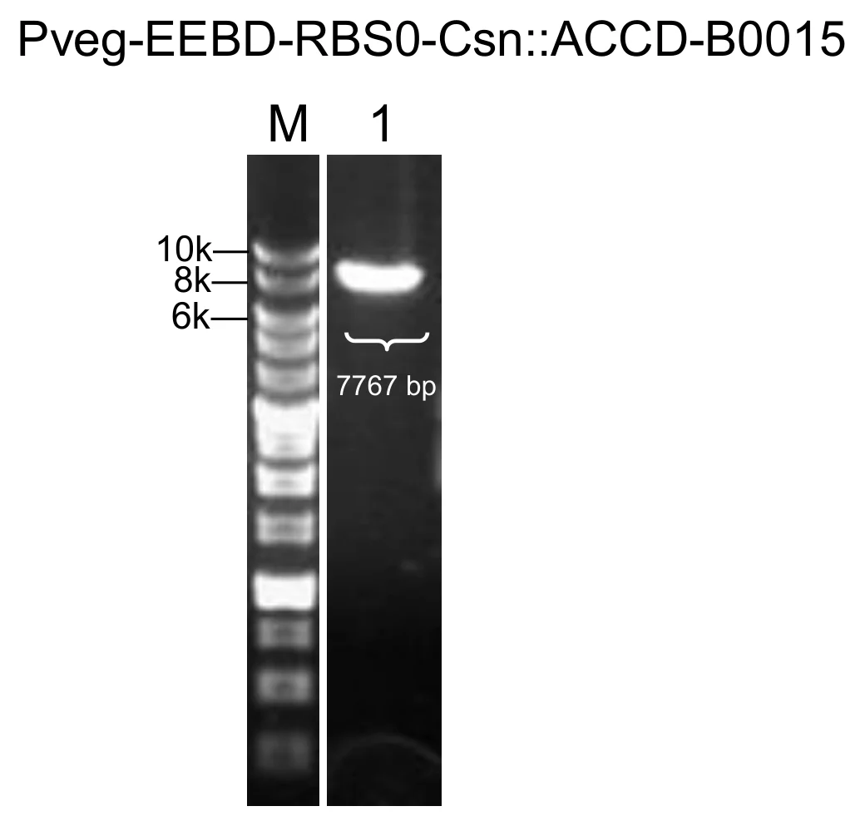
Figure 1. P veg –EEBD–RBS0–Csn–AcdS–Histag–B0015.
upload/07_BBa_26CXI09X_EXPE_fig1_pp-gel-prod-csn-accd.png (1040x993, 81 KB)

Characterisation
**Fig. 1. Western blot analysis of constitutive ACC deaminase expression in *Bacillus subtilis*.** Detection used a mouse monoclonal anti-Histag antibody. **(A)** Immunodetection verified expression and secretion of ACC deaminase from the constitutive Pveg construct. Lane ACCD is the culture supernatant, with a clear band at approximately 37 kDa, consistent with the predicted size of the secreted ACCD. **(B)** Western blot of the purification of ACC deaminase. S1 to S4 correspond to different concentrations of imidazole buffer (\[25 mM, 100 mM, 150 mM and 250 mM]). **(C)** Time course of protein expression and compartmental distribution of ACCD in a bioreactor. Samples were collected from the lumen side (cell lysate and culture medium fractions) and the shell side (culture medium fraction) at t \= 14, 16, 18, 20, 22, 24, 40, 42, and 44 h to assess expression, secretion efficiency, and diffusion.

###

Open questions: [25 mM, 100 mM, 150 mM and 250 mM] — not corroborated anywhere

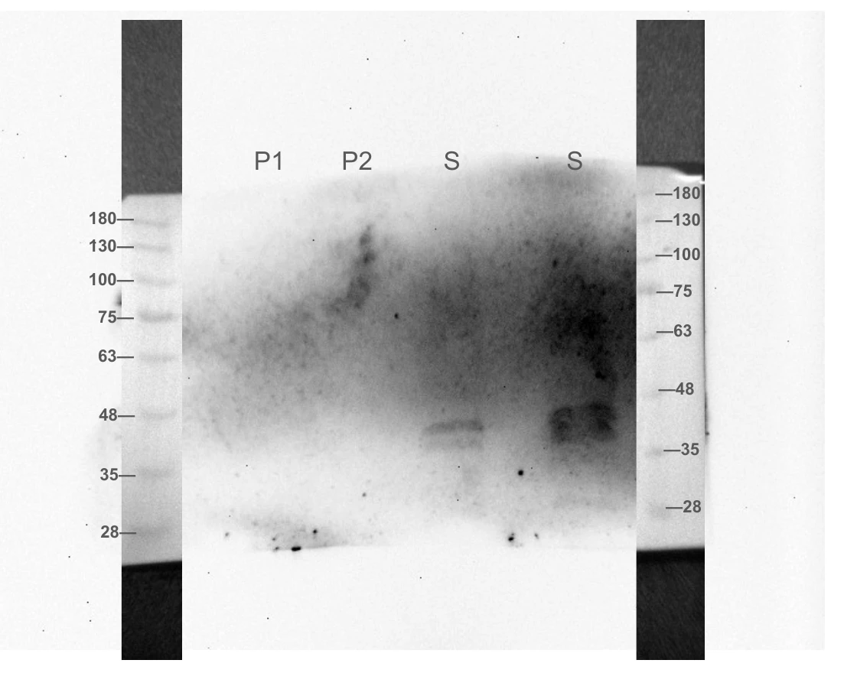
Figure 1. Western blot analysis of ACC deaminase secretion on 2 August 2026. P1 represents the total pellet, P2 the soluble pellet, and S the culture supernatant. Following a six-minute exposure, bands were detected only in the supernatant lanes, with molecular weight ladders spanning 28–180 kDa on both sides. This result is based on a single blot without a loading control, and the distinction between the two lanes labelled S was not documented.
upload/08_BBa_26CXI09X_CHAR_fig1_wb-260802-accd-fractionation.png (1120x880, 411 KB)

Application
### **Application**

This construct is the constitutive counterpart of the Light Responsive Expression Module in ccaSR-Csn-AcdS-Histag. It gives the maximal output of the same cassette, which the light-controlled version can be compared against. It was run in our bioreactor to monitor production and secretion, and its protein can be applied to plants for functional testing.

Discussion
**What the data mean.** ACCD is expressed in *B. subtilis* and secreted into the culture medium, so the construct works under optimal, constitutive conditions. Yield in the bioreactor was low, so there is room to improve it.

**Limitations.** Western blots show presence and size, not enzymatic activity, and activity assays are still planned. Pveg, EEBD-RBS0, and B0015 are reused across modules, which creates a risk of homologous recombination in the full circuit.

**Future directions.** We plan to improve yield through promoter strength and codon optimization, measure ACC deaminase activity directly, and compare Csn with SamyQ.

BBa_261XH2RS — PliaG-RBS0-ccaS-m3-B0015
light-sensing · tier A · published · 1693 bp · registry.igem.org/parts/bba-261xh2rs

Design
## Overview

When supplied with the chromophore phycocyanobilin (PCB) from the PCB Production Module, ccaS-m3 can detect green light and initiate signal transduction.

The part is a composite transcription unit with four elements, in this order:

· PliaG (BBa\_K823000): the promoter of the *liaG* gene of *B. subtilis*, described in the Registry as a weak constitutive promoter and characterised as part of the Bacillus BioBrick Box (Radeck et al., 2013). It transcribes the downstream coding sequence without any added inducer.

· RBS0 ([BBa\_26OSLRE4](https://registry.igem.org/parts/bba-26oslre4)): the ribosome binding site, which sets translation initiation of the downstream coding sequence.

· *ccaS-m3* (BBa\_K3317069): a miniaturised variant of *ccaS*, the cyanobacteriochrome histidine kinase of *Synechocystis* sp. PCC 6803. CcaS binds phycocyanobilin (PCB) through its GAF domain and phosphorylates the response regulator CcaR under green light. The variant corresponds to mini-CcaS#3 of Nakajima et al. (2016), in which the L1 linker and the two PAS domains are deleted and the GAF and histidine kinase domains are joined through a shortened linker.

· B0015 (BBa\_B0015): a high-efficiency double transcriptional terminator that stops RNA polymerase from continuing past the coding sequence and prevents transcriptional read-through into downstream modules.

The complete module was assembled by Golden gate assembly with BsaI-HFv2.

## About

* **Biosafety level:** S1
* **Target organism:** *Bacillus subtilis* WB800
* **Main purpose of use:** Constitutive expression of the CcaS light-sensing histidine kinase in the host *B. subtilis*.
* **Potential application:** Providing the green/red light input of the CcaSR system, as the light-sensing component of a stress-responsive optogenetic bioreactor for plant-growth-promoting bioprotectants.

## Literature

**Light sensing:** Holo-CcaS is produced in a green light-sensitive ground state with low autokinase activity, with a photostate absorbance maximum at 535 nm. Absorption of a green photon switches CcaS to a red light-sensitive active state with high autokinase activity, with a photostate absorbance maximum at 672 nm. The active kinase transfers a phosphoryl group from ATP to a conserved histidine, and from there to a conserved aspartate on CcaR, which activates CcaR and induces transcription from the PcpcG2 output promoter. Red light reverts the active state to the ground state and de-activates PcpcG2 transcription, probably through CcaS-mediated dephosphorylation of CcaR (Castillo-Hair et al., 2019). The 535 nm and 672 nm are absorbance maxima of the CcaS photostates (Hirose et al., 2008), and are distinct from the illumination used in the published characterization, which was delivered by a Light Plate Apparatus with 520 nm green and 660 nm red LEDs (Castillo-Hair et al., 2019).

**Dependence on the PCB module:** CcaS is photoactive only as a holoprotein with PCB bound to its GAF domain, and *B. subtilis* does not make PCB natively. This module therefore has no function on its own. It depends on the PCB supply module PtagC+RBS-Ho1-pcyA-L3S2P21, which converts endogenous heme to biliverdin IXα and then to PCB inside the host. In the Level 2 system the two modules are carried together for this reason.

**Choice of the miniaturised variant:** We used *ccaS-m3* in place of full-length *ccaS*. The miniaturised variants of Nakajima et al. (2016) remove the two PAS domains, whose function in CcaS is not known, and several of them regulate gene expression better than the wild-type kinase. Castillo-Hair et al. (2019) tested *ccaSm3* and *ccaSm10* in *B. subtilis* PY79 and reported that both increased dynamic range about ten-fold, to 71 ± 12-fold for *ccaSm3* and 62 ± 12-fold for *ccaSm10*; the two were not statistically different in *B. subtilis* (p \= 0.49) and *ccaSm10* gave lower overall output, so the system containing *ccaSm3* was named *B. subtilis* CcaSR v1.0. The same PAS deletions applied in the *E. coli* CcaSR v2.0 context gave a v3.0 sensor four times less leaky, with a dynamic range of nearly 600-fold and no deleterious effect on green light sensitivity or response dynamics (Ong & Tabor, 2018). We took *ccaS-m3* as the better-supported choice on both counts, low background and high dynamic range.

**Promoter strength for the sensor:** The published system expresses *ccaS* from the xylose-inducible PxylA promoter and *ccaR* from the IPTG-inducible Phy-spank promoter (Castillo-Hair et al., 2019), so the levels of both proteins are set by chemical inducers (Haller et al., 2025). Our bioreactor is intended to run on light alone, without xylose or IPTG dosing, so we replaced the inducible promoter with a constitutive one. This substitution is our own design decision and is not part of the published system. We chose a weak constitutive promoter deliberately. Castillo-Hair et al. (2019) found that output falls again at high CcaS levels, probably because PCB becomes limiting and the resulting apo-CcaS has phosphatase activity. A weak promoter keeps CcaS inside the range where the PCB supplied by the PCB module can be loaded onto it. PliaG is one of the weaker σA promoters in the Bacillus BioBrick Box set, whose constitutive promoters span more than three orders of magnitude (Radeck et al., 2013).&#x20;

## References

1\. Hirose, Y., Shimada, T., Narikawa, R., Katayama, M., & Ikeuchi, M. (2008). Cyanobacteriochrome CcaS is the green light receptor that induces the expression of phycobilisome linker protein. *Proceedings of the National Academy of Sciences, 105*(28), 9528–9533. [https://doi.org/10.1073/pnas.0801826105](https://doi.org/10.1073/pnas.0801826105)

2\. Nakajima, M., Ferri, S., Rögner, M., & Sode, K. (2016). Construction of a miniaturized chromatic acclimation sensor from cyanobacteria with reversed response to a light signal. *Scientific Reports, 6*, Article 37595. [https://doi.org/10.1038/srep37595](https://doi.org/10.1038/srep37595)

3\. Ong, N. T., & Tabor, J. J. (2018). A miniaturized *Escherichia coli* green light sensor with high dynamic range. *ChemBioChem, 19*(12), 1255–1258. [https://doi.org/10.1002/cbic.201800007](https://doi.org/10.1002/cbic.201800007)

4\. Castillo-Hair, S. M., Baerman, E. A., Fujita, M., Igoshin, O. A., & Voigt, C. A. (2019). Optogenetic control of *Bacillus subtilis* gene expression. *Nature Communications, 10*, Article 3099. [https://doi.org/10.1038/s41467-019-10906-6](https://doi.org/10.1038/s41467-019-10906-6)

5\. Haller, D. J., Castillo-Hair, S. M., & Tabor, J. J. (2025). Optogenetic control of *B. subtilis* gene expression using the CcaSR system. In A. Baumschlager (Ed.), *Optogenetics* (Methods in Molecular Biology, Vol. 2840, pp. 1–17). Humana. [https://doi.org/10.1007/978-1-0716-4047-0\_1](https://doi.org/10.1007/978-1-0716-4047-0_1)

6\. Radeck, J., Kraft, K., Bartels, J., Cikovic, T., Dürr, F., Emenegger, J., Kelterborn, S., Sauer, C., Fritz, G., Gebhard, S., & Mascher, T. (2013). The Bacillus BioBrick Box: generation and evaluation of essential genetic building blocks for standardized work with *Bacillus subtilis*. *Journal of Biological Engineering, 7*(1), 29. [https://doi.org/10.1186/1754-1611-7-29](https://doi.org/10.1186/1754-1611-7-29)

7\. Caro-Astorga, J., Rogan, M., Malcı, K., Ming, H., Debenedictis, E., James, P., & Ellis, T. (2025). SubtiToolKit: A bioengineering kit for *Bacillus subtilis* and Gram-positive bacteria. *Trends in Biotechnology, 43*(6), 1446–1469. [https://doi.org/10.1016/j.tibtech.2025.02.004](https://doi.org/10.1016/j.tibtech.2025.02.004)

8\. BBa\_K823000

9\. BBa\_B0015

Resolved: [168 / WB800] → WB800 (strain settled 7 Oct)

Experiment
## Construction/assembly (wet lab)

The *ccaS-m3* coding sequence was PCR-amplified as a single amplicon from the synthesised fragment using primers ccaS F and ccaS R. Each primer carries a 5' ATATAT spacer, a BpiI site (GAAGAC) for Level 0 entry cloning, and a BsaI site (GGTCTC) for Level 1 assembly. The inner BsaI overhangs are TATG (incorporating the start codon) at the 5' end and TGTC at the 3' end, which sets the CDS position and allows fusion to the downstream terminator. The amplicon was cloned into \[pGEM-T Easy] and sequence-verified.

The Level 0 parts PliaG (BBa\_K823000), RBS0 ([BBa\_26OSLRE4](https://registry.igem.org/parts/bba-26oslre4)), *ccaS-m3* (BBa\_K3317069) and B0015 (BBa\_B0015) were then combined in a single Golden Gate reaction (BsaI, T4 DNA ligase buffer, and T4 DNA ligase) into the pSTK-1B-sfGFP Level 1 cloning vector (Caro-Astorga et al., 2025), in the order promoter, RBS, CDS, terminator. The reaction was transformed into *E. coli* DH5α, and positive clones were identified by colony PCR and sent for sequencing before electroporation into *B. subtilis*.

**DETAILS:**

* Composite insert: PliaG – RBS0 – *ccaS-m3* – B0015, \[1723 bp]
* Level 1 vector: pSTK-1B-sfGFP (Level 1 cloning vector), (ampicillin)
* Template: synthesised fragment
* Annealing temperature (Level 0 amplification): \[60 °C]
* Assembly method: Golden Gate, \[BsaI-HFv2 enzyme
* Thermal cycle:

| Temperature | Time | Cycles |
| ----------- | ------ | --------- |
| 37 °C | 5 min | 45 cycles |
| 16 °C | 5 min | |
| 37 °C | 10 min | 1 cycle |
| 80 °C | 20 min | 1 cycle |

## Verification (wet lab)

Colonies from the pSTK-1B-sfGFP transformation were screened by colony PCR with pSTK-seq F and ccaSm3 R flanking the insertion site, and the products were run on an agarose gel alongside a DNA ladder. A correct band runs at the expected size, which is the length of 1602 bp. Colonies producing a single, clean band at this size were considered positive candidates.

Positive candidates were then sequenced to confirm that the promoter, RBS, *ccaS-m3* CDS and terminator are free of mutations and correctly ordered. Clones with a verified sequence were used for the Level 2 optogenetic system constructed in the pSTK-EXP2 vector.

| Primer name | Primer sequence (5' to 3') | |
| ----------- | -------------------------- | ------------------------------------------------------------------ |
| | ccaS F | ATA TAT GAA GAC ATC TGA GGT CTC ATA TGG GAA AAT TTT TAA TTC CAA TT |
| | ccaS R | ATA TAT GAA GAC ATG AGG GGT CTC ATG TCT TAA GCT CGA GGC AAA TGG T |
| | pSTK-seq F | agtgccacctgacgtctaagaaacc |
| | | |

## Results

![](https://registry.igem.wiki/documentation/1943545c-de1d-4107-bdc1-5ef1c1a6ef1f/b207909c8639ce0e3c7717c1bcfe9fc13049494069d17e87d8c158e6f7b36c17.avif)

**Figure 1. Colony PCR of pSTK-1B-PliaG-RBS0-*ccaS-m3*-B0015.** \[X] of \[X] colonies gave a band at the expected size (1602 bp).

**Figure 2. Clone \[X] was sequence-verified and used for downstream experiments.**

Resolved: [1602 bp] → 1602 bp (matches the wiki caption); [pSTK-1B] → pSTK-1B (stated unbracketed elsewhere on this part); [1602 bp] → 1602 bp (matches the wiki caption)
Open questions: [pGEM-T Easy] — not corroborated anywhere; [1723 bp] — no wiki caption confirms this band size; [60 °C] — not corroborated anywhere; [X] — clone number not stated in the wiki caption; [X] — clone number not stated in the wiki caption; [X] — clone number not stated in the wiki caption

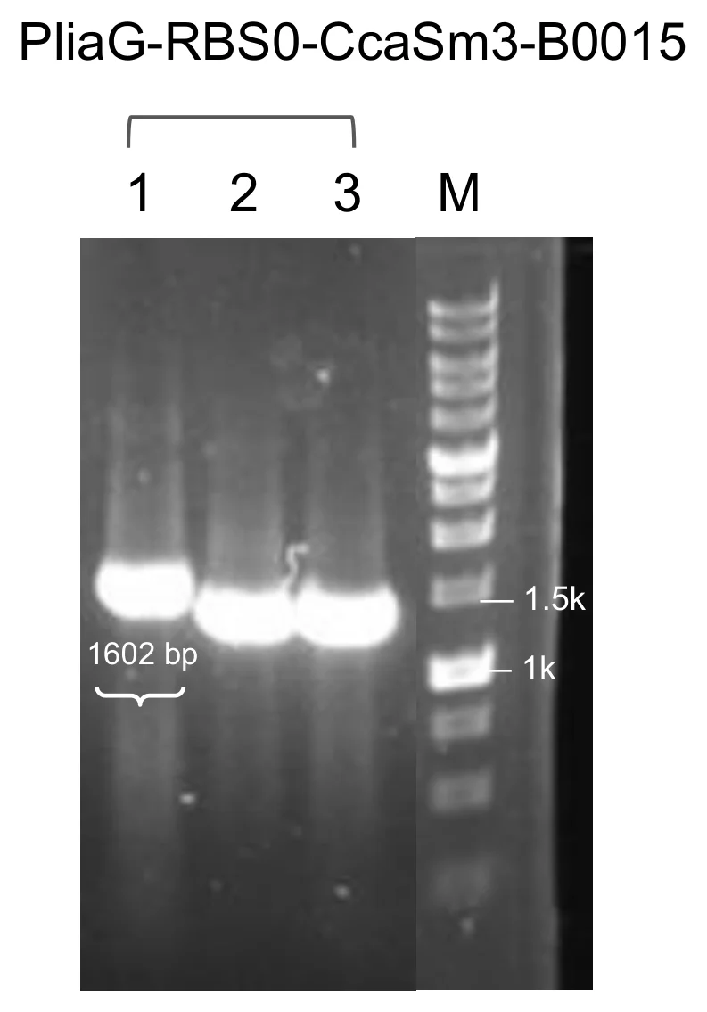
Figure 1. Module 2, P liaG –RBS0–ccaS-m3–B0015. One of three colonies gave a band at 1,602 bp, and that clone went to sequencing.
upload/01_BBa_261XH2RS_EXPE_fig1_pp-gel-m2.png (793x1135, 122 KB)

Application
This part was designed for the GEMS-Taiwan 2026 iGEM team’s work on a Stress-Responsive Optogenetic Bioreactor for Precision Plant Protection:

* **ccaSR-Csn-AcdS-Histag** ([<u>**BBa\_2654HAF3**</u>](https://registry.igem.org/parts/bba-2654haf3)): the system is an engineered construct that produces and secretes plant-protective proteins under green/red light control.
* **ccaSR-SamyQ-AcdS 2.1-Histag** ([<u>**BBa\_26U8UTMH**</u>](https://registry.igem.org/parts/bba-26u8utmh)): the system is an engineered construct that produces and secretes plant-protective proteins under green/red light control.

BBa_269A97I7 — Pveg-EEBD-RBS0-SamyQ-BoPep4 2.1-Histag-B0015
protectant · tier A · published · 712 bp · registry.igem.org/parts/bba-269a97i7

Design
## Overview

This part encodes BoPep4, a 23-residue plant elicitor peptide (PEP) from broccoli (*Brassica oleracea var. italica).*

The part is a composite transcription unit with four elements, in this order:

· Pveg (BBa\_K143012): a constitutive bacterial promoter originally derived from *Bacillus subtilis* that drives continuous gene transcription without requiring external induction.

· EEBD-RBS0 ([BBa\_26V6CPEV](https://registry.igem.org/parts/bba-26v6cpev)): a composite ribosome binding site element containing a synthetic RBS sequence and expression-enhancing nucleotide context to improve translation initiation efficiency. EEBD is a blocking device, consisting of a B0015 terminator between two recombination sites to prevent unwanted gene expression or the production of toxic proteins while cloning DNA constructs inside *Escherichia coli*.

· SamyQ-BoPep4 2.1-Histag ([BBa\_26PX0UGH](https://registry.igem.org/parts/bba-26px0ugh)): The part is a translational fusion with three elements, in this order:

1. **SamyQ signal peptide (BBa\_K1074014):** N-terminal signal peptide of the amyQ gene, which encodes a highly efficient α-amylase natively found in Bacillus subtilis (and related lineages like Bacillus amyloliquefaciens). Csn and SamyQ were selected as candidates to determine which signal peptide offers higher secretion efficiency.
2. **BoPep4 2.1 (**[<u>**BBa\_26LYCBW0**</u>](https://registry.igem.org/parts/bba-26lycbw0)**):** encodes BoPep4, a 23-residue plant elicitor peptide (PEP) from broccoli (*Brassica oleracea var. italica),* with its native start codon removed, followed by a stop codon. In this variant, the first 15 codons of the coding sequence were optimized to improve the mRNA secondary structure of the translation start site.
3. **6x Histag:** fused N-terminally to the peptide. This allows detection and quantification of the short peptide after successful assembly and electroporation.

· B0015 (BBa\_B0015): a high-efficiency double transcriptional terminator that stops RNA polymerase from continuing transcription past the CDS protectant, preventing transcriptional read-through into downstream modules.

The complete cassette was obtained by de novo gene synthesis.

## About

* **Biosafety level:** S1
* **Target organism:** *Bacillus subtilis* (168 / WB800)
* **Main purpose of use:** Constitutive expression and secretion of BoPep4
* **Potential application:** Enhancing plant salt-stress tolerance as a component of plant-protecting bioprotectants

## Literature

**Rationale.** BoPep4 is a 23-residue mature plant elicitor peptide from broccoli (*Brassica oleracea* var. *italica*), sequence GILIGSKKRPREPHSSGKPGGHN. It works through auxin and abscisic acid signalling crosstalk to raise salt-stress tolerance in broccoli, lowering the Na⁺/K⁺ ratio and promoting leaf wax and cutin accumulation (Wang, A., et al., 2022). This cassette carries the recoded BoPep4 2.1 coding sequence behind the SamyQ signal peptide, which directs the peptide into the Sec-dependent secretion pathway. The 6x Histag is fused N-terminally to the peptide, which allows detection and quantification of the short peptide.

**Why the recoded 5′ end.** The mRNA secondary structure around the ribosome binding site and the start codon influences translation initiation in bacteria, independently of the encoded protein sequence. Following Castillo-Hair et al. (2019), our design pipeline treated the first 15 codons of the BoPep4 coding sequence as an editable region. ViennaRNA 2.7.2 (Lorenz et al., 2011) generated and folded tens of thousands of synonymous variants in the RS-inclusive 236-nt 5′ window (residual recombination site, MF001 RBS, spacer, SamyQ ORF and the first 90 nt of the CDS), scoring the mean base-pair unpaired probability across the 15 nt following the ATG and across the MF001 Shine-Dalgarno core (AAGGAGG) and combining the two into a balance score. Wild-type BoPep4 was the weakest starting point of the whole construct series, with start+15 accessibility 0.396 and Shine-Dalgarno core accessibility 0.067, both below the roughly 0.50 usability threshold and below the Ho1 reference baseline of 0.681, which is why this cargo had the most to gain. BoPep4 2.1 was the best candidate of the run. Nine of the first 15 BoPep4 codons were changed (c2 ATT→ATC, c5 GGA→GGT, c6 TCA→AGT, c7 AAA→AAG, c10 CCG→CCT, c11 AGA→AGG, c13 CCG→CCT, c14 CAT→CAC, c15 TCA→TCC). Predicted start+15 accessibility improved from 0.396 to 0.497 and Shine-Dalgarno core accessibility rose from 0.067 to 0.634, roughly a 9.5-fold gain, for a balance score gain of 0.462 to 1.131. The codon adaptation index against *B. subtilis* 168 usage (Kazusa DNA Research Institute, n.d.) dropped from 0.87 to 0.77. Instead of applying Castillo's rule, which prioritises low GC content and A over U, the pipeline folded and checked every candidate individually; the Castillo-rule control reached a start+15 score of 0.677 and a Shine-Dalgarno core score of 0.425 (balance 1.102), below the balance reached by individual verification. The encoded peptide sequence is unchanged. These scores are predictions. Translation initiation from this cassette has not been measured.

**Why three BoPep4 versions.** Our three BoPep4 cassettes, carrying wild-type BoPep4, BoPep4 2.1 and BoPep4 2.2, all use the SamyQ signal peptide and differ only in the first 15 codons. They are the one place in our part set where the effect of 5′ recoding can be read on its own, with everything else held fixed.

**Why a constitutive version.** We used the constitutive Pveg version in addition to the whole light-sensing construct because it lets us see the maximal secretion and protein production rate without the light switch. This version can be applied to plants and characterized directly by Western blot, which shows whether our constructs work under the most optimal conditions.

**Why Pveg and EEBD-RBS0.** Pveg gives high, continuous expression at a fixed level, so differences between protectants and signal peptides reflect the cargo. RBS0 sets translation initiation, and the EEBD protects *Escherichia coli* during cloning. These are standard SubtiToolKit (STK) parts (Caro-Astorga et al., 2025), so they assemble with the other protectant cassettes in the same format.

1\. Wang, A., Guo, J., Wang, S., Zhang, Y., Lu, F., Duan, J., Liu, Z., & Ji, W. (2022). BoPEP4, a C-terminally encoded plant elicitor peptide from broccoli, plays a role in salinity stress tolerance. International Journal of Molecular Sciences, 23(6), Article 3090. [https://doi.org/10.3390/ijms23063090](https://doi.org/10.3390/ijms23063090)

2\. Caro-Astorga, J., Rogan, M., Malcı, K., Ming, H., Debenedictis, E., James, P., & Ellis, T. (2025). SubtiToolKit: A bioengineering kit for *Bacillus subtilis* and Gram-positive bacteria. Trends in Biotechnology, 43(6), 1446–1469. [https://doi.org/10.1016/j.tibtech.2025.02.004](https://doi.org/10.1016/j.tibtech.2025.02.004)

Experiment
## Construction/assembly (wet lab)

* **Composite insert:** Pveg – EEBD-RBS0 – SamyQ-BoPep4 2.1-Histag – B0015, \[906 bp]
* **Level 1 vector:** pSTK-EXP1 expression shuttle vector (STK), \[ampicillin]
* **Template:** synthesized fragments assembled together
* **Annealing temperature (Level 0 amplification):** 60 °C
* **Assembly method (Level 1):** Golden Gate, \[BsaI-HFv2 enzyme]
* **Thermal cycle:**

| Temperature | Time | Cycles |
| ----------- | ------ | --------- |
| 37 °C | 5 min | 45 cycles |
| 16 °C | 5 min | |
| 37 °C | 10 min | 1 cycle |
| 80 °C | 20 min | 1 cycle |

The full CDS was cloned into pSTK-0C-sfGFP and sequence-verified.

The Level 0 parts Pveg (BBa\_K143012), EEBD-RBS0 ([BBa\_26V6CPEV](https://registry.igem.org/parts/bba-26v6cpev)), SamyQ-BoPep 2.1-Histag ([BBa\_26PX0UGH](https://registry.igem.org/parts/bba-26px0ugh)) and B0015 (BBa\_B0015) were then combined in a single Golden Gate reaction (BsaI, T4 DNA ligase buffer, and T4 DNA ligase) into the pSTK-EXP1 expression shuttle vector, a Level 1 vector, in the order promoter, RBS, CDS, terminator. The reaction was transformed into *E. coli* DH5α, and positive clones were identified by colony PCR and sent for sequencing before electroporation into *B. subtilis*.

| Primer name | Primer sequence (5′ to 3′) |
| -------------- | -------------------------------------------------------------- |
| pSTK-EXP-seq F | atagtcgatcggttcatcattcaccaaatca |
| SamyQ F | ATATATGAAGACATCTGAGGTCTCATATGATTC AAAAACGAAAGCGGAC |
| BoPep R | ATA TAT GAA GAC ATG AGG GGT CTC ATG TCA TGA TGA TGA TGA TGA TG |
| pSTK-EXP-seq R | ctcactcattaggcaccccagg |

## Verification (wet lab)

Colonies from the pSTK-EXP1-sfGFP transformation were screened by colony PCR with backbone primers primers flanking the CDS insertion site, and the products were run on an agarose gel alongside a DNA ladder. A correct band runs at the expected size 678 bp. Colonies producing a single, clean band at this size were considered positive candidates.

Positive candidates were then sequenced to confirm that the promoter, RBS, CDS and terminator are free of mutations and correctly ordered. Clones with a verified sequence were used for further experiments.

## Results

![](https://registry.igem.wiki/documentation/eebe25ab-2090-4a56-92ea-26f9be11d10b/469dcae98058bf052c5d7026ee3448aa788dd36eb0a6ba6d0054ffd3a5eeecd7.avif)

***Figure 1.*** **Colony PCR of pSTK-EXP1-Pveg-EEBD-RBS0-SamyQ-BoPep4 2.1-Histag-B0015.** 1 of 10 colonies gave a band at the expected size (678 bp).

***Figure 2.*** **Clone 1 was sequence-verified and used downstream.**

Resolved: [678 bp] → 678 bp (matches the wiki caption); [678 bp] → 678 bp (matches the wiki caption)
Open questions: [906 bp] — no wiki caption confirms this band size; [ampicillin] — not corroborated anywhere; [BsaI-HFv2 enzyme] — not corroborated anywhere

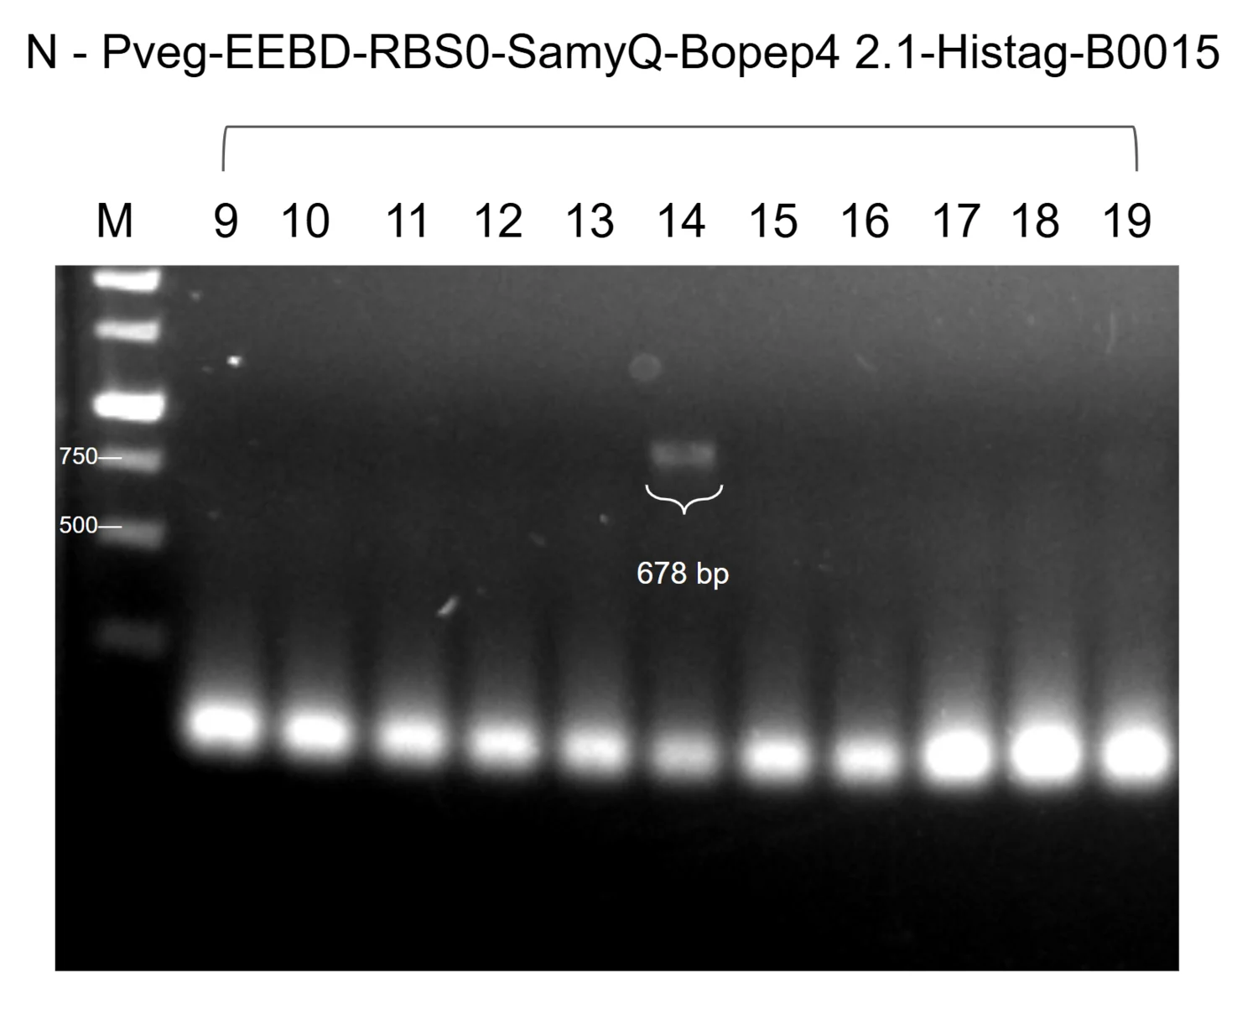
Figure 1. P veg –EEBD–RBS0–SamyQ–BoPep4 2.1–Histag–B0015. One of eleven colonies at 678 bp; clone 14 sequenced.
upload/05_BBa_269A97I7_EXPE_fig1_pp-gel-prod-bopep4-21.png (1500x1215, 358 KB)

Application
A full ccaSR construct with BoPep4 as Module 4 was not built. The constitutive BoPep4 version lets us assess its behavior in the system, and it also helped plants under salinity stress, without duplicating the work, because ccaSR-Csn-AcdS-Histag ([BBa\_2654HAF3](https://registry.igem.org/parts/bba-2654haf3)) and ccaSR-SamyQ-AcdS 2.1-Histag ([BBa\_26U8UTMH](https://registry.igem.org/parts/bba-26u8utmh)) already serves as proof of concept for the circuit.

BBa_26BDO8AQ — Pveg-RBS0-ccaR-B0015
light-sensing · tier A · published · 964 bp · registry.igem.org/parts/bba-26bdo8aq

Design
## Overview

The Transduction Module relays the light signal from the sensor to the gene expression module. It consists of ccaR, the response regulator of the cyanobacterial ccaS/ccaR two-component system.&#x20;

The part is a composite transcription unit with four elements, in this order:

· Pveg (BBa\_K143012): a constitutive bacterial promoter originally derived from *Bacillus subtilis* that drives continuous gene transcription without requiring external induction.

· RBS0 ([BBa\_26OSLRE4](https://registry.igem.org/parts/bba-26oslre4)): the ribosome binding site, which sets translation initiation of the downstream coding sequence.

· *ccaR* (BBa\_K5431017): the coding sequence of CcaR, the response regulator of *Synechocystis* sp. PCC 6803 that is cognate to the CcaS histidine kinase. Phosphorylated CcaR binds the operator region of the PcpcG2 promoter and activates transcription from it.

· B0015 (BBa\_B0015): a high-efficiency double transcriptional terminator that stops RNA polymerase from continuing past the coding sequence and prevents transcriptional read-through into downstream modules.

The complete module was assembled by Golden gate assembly with BsaI-HFv2.

## About

* **Biosafety level:** S1
* **Target organism:** *Bacillus subtilis* WB800
* **Main purpose of use:** Constitutive expression of the CcaR response regulator in the host *B. subtilis*.
* **Potential application:** Transducing the CcaS light signal to the PcpcG2-veg output promoter, as the signal transduction component of a stress-responsive optogenetic bioreactor for plant-growth-promoting bioprotectants.

## Literature

**Signal transduction:** CcaS and CcaR form a two-component system. Under green light the active CcaS kinase transfers a phosphoryl group from ATP to a conserved histidine in its own kinase domain, and from there to a conserved aspartate on CcaR. Phosphorylation activates CcaR, which then induces transcription from the PcpcG2 output promoter. Red light reverts CcaS to its ground state and de-activates PcpcG2 transcription, probably through CcaS-mediated dephosphorylation of CcaR (Castillo-Hair et al., 2019). In the original description of the pathway, autophosphorylation of the CcaS histidine kinase domain is up-regulated by green light, and CcaS then phosphorylates CcaR, which induces *cpcG2* expression (Hirose et al., 2008). CcaR carries the light signal from the sensor to the output promoter, and the light-responsive expression module cannot respond to light without it.

**Why a constitutive promoter:** The published system drives *ccaR* from the IPTG-inducible Phy-spank promoter (Castillo-Hair et al., 2019). Replacing it with constitutive Pveg is our own decision, made so that light is the only input to the circuit and the bioreactor needs no inducer dosing. Pveg gives high, continuous expression, and Castillo-Hair et al. (2019) report that of all the cyanobacterial genes in their study *ccaR* was the only one that did not initially suffer from poor expression. Expressing CcaR constitutively also means its level no longer tracks an inducer, so it becomes a fixed property of the strain.

**Background activation of CcaR:** This design's main risk is on the CcaR side. In the published v0.1 system, adding IPTG alone, which raised CcaR without any green light, increased sfGFP output up to 40-fold, probably because CcaR can be phosphorylated by a small-molecule donor such as acetyl phosphate (Castillo-Hair et al., 2019). The amount of CcaR in the cell therefore sets how much output the circuit gives in the dark, and a constitutive promoter fixes that background. Dark-state and red-light output must therefore be measured for this module in our strain and reported alongside the green-light output; a fold-change quoted without a measured background would not be meaningful. These measurements have not yet been made. If the background proves too high, the correction is a weaker promoter or a weaker RBS on this module.

**Reuse of standard parts:** Pveg, RBS0 and B0015 are reused across our modules, which keeps every cassette in the same SubtiToolKit format and makes the Level 2 assembly straightforward (Caro-Astorga et al., 2025). The cost is that the Level 2 system carries several copies of the same promoter, RBS and terminator sequence, which creates a risk of homologous recombination between modules in the assembled circuit. We accepted this at Level 1, and sequence verification of the full Level 2 construct is the check on it. The PCB module uses PtagC+RBS in place of Pveg and RBS0 partly for the same reason.

## References

1\. Hirose, Y., Shimada, T., Narikawa, R., Katayama, M., & Ikeuchi, M. (2008). Cyanobacteriochrome CcaS is the green light receptor that induces the expression of phycobilisome linker protein. *Proceedings of the National Academy of Sciences, 105*(28), 9528–9533. [https://doi.org/10.1073/pnas.0801826105](https://doi.org/10.1073/pnas.0801826105)

2\. Castillo-Hair, S. M., Baerman, E. A., Fujita, M., Igoshin, O. A., & Voigt, C. A. (2019). Optogenetic control of *Bacillus subtilis* gene expression. *Nature Communications, 10*, Article 3099. [https://doi.org/10.1038/s41467-019-10906-6](https://doi.org/10.1038/s41467-019-10906-6)

3\. Haller, D. J., Castillo-Hair, S. M., & Tabor, J. J. (2025). Optogenetic control of *B. subtilis* gene expression using the CcaSR system. In A. Baumschlager (Ed.), *Optogenetics* (Methods in Molecular Biology, Vol. 2840, pp. 1–17). Humana. [https://doi.org/10.1007/978-1-0716-4047-0\_1](https://doi.org/10.1007/978-1-0716-4047-0_1)

4\. Caro-Astorga, J., Rogan, M., Malcı, K., Ming, H., Debenedictis, E., James, P., & Ellis, T. (2025). SubtiToolKit: A bioengineering kit for *Bacillus subtilis* and Gram-positive bacteria. *Trends in Biotechnology, 43*(6), 1446–1469. [https://doi.org/10.1016/j.tibtech.2025.02.004](https://doi.org/10.1016/j.tibtech.2025.02.004)

5\. BBa\_K143012

6\. BBa\_B0015

Resolved: [168 / WB800] → WB800 (strain settled 7 Oct)

Experiment
## Construction/assembly (wet lab)

The *ccaR* coding sequence was PCR-amplified as a single amplicon from the synthesised fragment using primers ccaR F and ccaR R. Each primer carries a 5' ATATAT spacer, a BpiI site (GAAGAC) for Level 0 entry cloning, and a BsaI site (GGTCTC) for Level 1 assembly. The inner BsaI overhangs are TATG (incorporating the start codon) at the 5' end and TGTC at the 3' end, which sets the CDS position and allows fusion to the downstream terminator. The amplicon was cloned into pGEM-T Easy and sequence-verified.

The Level 0 parts Pveg (BBa\_K143012), RBS0 ([BBa\_26OSLRE4](https://registry.igem.org/parts/bba-26oslre4)), *ccaR* (BBa\_K5431017) and B0015 (BBa\_B0015) were then combined in a single Golden Gate reaction (BsaI, T4 DNA ligase buffer, and T4 DNA ligase) into the pSTK-1C-sfGFP Level 1 cloning vector (Caro-Astorga et al., 2025), in the order promoter, RBS, CDS, terminator. The reaction was transformed into *E. coli* DH5α, and positive clones were identified by colony PCR and sent for sequencing before electroporation into *B. subtilis*.

**CONSTRUCT DETAILS:**

* Composite insert: Pveg – RBS0 – *ccaR* – B0015, \[XXXX bp]
* Level 1 vector: pSTK-1C-sfGFP (Level 1 cloning vector), \[marker to be confirmed]
* Template: synthesised fragment
* Annealing temperature (Level 0 amplification): \[60 °C]
* Assembly method: Golden Gate, BsaI-HFv2 enzyme
* Thermal cycle:

| Temperature | Time | Cycles |
| ----------- | ------ | --------- |
| 37 °C | 5 min | 45 cycles |
| 16 °C | 5 min | |
| 37 °C | 10 min | 1 cycle |
| 80 °C | 20 min | 1 cycle |

## Verification (wet lab)

Colonies from the pSTK-1C-sfGFP transformation were screened by colony PCR with pSTK-seq F and pSTK-seq R flanking the insertion site, and the products were run on an agarose gel alongside a DNA ladder. A correct band runs at the expected size, which is the length of the insert \[1174 bp] plus the vector sequence between the priming sites, for a total of 1442 bp. Colonies producing a single, clean band at this size were considered positive candidates.

Positive candidates were then sequenced to confirm that the promoter, RBS, *ccaR* CDS and terminator are free of mutations and correctly ordered. Clones with a verified sequence were used for the Level 2 optogenetic system constructed in the pSTK-EXP2 vector.

| Primer name | Primer sequence (5' to 3') |
| ----------- | ------------------------------------------------------------------ |
| ccaR F | ATA TAT GAA GAC ATC TGA GGT CTC ATA TGA GAA TTC TTT TAG TGG AGG AT |
| ccaR R | ATA TAT GAA GAC ATG AGG GGT CTC ATG TCC TAG TTT TTC CCT TGG CAC AA |
| pSTK-seq F | agtgccacctgacgtctaagaaacc |
| pSTK-seq R | tctttcctgc gttatcccct gattc |

## Results

![](https://registry.igem.wiki/documentation/a624c01e-1fc3-4ecd-b13d-c2b08788b2f5/fa7885bfe062bde6a5b9dd458239954935da17bdf37c95e2f52b07f62a804a5c.avif)

**Figure 1. Colony PCR of pSTK-1C-Pveg-RBS0-ccaR-B0015.** 2 of 4 colonies gave a band at the expected size (1442 bp).

**Figure 2. Clone 2 was sequence-verified and used for downstream experiments.**

Resolved: [pSTK-1C-sfGFP] → pSTK-1C-sfGFP (stated unbracketed elsewhere on this part); [BsaI-HFv2 enzyme] → BsaI-HFv2 enzyme (stated unbracketed elsewhere on this part); [1442 bp] → 1442 bp (matches the wiki caption); [1442 bp] → 1442 bp (matches the wiki caption)
Open questions: [XXXX bp] — genuinely unknown; [marker to be confirmed] — genuinely unknown; [60 °C] — not corroborated anywhere; [1174 bp] — no wiki caption confirms this band size

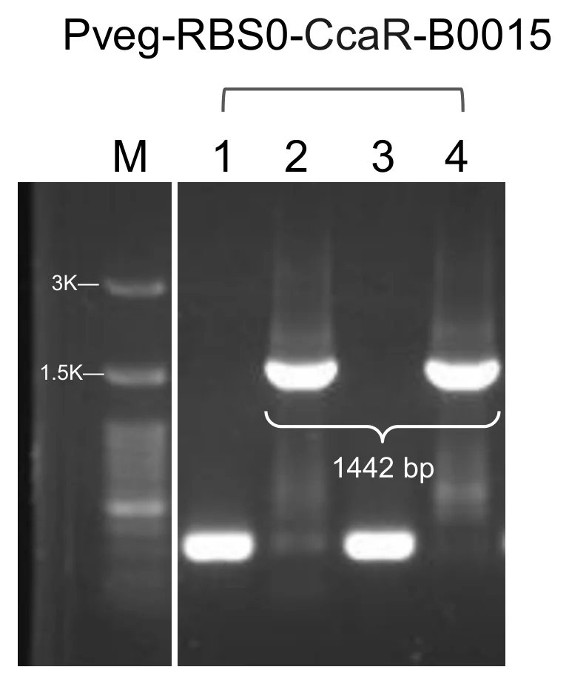
Figure 1. Module 3, P veg –RBS0–ccaR–B0015. Two of four colonies gave a band at 1,442 bp. Clone 2 was selected for sequencing.
upload/06_BBa_26BDO8AQ_EXPE_fig1_pp-gel-m3.png (769x924, 75 KB)

Application
This part was designed for the GEMS-Taiwan 2026 iGEM team’s work on a Stress-Responsive Optogenetic Bioreactor for Precision Plant Protection:

* **ccaSR-Csn-AcdS-Histag** ([<u>**BBa\_2654HAF3**</u>](https://registry.igem.org/parts/bba-2654haf3)): the system is an engineered construct that produces and secretes plant-protective proteins under green/red light control.
* **ccaSR-SamyQ-AcdS 2.1-Histag** ([<u>**BBa\_26U8UTMH**</u>](https://registry.igem.org/parts/bba-26u8utmh)): the system is an engineered construct that produces and secretes plant-protective proteins under green/red light control.

BBa_26D5AX7S — Pveg-EEBD-RBS0-SamyQ-LEA14 2.1-Histag-B0015
protectant · tier A · published · 1093 bp · registry.igem.org/parts/bba-26d5ax7s

Design
## Overview

This part encodes a Late Embryogenesis Abundant 14 protein (LEA14) (LEA: [BBa\_26LTB0W1](https://registry.igem.org/parts/bba-26ltb0w1)) from *Arabidopsis thaliana* gene *At1g01470.1*, which belongs to LEA\_2 subgroup.

The part is a composite transcription unit with four elements, in this order:

· Pveg (BBa\_K143012): a constitutive bacterial promoter originally derived from *Bacillus subtilis* that drives continuous gene transcription without requiring external induction.

· EEBD-RBS0 ([BBa\_26V6CPEV](https://registry.igem.org/parts/bba-26v6cpev)): a composite ribosome binding site element containing a synthetic RBS sequence and expression-enhancing nucleotide context to improve translation initiation efficiency. EEBD is a blocking device, consisting of a B0015 terminator between two recombination sites to prevent unwanted gene expression or the production of toxic proteins while cloning DNA constructs inside *Escherichia coli*.

· SamyQ-LEA14 2.1-Histag ([BBa\_26J0GJGZ](https://registry.igem.org/parts/bba-26j0gjgz)): a translational fusion of three elements:

1. **SamyQ signal peptide (**[<u>BBa\_K1074014</u>](https://registry.igem.org/parts/bba-k1074014)**):** N-terminal signal peptide of the *amyQ* gene, which encodes a highly efficient α-amylase natively found in *Bacillus subtilis* (and related lineages like *Bacillus amyloliquefaciens*). Csn and SamyQ were selected as candidates to determine which signal peptide offers higher secretion efficiency.
2. **LEA14 2.1 (**[<u>BBa\_26IN6G1D</u>](https://registry.igem.org/parts/bba-26in6g1d)**):** This part encodes a Late Embryogenesis Abundant 14 protein (LEA14) from [<u>*Arabidopsis thaliana*</u>](https://www.uniprot.org/uniprotkb/O03983/entry) with its native start codon and stop codon removed. In this variant, the first 15 codons of the coding sequence from LEA14 wild-type ([<u>BBa\_26LTB0W1</u>](https://registry.igem.org/parts/bba-26ltb0w1)) were optimized to improve the mRNA secondary structure of the translation start site.
3. **6x Histag:** Fused at the C-terminus followed by a stop codon. This allows protein purification and identification after successful assembly and electroporation.

· B0015 (BBa\_B0015): a high-efficiency double transcriptional terminator that stops RNA polymerase from continuing transcription past the CDS protectant, preventing transcriptional read-through into downstream modules.

The complete module was assembled by Golden gate assembly with BsaI-HFv2.

## About

* **Biosafety level:** S1
* **Target organism:** *Bacillus subtilis* (168 / WB800)
* **Main purpose of use:** Constitutive expression and secretion of LEA14
* **Potential application:** Protecting cellular structures and maintaining cellular stability under environmental stress conditions.

## Literature

**Rationale.** LEA proteins are small, partially folded, hydrophilic proteins that stabilise membranes and isolate ions to prevent water loss, and they keep other proteins from aggregating when water is withdrawn (Goyal et al., 2005; Hundertmark et al., 2008; Mertens et al., 2018). LEA14 from *Arabidopsis thaliana* is an intrinsically disordered protein of this family (Singh et al., 2005), and its overexpression raises salt-stress tolerance in *A. thaliana* (Jia et al., 2014). We selected it as a protectant cargo on the expectation that a secreted copy can help stabilise plant cell membranes under drought, salinity, heat and osmotic stress. This cassette carries the wild-type LEA14 coding sequence behind the Csn signal peptide, which exports the protein from the cell, and a C-terminal 6x Histag for detection and purification.

**Why a constitutive version.** We used the constitutive Pveg version in addition to the whole light-sensing construct because it lets us see the maximal secretion and protein production rate without the light switch. This version can be applied to plants and characterized directly by Western blot, which shows whether our constructs work under the most optimal conditions.

**Why Pveg and EEBD-RBS0.** Pveg gives high, continuous expression at a fixed level, so differences between protectants and signal peptides reflect the cargo. RBS0 sets translation initiation, and the EEBD protects *Escherichia coli* during cloning. These are standard SubtiToolKit (STK) parts (Caro-Astorga et al., 2025), so they assemble with the other protectant cassettes in the same format.

## References

1\. Goyal, K., Walton, L. J., & Tunnacliffe, A. (2005). LEA proteins prevent protein aggregation due to water stress. Biochemical Journal, 388(1), 151–157. [https://doi.org/10.1042/bj20041931](https://doi.org/10.1042/bj20041931)

2\. Hundertmark, M., Hincha, D. K., & Thalhammer, A. (2008). LEA (late embryogenesis abundant) proteins and their encoding genes in *Arabidopsis thaliana*. BMC Genomics, 9, Article 118. [https://doi.org/10.1186/1471-2164-9-118](https://doi.org/10.1186/1471-2164-9-118)

3\. Jia, F., Qi, S., Li, H., Liu, P., Li, P., Wu, C., Zheng, C., & Huang, J. (2014). Overexpression of late embryogenesis abundant 14 enhances *Arabidopsis* salt stress tolerance. Biochemical and Biophysical Research Communications, 454(4), 505–511. [https://doi.org/10.1016/j.bbrc.2014.10.136](https://doi.org/10.1016/j.bbrc.2014.10.136)

4\. Mertens, J., Aliyu, H., & Cowan, D. A. (2018). LEA proteins and the evolution of the WHy domain. Applied and Environmental Microbiology, 84(15), Article e00539-18. [https://doi.org/10.1128/AEM.00539-18](https://doi.org/10.1128/AEM.00539-18)

5\. Singh, S., Cornilescu, C. C., Tyler, R. C., Cornilescu, G., Tonelli, M., Lee, M. S., & Markley, J. L. (2005). Solution structure of a late embryogenesis abundant protein (LEA14) from *Arabidopsis thaliana*, a cellular stress-related protein. Protein Science, 14(10), 2601–2609. [https://doi.org/10.1110/ps.051579205](https://doi.org/10.1110/ps.051579205)

6\. Wang, J. W., Squire, H. J., Goh, N. S., Ni, H. M., Lien, E., Wong, C., González-Grandío, E., & Landry, M. P. (2023). Delivered complementation in planta (DCIP) enables measurement of peptide-mediated protein delivery efficiency in plants. Communications Biology, 6(1), Article 829. [https://doi.org/10.1038/s42003-023-05191-5](https://doi.org/10.1038/s42003-023-05191-5)

7\. Castillo-Hair, S. M., Baerman, E. A., Fujita, M., Igoshin, O. A., & Voigt, C. A. (2019). Optogenetic control of *Bacillus subtilis* gene expression. Nature Communications, 10, Article 3099. [https://doi.org/10.1038/s41467-019-10906-6](https://doi.org/10.1038/s41467-019-10906-6)

8\. Lorenz, R., Bernhart, S. H., Höner zu Siederdissen, C., Tafer, H., Flamm, C., Stadler, P. F., & Hofacker, I. L. (2011). ViennaRNA Package 2.0. Algorithms for Molecular Biology, 6, Article 26. [https://doi.org/10.1186/1748-7188-6-26](https://doi.org/10.1186/1748-7188-6-26)

9\. Kazusa DNA Research Institute. (n.d.). Codon usage database: *Bacillus subtilis* subsp. *subtilis* str. 168 (taxid:1423). [https://www.kazusa.or.jp/codon/](https://www.kazusa.or.jp/codon/)

10\. Caro-Astorga, J., Rogan, M., Malcı, K., Ming, H., Debenedictis, E., James, P., & Ellis, T. (2025). SubtiToolKit: A bioengineering kit for *Bacillus subtilis* and Gram-positive bacteria. Trends in Biotechnology, 43(6), 1446–1469. [https://doi.org/10.1016/j.tibtech.2025.02.004](https://doi.org/10.1016/j.tibtech.2025.02.004)

Experiment
## Construction/assembly (wet lab)

* Composite insert: Pveg – EEBD-RBS0 – SamyQ-LEA14 2.1-Histag – B0015, \[1287 bp]
* Level 1 vector: pSTK-EXP1 expression shuttle vector (STK), \[ampicillin]
* Template: synthesized fragments assembled together
* Annealing temperature (Level 0 amplification): 60 °C
* Assembly method (Level 1): Golden Gate, BsaI-HFv2 enzyme
* Thermal cycle:

| Temperature | Time | Cycles |
| ----------- | ------ | --------- |
| 37 °C | 5 min | 45 cycles |
| 16 °C | 5 min | |
| 37 °C | 10 min | 1 cycle |
| 80 °C | 20 min | 1 cycle |

The full CDS was PCR-amplified as a single amplicon from the synthesized fragment using primers SamyQ F and ACCD R. Each primer carries a 5′ ATATAT spacer, a BpiI site (GAAGAC) for level 0 vector entry cloning, and a BsaI site (GGTCTC) for Level 1 assembly. The inner BsaI overhangs are TATG (incorporating the SamyQ start codon) at the 5′ end and TGTC at the 3′ end, which sets the CDS position and allows fusion to the downstream terminator. The amplicon was cloned into pSTK-0C-sfGFP and sequence-verified.

The Level 0 parts Pveg (BBa\_K143012), EEBD-RBS0 ([BBa\_26V6CPEV](https://registry.igem.org/parts/bba-26v6cpev)), SamyQ-LEA14 2.1-Histag ([BBa\_26J0GJGZ](https://registry.igem.org/parts/bba-26j0gjgz)) and B0015 (BBa\_B0015) were then combined in a single Golden Gate reaction (BsaI, T4 DNA ligase buffer, and T4 DNA ligase) into the pSTK-EXP1 expression shuttle vector, a Level 1 vector, in the order promoter, RBS, CDS, terminator. The reaction was transformed into *E. coli* DH5α, and positive clones were identified by colony PCR and sent for sequencing before electroporation into *B. subtilis*.

| Primer name | Primer sequence (5′ to 3′) |
| -------------- | ----------------------------------------------------------------- |
| pSTK-EXP-seq F | atagtcgatcggttcatcattcaccaaatca |
| SamyQ F | ATATAT GAA GAC ATC TGA GGT CTC ATA TGA TTC AAA AAC GAA AGC GGA C |
| LEA R | ATA TAT GAA GAC ATG AGG GGT CTC ATG TCT TAA TGA TGA TGA TGA TGA T |
| pSTK-EXP-seq R | ctcactcattaggcaccccagg |

## Verification (wet lab)

Colonies from the pSTK-EXP1-sfGFP transformation were screened by colony PCR with pSTK-EXP-seq F and pSTK-EXP-seq R backbone primers, and the products were run on an agarose gel alongside a DNA ladder. A correct band runs at the expected size 1423 bp. Colonies producing a single, clean band at this size were considered positive candidates.

Positive candidates were then sequenced to confirm that the promoter, RBS, CDS and terminator are free of mutations and correctly ordered. Clones with a verified sequence were used for further experiments.

## Results

![](https://registry.igem.wiki/documentation/a381f6ca-1228-4197-882d-fff4e1e9451b/ebfd0c76c34d04f11956d58605357d68079855d15bd02b40b5224ffebfa2c34a.avif)

**Figure 1. Colony PCR of pSTK-EXP1-Pveg-EEBD-RBS0-SamyQ-LEA14 2.1-Histag-B0015.** 2 of 7 colonies gave a band at the expected size (1423 bp).

**Figure 2. Clone \[X] was sequence-verified and used downstream.**

Resolved: [BsaI-HFv2 enzyme] → BsaI-HFv2 enzyme (stated unbracketed elsewhere on this part); [1423 bp] → 1423 bp (matches the wiki caption); [1423 bp] → 1423 bp (matches the wiki caption)
Open questions: [1287 bp] — no wiki caption confirms this band size; [ampicillin] — not corroborated anywhere; [X] — clone number not stated in the wiki caption

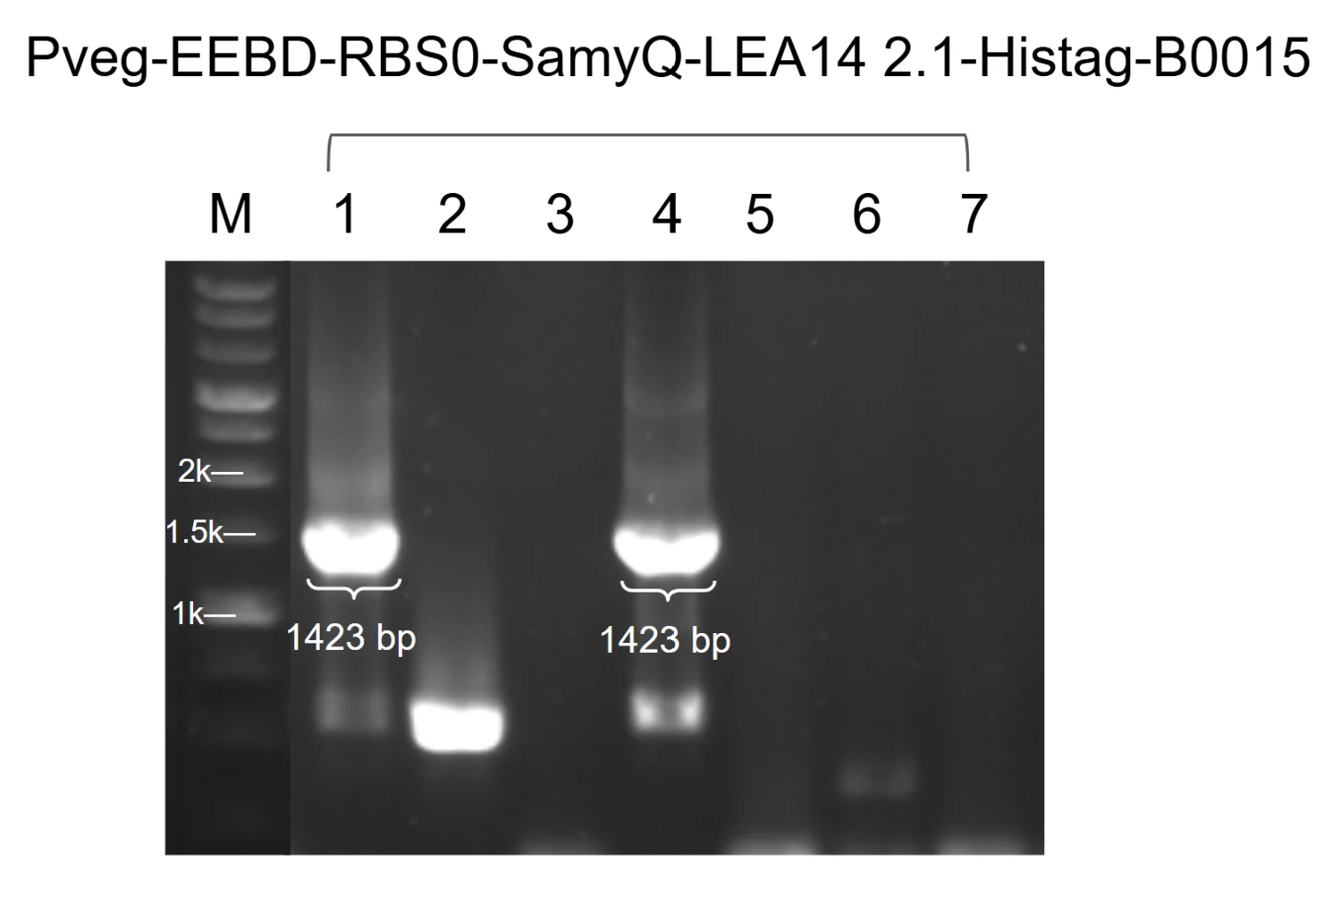
Figure 1. P veg –EEBD–RBS0–SamyQ–LEA14–Histag 2.1–B0015. Two of seven colonies at 1,423 bp; clone 1 sequenced.
upload/09_BBa_26D5AX7S_EXPE_fig1_pp-gel-prod-samyq-lea14.png (1500x1020, 196 KB)

Application
A full ccaSR construct with LEA14 as Module 4 was not built. The constitutive LEA14 version lets us assess its behavior in the system, and it also helped plants under salinity stress, without duplicating the work, because ccaSR-Csn-AcdS-Histag ([BBa\_2654HAF3](https://registry.igem.org/parts/bba-2654haf3)) and ccaSR-SamyQ-AcdS 2.1-Histag ([BBa\_26U8UTMH](https://registry.igem.org/parts/bba-26u8utmh)) already serves as proof of concept for the circuit.

BBa_26DE5E2Q — PcpcG2-veg-EEBD-RBS0-SamyQ-AcdS 2.1-Histag-B0015
hybrid · tier A · published · 2602 bp · registry.igem.org/parts/bba-26de5e2q

Design
## Overview

The Light-Responsive Expression Module drives the expression of downstream genes in response to green-light signaling in Bacillus subtilis.

The part is a composite transcription unit with four elements, in this order:

· PcpcG2-veg (BBa\_254UKC9E): the light-responsive output promoter of the CcaSR system, activated by phosphorylated CcaR. It is a *B. subtilis*-adapted chimera of the cyanobacterial PcpcG2 promoter, engineered by Castillo-Hair et al. (2019).

· EEBD-RBS0 (BBa\_26V6CPEV): a composite ribosome binding site element containing a synthetic RBS sequence and expression-enhancing nucleotide context to improve translation initiation efficiency. EEBD is a blocking device, consisting of a B0015 terminator between two recombination sites to prevent unwanted gene expression or the production of toxic proteins while cloning DNA constructs inside *Escherichia coli*.

· SamyQ-AcdS 2.1-Histag ([BBa\_26TOGLX3](https://registry.igem.org/parts/bba-26toglx3)): a translational fusion of an N-terminal Sec-dependent signal peptide, the ACC deaminase coding sequence with its native start and stop codons removed, and a 6x Histag fused at the C terminus followed by a stop codon, which allows protein detection and purification. The signal peptide and the *acdS* variant differ between the two versions of the module, as set out below.

· B0015 (BBa\_B0015): a high-efficiency double transcriptional terminator that stops RNA polymerase from continuing transcription past the CDS protectant, preventing transcriptional read-through into downstream modules.

The complete module was assembled by Golden gate assembly with BsaI-HFv2.

## About

* **Biosafety level:** S1
* **Target organism:** *Bacillus subtilis* WB800
* **Main purpose of use:** Green light-responsive expression and secretion of ACC deaminase in the host *B. subtilis*.
* **Potential application:** Lowering plant ethylene levels under stress on demand, as the output component of a stress-responsive optogenetic bioreactor for plant-growth-promoting bioprotectants.

## Literature

**How PcpcG2-veg was engineered:** The output promoter was adapted to *B. subtilis* in stages by Castillo-Hair et al. (2019). The starting point was PcpcG2-172, the *E. coli*-optimised truncation of Schmidl et al. (2014), which removes an unwanted transcriptional start site. In *B. subtilis* it was weak. Swapping the original -10 hexamer for the *B. subtilis* consensus sequence, to improve σA RNA polymerase recruitment, gave PcpcG2-hy and about three times more output. Replacing the proximal region, meaning the sequence following the -10 hexamer, with that of the strong constitutive promoters PrpsD and Pveg gave the chimeras PcpcG2-rpsD and PcpcG2-veg; those two swaps are reported as increasing output transcription by 22- and 44-fold, and PcpcG2-veg was selected for its superior activity.

The values below are from Castillo-Hair et al. (2019), measured in *B. subtilis* PY79 by calibrated flow cytometry with an sfGFP reporter. They are not our measurements.

| Output promoter | Induced output (MEFL) | Uninduced output (MEFL) |
| --------------- | --------------------- | ----------------------- |
| PcpcG2-172 | 555 ± 65 | not reported |
| PcpcG2-hy | 1470 ± 110 | not reported |
| PcpcG2-rpsD | 32,400 ± 2800 | 174 ± 23 |
| PcpcG2-veg | 64,000 ± 7600 | 378 ± 38 |

Two limits of that engineering matter for reading the part. The -35 box was left untouched, and only the -10 hexamer and the proximal region downstream of it were changed, because the CcaR operator region had to be kept intact. We chose PcpcG2-veg as the output promoter for the same reason it was selected in the published work, its higher output.

**Why the blocking device is on this module:** EEBD sits on this module and is absent from the light-sensing and transduction modules, because of the cargo. ACC deaminase is a secreted enzyme carried on a Sec signal peptide, and expression during cloning in *E. coli* risks unwanted protein production and loss of the construct. CcaS and CcaR, by contrast, have nothing to act on in *E. coli*, which has neither PCB nor a PcpcG2 promoter. Placing the terminator-between-recombination-sites device in front of the protectant CDS keeps the cassette silent through the *E. coli* cloning steps, and the same EEBD-RBS0 part supplies the RBS for the protectant CDS.

**What AcdS does:** ACC deaminase hydrolyses 1-aminocyclopropane-1-carboxylate, the precursor of the plant stress hormone ethylene, and so lowers the ethylene levels that inhibit plant growth under stress (Glick et al., 1998; Shah et al., 1998). The coding sequence is that of *Pseudomonas putida* strain UW4, taken from UniProt Q5PWZ8. The recombinant enzyme from that strain is 41 kDa and is selective and highly active towards ACC, with K(M) \= 3.4 ± 0.2 mM and k(cat) \= 146 ± 5 min⁻¹ at pH 8.0 and 22 °C. Activity is optimal at pH 8.0, declines sharply to essentially nothing below pH 6.5, tapers off more gradually at higher pH, and is lost above pH 10 (Hontzeas et al., 2004).

**The constitutive counterpart:** The constitutive Pveg versions of this cassette exist so that maximal secretion and production can be measured without the light switch, which gives the light-controlled module something to be compared against. A Western blot of the constitutive Csn-AcdS construct gave a band at about 37 kDa in the culture supernatant, consistent with the predicted size of the secreted enzyme. The 41 kDa quoted above is the purified recombinant enzyme of Hontzeas et al. (2004), which carries neither a cleaved signal peptide nor a His tag, and we have not compared the two forms directly. The equivalent characterisation of the light-responsive versions is not yet complete.

## References

Schmidl, S. R., Sheth, R. U., Wu, A., & Tabor, J. J. (2014). Refactoring and optimization of light-switchable *Escherichia coli* two-component systems. *ACS Synthetic Biology, 3*(11), 820–831. [https://doi.org/10.1021/sb500273n](https://doi.org/10.1021/sb500273n)

2\. Castillo-Hair, S. M., Baerman, E. A., Fujita, M., Igoshin, O. A., & Voigt, C. A. (2019). Optogenetic control of *Bacillus subtilis* gene expression. *Nature Communications, 10*, Article 3099. [https://doi.org/10.1038/s41467-019-10906-6](https://doi.org/10.1038/s41467-019-10906-6)

3\. Hontzeas, N., Zoidakis, J., Glick, B. R., & Abu-Omar, M. M. (2004). Expression and characterization of 1-aminocyclopropane-1-carboxylate deaminase from the rhizobacterium *Pseudomonas putida* UW4: A key enzyme in bacterial plant growth promotion. *Biochimica et Biophysica Acta, 1703*(1), 11–19. [https://doi.org/10.1016/j.bbapap.2004.09.015](https://doi.org/10.1016/j.bbapap.2004.09.015)

4\. Shah, S., Li, J., Moffatt, B. A., & Glick, B. R. (1998). Isolation and characterization of ACC deaminase genes from two different plant growth-promoting rhizobacteria. *Canadian Journal of Microbiology, 44*(9), 833–843. [https://doi.org/10.1139/w98-074](https://doi.org/10.1139/w98-074)

5\. Glick, B. R., Penrose, D. M., & Li, J. (1998). A model for the lowering of plant ethylene concentrations by plant growth-promoting bacteria. *Journal of Theoretical Biology, 190*(1), 63–68. [https://doi.org/10.1006/jtbi.1997.0532](https://doi.org/10.1006/jtbi.1997.0532)

6\. UniProt Consortium. (n.d.). Q5PWZ8. UniProt. Retrieved October 18, 2026, from UniProt entry Q5PWZ8

7\. Lorenz, R., Bernhart, S. H., Höner zu Siederdissen, C., Tafer, H., Flamm, C., Stadler, P. F., & Hofacker, I. L. (2011). ViennaRNA Package 2.0. *Algorithms for Molecular Biology, 6*, Article 26. [https://doi.org/10.1186/1748-7188-6-26](https://doi.org/10.1186/1748-7188-6-26)

8\. Kazusa DNA Research Institute. (n.d.). Codon usage database: *Bacillus subtilis* subsp. *subtilis* str. 168 (taxid:1423). [https://www.kazusa.or.jp/codon/](https://www.kazusa.or.jp/codon/)

9\. Caro-Astorga, J., Rogan, M., Malcı, K., Ming, H., Debenedictis, E., James, P., & Ellis, T. (2025). SubtiToolKit: A bioengineering kit for *Bacillus subtilis* and Gram-positive bacteria. *Trends in Biotechnology, 43*(6), 1446–1469. [https://doi.org/10.1016/j.tibtech.2025.02.004](https://doi.org/10.1016/j.tibtech.2025.02.004)

10\. BBa\_K1074014

11\. BBa\_B0015

Resolved: [168 / WB800] → WB800 (strain settled 7 Oct)

Experiment
## Construction/assembly (wet lab)

The protectant coding sequence was PCR-amplified as a single amplicon from the synthesised fragment, using primers SamyQ F and ACCD R for the SamyQ-AcdS 2.1-Histag version. Each primer carries a 5' ATATAT spacer, a BpiI site (GAAGAC) for Level 0 entry cloning, and a BsaI site (GGTCTC) for Level 1 assembly. The inner BsaI overhangs are TATG (incorporating the start codon) at the 5' end and TGTC at the 3' end, which sets the CDS position and allows fusion to the downstream terminator. The amplicon was cloned into pSTK-0C-sfGFP and sequence-verified.

The Level 0 parts PcpcG2-veg (BBa\_254UKC9E), EEBD-RBS0 (BBa\_26V6CPEV), the protectant CDS fusion ([BBa\_26TOGLX3](https://registry.igem.org/parts/bba-26toglx3)) and B0015 (BBa\_B0015) were then combined in a single Golden Gate reaction (BsaI, T4 DNA ligase buffer, and T4 DNA ligase) into the pSTK-1D-sfGFP Level 1 cloning vector (Caro-Astorga et al., 2025), in the order promoter, RBS, CDS, terminator. The reaction was transformed into *E. coli* DH5α, and positive clones were identified by colony PCR and sent for sequencing before electroporation into *B. subtilis*.

**CONSTRUCT DETAILS**

* Composite insert: PcpcG2-veg – EEBD-RBS0 – SamyQ-AcdS 2.1-Histag – B0015, \[1773 bp]
* Level 1 vector: pSTK-1D-sfGFP (Level 1 cloning vector), \[ampicillin]
* Template: synthesised fragments assembled together
* Annealing temperature (Level 0 amplification): 60 °C
* Assembly method: Golden Gate, BsaI-HFv2 enzyme
* Thermal cycle:

| Temperature | Time | Cycles |
| ----------- | ------ | --------- |
| 37 °C | 5 min | 45 cycles |
| 16 °C | 5 min | |
| 37 °C | 10 min | 1 cycle |
| 80 °C | 20 min | 1 cycle |

## Verification (wet lab)

Colonies from the pSTK-1D-sfGFP transformation were screened by colony PCR with CDS SamyQ F and pSTK-seq R primers.The products were run on an agarose gel alongside a DNA ladder. A correct band runs at the expected size, which is the length of the insert plus the vector sequence between the priming sites, for a total of 1420 bp. Colonies producing a single, clean band at this size were considered positive candidates.

Positive candidates were then sequenced to confirm that the promoter, blocking device, RBS, protectant CDS and terminator are free of mutations and correctly ordered. Clones with a verified sequence were used for the Level 2 optogenetic system constructed in the pSTK-EXP2 vector.

| Primer name | Primer sequence (5' to 3') |
| ----------- | --------------------------------------------------- |
| SamyQ | ATATATGAAGACATCTGAGGTCTCATATGATTCAAAAACGAAAGC GGA C |
| ACCD R | ATATATGAAGACATGAGGGGTCTCATGTCTTAATGATGATGATGATGAT |
| pSTK-seq F | agtgccacctgacgtctaagaaacc |
| pSTK-seq R | tctttcctgcgttatcccctgattc |

## Results

![](https://registry.igem.wiki/documentation/c0cbcb5b-9728-4996-96e4-94e6e495f2b7/101fcb99f2b18efa6b22dd3433fe8020d812e4d745e3447fc64727d36b49072a.avif)

**Figure 1. Colony PCR of pSTK-1D-PcpcG2-veg-EEBD-RBS0-SamyQ-AcdS 2.1-Histag-B0015**. 7 of 16 colonies gave a band at the expected size (\[1588 bp]).

**Figure 2. Clone \[X] of each version was sequence-verified and used for downstream experiments.**

Resolved: [BsaI-HFv2 enzyme] → BsaI-HFv2 enzyme (stated unbracketed elsewhere on this part); [1420 bp] → 1420 bp (matches the wiki caption)
Open questions: [1773 bp] — no wiki caption confirms this band size; [ampicillin] — not corroborated anywhere; [1588 bp] — no wiki caption confirms this band size; [X] — clone number not stated in the wiki caption

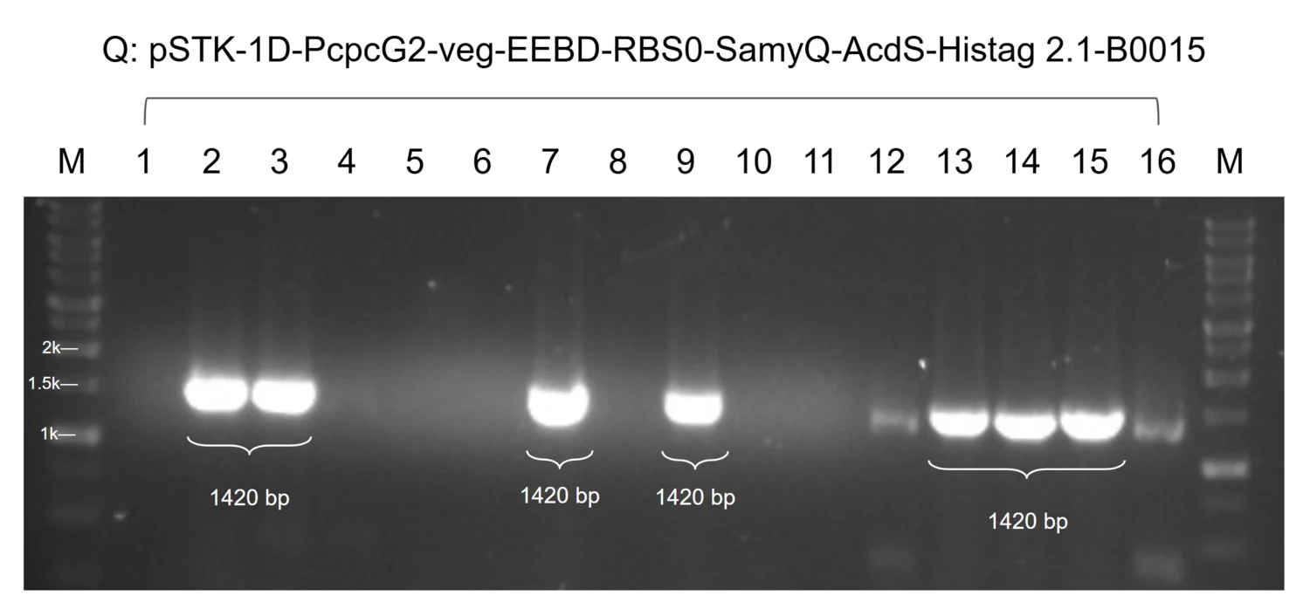
Figure 1. Module 4, P cpcG2-veg –EEBD–RBS0–SamyQ–AcdS–Histag 2.1–B0015. Seven of sixteen colonies gave a band at 1,420 bp. Clone 2 was selected for sequencing.
upload/10_BBa_26DE5E2Q_EXPE_fig1_pp-gel-m4-samyq.png (1500x706, 219 KB)

Application
This part was designed for the GEMS-Taiwan 2026 iGEM team’s work on a Stress-Responsive Optogenetic Bioreactor for Precision Plant Protection:

* **ccaSR-Csn-AcdS-Histag** ([<u>**BBa\_2654HAF3**</u>](https://registry.igem.org/parts/bba-2654haf3)): the system is an engineered construct that produces and secretes plant-protective proteins under green/red light control.
* **ccaSR-SamyQ-AcdS 2.1-Histag** ([<u>**BBa\_26U8UTMH**</u>](https://registry.igem.org/parts/bba-26u8utmh)): the system is an engineered construct that produces and secretes plant-protective proteins under green/red light control.

BBa_26IA55UY — Pveg-EEBD-RBS0-SamyQ-BoPep4 2.2-Histag-B0015
protectant · tier A · published · 712 bp · registry.igem.org/parts/bba-26ia55uy

Design
## Overview

This part encodes BoPep4, a 23-residue plant elicitor peptide (PEP) from broccoli (*Brassica oleracea var. italica).*

The part is a composite transcription unit with four elements, in this order:

· Pveg (BBa\_K143012): a constitutive bacterial promoter originally derived from *Bacillus subtilis* that drives continuous gene transcription without requiring external induction.

· EEBD-RBS0 ([BBa\_26V6CPEV](https://registry.igem.org/parts/bba-26v6cpev)): a composite ribosome binding site element containing a synthetic RBS sequence and expression-enhancing nucleotide context to improve translation initiation efficiency. EEBD is a blocking device, consisting of a B0015 terminator between two recombination sites to prevent unwanted gene expression or the production of toxic proteins while cloning DNA constructs inside *Escherichia coli*.

· SamyQ-BoPep4 2.2-Histag ([BBa\_267B69E3](https://registry.igem.org/parts/bba-267b69e3)): The part is a translational fusion with three elements, in this order:

1. **SamyQ signal peptide (BBa\_K1074014):** N-terminal signal peptide of the amyQ gene, which encodes a highly efficient α-amylase natively found in Bacillus subtilis (and related lineages like Bacillus amyloliquefaciens). Csn and SamyQ were selected as candidates to determine which signal peptide offers higher secretion efficiency.
2. **BoPep4 2.2 (**[<u>**BBa\_26ERHWWI**</u>](https://registry.igem.org/parts/bba-26erhwwi) **):** encodes BoPep4, a 23-residue plant elicitor peptide (PEP) from broccoli (*Brassica oleracea var. italica),* with its native start codon removed, followed by a stop codon. In this variant, the first 15 codons of the coding sequence were optimized to improve the mRNA secondary structure of the translation start site.
3. **6x Histag:** fused N-terminally to the peptide. This allows detection and quantification of the short peptide after successful assembly and electroporation.

· B0015 (BBa\_B0015): a high-efficiency double transcriptional terminator that stops RNA polymerase from continuing transcription past the CDS protectant, preventing transcriptional read-through into downstream modules.

The complete cassette was obtained by de novo gene synthesis.

## About

* **Biosafety level:** S1
* **Target organism:** *Bacillus subtilis* (168 / WB800)
* **Main purpose of use:** Constitutive expression and secretion of BoPep4
* **Potential application:** Enhancing plant salt-stress tolerance as a component of plant-protecting bioprotectants

## Literature

**Rationale.** BoPep4 is a 23-residue mature plant elicitor peptide from broccoli (*Brassica oleracea* var. *italica*), sequence GILIGSKKRPREPHSSGKPGGHN. It works through auxin and abscisic acid signalling crosstalk to raise salt-stress tolerance in broccoli, lowering the Na⁺/K⁺ ratio and promoting leaf wax and cutin accumulation (Wang, A., et al., 2022). This cassette carries the recoded BoPep4 2.1 coding sequence behind the SamyQ signal peptide, which directs the peptide into the Sec-dependent secretion pathway. The 6x Histag is fused N-terminally to the peptide, which allows detection and quantification of the short peptide.

**Why the recoded 5′ end.**&#x54;he mRNA secondary structure around the ribosome binding site and the start codon influences translation initiation in bacteria, independently of the encoded protein sequence. Following Castillo-Hair et al. (2019), our design pipeline treated the first 15 codons of the BoPep4 coding sequence as an editable region. ViennaRNA 2.7.2 (Lorenz et al., 2011) generated and folded tens of thousands of synonymous variants in the RS-inclusive 236-nt 5′ window (residual recombination site, MF001 RBS, spacer, SamyQ ORF and the first 90 nt of the CDS), scoring the mean base-pair unpaired probability across the 15 nt following the ATG and across the MF001 Shine-Dalgarno core (AAGGAGG) and combining the two into a balance score. Wild-type BoPep4 was the weakest starting point of the whole construct series, with start+15 accessibility 0.396 and Shine-Dalgarno core accessibility 0.067. BoPep4 2.2 is the second recoding solution we took forward from that run, alongside BoPep4 2.1. Eight of the first 15 BoPep4 codons were changed (c1 GGC→GGT, c2 ATT→ATA, c3 TTA→CTC, c5 GGA→GGT, c6 TCA→AGT, c9 AGA→CGG, c11 AGA→CGG, c15 TCA→AGT), and the peptide sequence is unchanged from wild type. Predicted start+15 accessibility rose from 0.396 to 0.432 and Shine-Dalgarno core accessibility from 0.067 to 0.658, giving a combined balance score of 1.090. The codon adaptation index against *B. subtilis* 168 usage (Kazusa DNA Research Institute, n.d.) dropped from 0.87 to 0.77. These scores are predictions. Translation initiation from this cassette has not been measured.

**Why 2.2 as well as 2.1.** The two solutions divide the gain differently. BoPep4 2.1 changed nine codons and reached start+15 0.497 with a Shine-Dalgarno core of 0.634, for a balance of 1.131; BoPep4 2.2 changed eight codons and reached start+15 0.432 with a Shine-Dalgarno core of 0.658, for a balance of 1.090. BoPep4 2.2 therefore gains more access at the Shine-Dalgarno core and less at the start codon, and we carry both so that the two can be compared at the bench.

**Why three BoPep4 versions.** Our three BoPep4 cassettes, carrying wild-type BoPep4, BoPep4 2.1 and BoPep4 2.2, all use the SamyQ signal peptide and differ only in the first 15 codons. They are the one place in our part set where the effect of 5′ recoding can be read on its own, with everything else held fixed.

**Why a constitutive version.** We used the constitutive Pveg version in addition to the whole light-sensing construct because it lets us see the maximal secretion and protein production rate without the light switch. This version can be applied to plants and characterized directly by Western blot, which shows whether our constructs work under the most optimal conditions.

**Why Pveg and EEBD-RBS0.** Pveg gives high, continuous expression at a fixed level, so differences between protectants and signal peptides reflect the cargo. RBS0 sets translation initiation, and the EEBD protects *Escherichia coli* during cloning. These are standard SubtiToolKit (STK) parts (Caro-Astorga et al., 2025), so they assemble with the other protectant cassettes in the same format.

## References

1\. Wang, A., Guo, J., Wang, S., Zhang, Y., Lu, F., Duan, J., Liu, Z., & Ji, W. (2022). BoPEP4, a C-terminally encoded plant elicitor peptide from broccoli, plays a role in salinity stress tolerance. International Journal of Molecular Sciences, 23(6), Article 3090. [https://doi.org/10.3390/ijms23063090](https://doi.org/10.3390/ijms23063090)

2\. Caro-Astorga, J., Rogan, M., Malcı, K., Ming, H., Debenedictis, E., James, P., & Ellis, T. (2025). SubtiToolKit: A bioengineering kit for *Bacillus subtilis* and Gram-positive bacteria. Trends in Biotechnology, 43(6), 1446–1469. [https://doi.org/10.1016/j.tibtech.2025.02.004](https://doi.org/10.1016/j.tibtech.2025.02.004)

Experiment
## Construction/assembly (wet lab)

* **Composite insert:** Pveg – EEBD-RBS0 – SamyQ-BoPep4 2.2-Histag – B0015, \[906 bp]
* **Level 1 vector:** pSTK-EXP1 expression shuttle vector (STK), \[ampicillin]
* **Template:** synthesized fragments assembled together
* **Annealing temperature (Level 0 amplification):** 60 °C
* **Assembly method (Level 1):** Golden Gate, \[BsaI-HFv2 enzyme]
* **Thermal cycle:**

| Temperature | Time | Cycles |
| ----------- | ------ | --------- |
| 37 °C | 5 min | 45 cycles |
| 16 °C | 5 min | |
| 37 °C | 10 min | 1 cycle |
| 80 °C | 20 min | 1 cycle |

The full CDS was cloned into pSTK-0C-sfGFP and sequence-verified.

The Level 0 parts Pveg (BBa\_K143012), EEBD-RBS0 ([BBa\_26V6CPEV](https://registry.igem.org/parts/bba-26v6cpev)), SamyQ-BoPep 2.2-Histag ([BBa\_267B69E3](https://registry.igem.org/parts/bba-267b69e3)) and B0015 (BBa\_B0015) were then combined in a single Golden Gate reaction (BsaI, T4 DNA ligase buffer, and T4 DNA ligase) into the pSTK-EXP1 expression shuttle vector, a Level 1 vector, in the order promoter, RBS, CDS, terminator. The reaction was transformed into *E. coli* DH5α, and positive clones were identified by colony PCR and sent for sequencing before electroporation into *B. subtilis*.

| Primer name | Primer sequence (5′ to 3′) |
| -------------- | -------------------------------------------------------------- |
| pSTK-EXP-seq F | atagtcgatcggttcatcattcaccaaatca |
| SamyQ F | ATATATGAAGACATCTGAGGTCTCATATGATTC AAAAACGAAAGCGGAC |
| BoPep R | ATA TAT GAA GAC ATG AGG GGT CTC ATG TCA TGA TGA TGA TGA TGA TG |
| pSTK-EXP-seq R | ctcactcattaggcaccccagg |

## Verification (wet lab)

Colonies from the pSTK-EXP1-sfGFP transformation were screened by colony PCR with backbone primers primers flanking the CDS insertion site, and the products were run on an agarose gel alongside a DNA ladder. A correct band runs at the expected size 678 bp. Colonies producing a single, clean band at this size were considered positive candidates.

Positive candidates were then sequenced to confirm that the promoter, RBS, CDS and terminator are free of mutations and correctly ordered. Clones with a verified sequence were used for further experiments.

## Results

![](https://registry.igem.wiki/documentation/e8fee956-00f9-4129-92e7-4ee7882e2bd5/7ae42b9bff17d0d916103775d7a1c7529452c0fb34b08ae881e2f5d1dfc68cc9.avif)

***Figure 1.*** **Colony PCR of pSTK-EXP1-Pveg-EEBD-RBS0-SamyQ-BoPep4 2.2-Histag-B0015.** 4 of 5 colonies gave a band at the expected size (678 bp).

***Figure 2.*** **Clone 1 was sequence-verified and used downstream.**

Resolved: [678 bp] → 678 bp (matches the wiki caption); [678 bp] → 678 bp (matches the wiki caption)
Open questions: [906 bp] — no wiki caption confirms this band size; [ampicillin] — not corroborated anywhere; [BsaI-HFv2 enzyme] — not corroborated anywhere

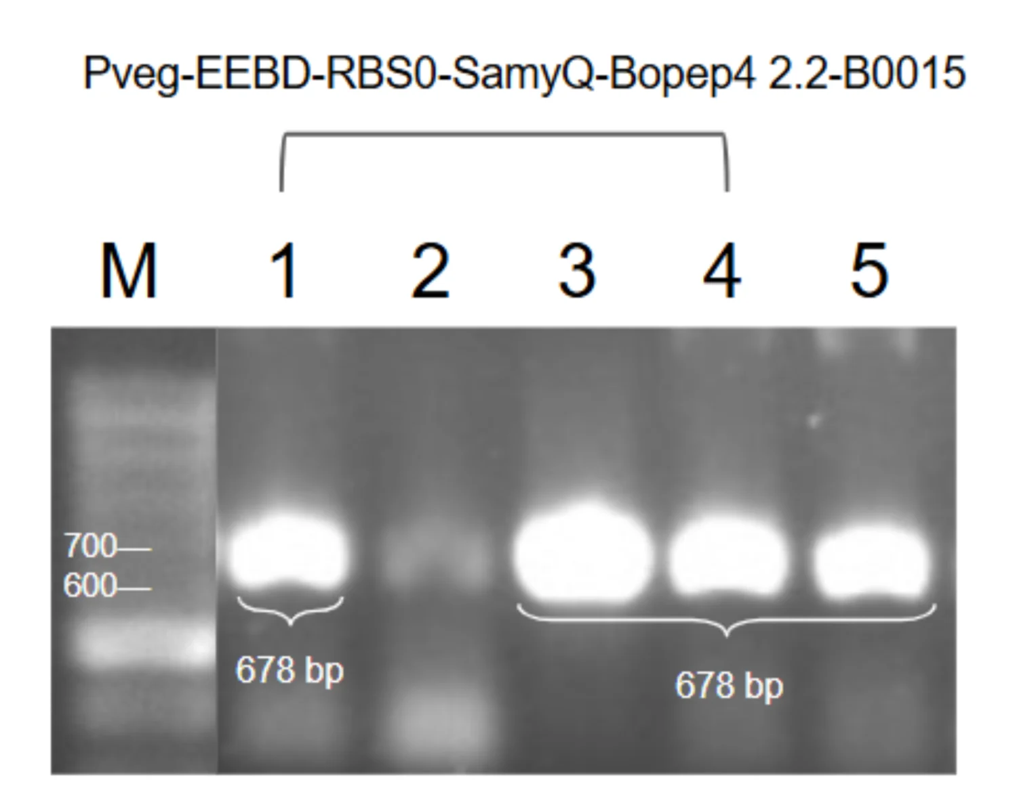
Figure 1. P veg –EEBD–RBS0–SamyQ–BoPep4 2.2–Histag–B0015. Four of five colonies at 678 bp; clone 5 sequenced.
upload/11_BBa_26IA55UY_EXPE_fig1_pp-gel-prod-bopep4-22.png (1500x1195, 333 KB)

BBa_26Q3LKZU — PcpcG2-veg-EEBD-RBS0-Csn-AcdS-Histag-B0015
hybrid · tier A · published · 2617 bp · registry.igem.org/parts/bba-26q3lkzu

Design
## Overview

The Light-Responsive Expression Module drives the expression of downstream genes in response to green-light signaling in Bacillus subtilis.&#x20;

The part is a composite transcription unit with four elements, in this order:

· PcpcG2-veg (BBa\_254UKC9E): the light-responsive output promoter of the CcaSR system, activated by phosphorylated CcaR. It is a *B. subtilis*-adapted chimera of the cyanobacterial PcpcG2 promoter, engineered by Castillo-Hair et al. (2019).

· EEBD-RBS0 (BBa\_26V6CPEV): a composite ribosome binding site element containing a synthetic RBS sequence and expression-enhancing nucleotide context to improve translation initiation efficiency. EEBD is a blocking device, consisting of a B0015 terminator between two recombination sites to prevent unwanted gene expression or the production of toxic proteins while cloning DNA constructs inside *Escherichia coli*.

· Csn-AcdS-Histag ([BBa\_26NXOP7S](https://registry.igem.org/parts/bba-26nxop7s)): a translational fusion of an N-terminal Sec-dependent signal peptide, the ACC deaminase coding sequence with its native start and stop codons removed, and a 6x Histag fused at the C terminus followed by a stop codon, which allows protein detection and purification. The signal peptide and the *acdS* variant differ between the two versions of the module, as set out below.

· B0015 (BBa\_B0015): a high-efficiency double transcriptional terminator that stops RNA polymerase from continuing transcription past the CDS protectant, preventing transcriptional read-through into downstream modules.

The complete module was assembled by Golden gate assembly with BsaI-HFv2.

## About

* **Biosafety level:** S1
* **Target organism:** *Bacillus subtilis* WB800
* **Main purpose of use:** Green light-responsive expression and secretion of ACC deaminase in the host *B. subtilis*.
* **Potential application:** Lowering plant ethylene levels under stress on demand, as the output component of a stress-responsive optogenetic bioreactor for plant-growth-promoting bioprotectants.

## Literature

**How PcpcG2-veg was engineered:** The output promoter was adapted to *B. subtilis* in stages by Castillo-Hair et al. (2019). The starting point was PcpcG2-172, the *E. coli*-optimised truncation of Schmidl et al. (2014), which removes an unwanted transcriptional start site. In *B. subtilis* it was weak. Swapping the original -10 hexamer for the *B. subtilis* consensus sequence, to improve σA RNA polymerase recruitment, gave PcpcG2-hy and about three times more output. Replacing the proximal region, meaning the sequence following the -10 hexamer, with that of the strong constitutive promoters PrpsD and Pveg gave the chimeras PcpcG2-rpsD and PcpcG2-veg; those two swaps are reported as increasing output transcription by 22- and 44-fold, and PcpcG2-veg was selected for its superior activity.

The values below are from Castillo-Hair et al. (2019), measured in *B. subtilis* PY79 by calibrated flow cytometry with an sfGFP reporter. They are not our measurements.

| Output promoter | Induced output (MEFL) | Uninduced output (MEFL) |
| --------------- | --------------------- | ----------------------- |
| PcpcG2-172 | 555 ± 65 | not reported |
| PcpcG2-hy | 1470 ± 110 | not reported |
| PcpcG2-rpsD | 32,400 ± 2800 | 174 ± 23 |
| PcpcG2-veg | 64,000 ± 7600 | 378 ± 38 |

Two limits of that engineering matter for reading the part. The -35 box was left untouched, and only the -10 hexamer and the proximal region downstream of it were changed, because the CcaR operator region had to be kept intact. We chose PcpcG2-veg as the output promoter for the same reason it was selected in the published work, its higher output.

**Why the blocking device is on this module:** EEBD sits on this module and is absent from the light-sensing and transduction modules, because of the cargo. ACC deaminase is a secreted enzyme carried on a Sec signal peptide, and expression during cloning in *E. coli* risks unwanted protein production and loss of the construct. CcaS and CcaR, by contrast, have nothing to act on in *E. coli*, which has neither PCB nor a PcpcG2 promoter. Placing the terminator-between-recombination-sites device in front of the protectant CDS keeps the cassette silent through the *E. coli* cloning steps, and the same EEBD-RBS0 part supplies the RBS for the protectant CDS.

**What AcdS does:** ACC deaminase hydrolyses 1-aminocyclopropane-1-carboxylate, the precursor of the plant stress hormone ethylene, and so lowers the ethylene levels that inhibit plant growth under stress (Glick et al., 1998; Shah et al., 1998). The coding sequence is that of *Pseudomonas putida* strain UW4, taken from UniProt Q5PWZ8. The recombinant enzyme from that strain is 41 kDa and is selective and highly active towards ACC, with K(M) \= 3.4 ± 0.2 mM and k(cat) \= 146 ± 5 min⁻¹ at pH 8.0 and 22 °C. Activity is optimal at pH 8.0, declines sharply to essentially nothing below pH 6.5, tapers off more gradually at higher pH, and is lost above pH 10 (Hontzeas et al., 2004).

**The constitutive counterpart:** The constitutive Pveg versions of this cassette exist so that maximal secretion and production can be measured without the light switch, which gives the light-controlled module something to be compared against. A Western blot of the constitutive Csn-AcdS construct gave a band at about 37 kDa in the culture supernatant, consistent with the predicted size of the secreted enzyme. The 41 kDa quoted above is the purified recombinant enzyme of Hontzeas et al. (2004), which carries neither a cleaved signal peptide nor a His tag, and we have not compared the two forms directly. The equivalent characterisation of the light-responsive versions is not yet complete.

## References

Schmidl, S. R., Sheth, R. U., Wu, A., & Tabor, J. J. (2014). Refactoring and optimization of light-switchable *Escherichia coli* two-component systems. *ACS Synthetic Biology, 3*(11), 820–831. [https://doi.org/10.1021/sb500273n](https://doi.org/10.1021/sb500273n)

2\. Castillo-Hair, S. M., Baerman, E. A., Fujita, M., Igoshin, O. A., & Voigt, C. A. (2019). Optogenetic control of *Bacillus subtilis* gene expression. *Nature Communications, 10*, Article 3099. [https://doi.org/10.1038/s41467-019-10906-6](https://doi.org/10.1038/s41467-019-10906-6)

3\. Hontzeas, N., Zoidakis, J., Glick, B. R., & Abu-Omar, M. M. (2004). Expression and characterization of 1-aminocyclopropane-1-carboxylate deaminase from the rhizobacterium *Pseudomonas putida* UW4: A key enzyme in bacterial plant growth promotion. *Biochimica et Biophysica Acta, 1703*(1), 11–19. [https://doi.org/10.1016/j.bbapap.2004.09.015](https://doi.org/10.1016/j.bbapap.2004.09.015)

4\. Shah, S., Li, J., Moffatt, B. A., & Glick, B. R. (1998). Isolation and characterization of ACC deaminase genes from two different plant growth-promoting rhizobacteria. *Canadian Journal of Microbiology, 44*(9), 833–843. [https://doi.org/10.1139/w98-074](https://doi.org/10.1139/w98-074)

5\. Glick, B. R., Penrose, D. M., & Li, J. (1998). A model for the lowering of plant ethylene concentrations by plant growth-promoting bacteria. *Journal of Theoretical Biology, 190*(1), 63–68. [https://doi.org/10.1006/jtbi.1997.0532](https://doi.org/10.1006/jtbi.1997.0532)

6\. UniProt Consortium. (n.d.). Q5PWZ8. UniProt. Retrieved October 18, 2026, from UniProt entry Q5PWZ8

7\. Caro-Astorga, J., Rogan, M., Malcı, K., Ming, H., Debenedictis, E., James, P., & Ellis, T. (2025). SubtiToolKit: A bioengineering kit for *Bacillus subtilis* and Gram-positive bacteria. *Trends in Biotechnology, 43*(6), 1446–1469. [https://doi.org/10.1016/j.tibtech.2025.02.004](https://doi.org/10.1016/j.tibtech.2025.02.004)

8\. BBa\_K1074014

9\. BBa\_B0015

Resolved: [168 / WB800] → WB800 (strain settled 7 Oct)

Experiment
## Construction/assembly (wet lab)

The protectant coding sequence was PCR-amplified as a single amplicon from the synthesised fragment, using primers Csn F and ACCD R for the Csn-AcdS-Histag version. Each primer carries a 5' ATATAT spacer, a BpiI site (GAAGAC) for Level 0 entry cloning, and a BsaI site (GGTCTC) for Level 1 assembly. The inner BsaI overhangs are TATG (incorporating the start codon) at the 5' end and TGTC at the 3' end, which sets the CDS position and allows fusion to the downstream terminator. The amplicon was cloned into pGEM-T Easy and sequence-verified.

The Level 0 parts PcpcG2-veg (BBa\_254UKC9E), EEBD-RBS0 (BBa\_26V6CPEV), the protectant CDS fusion ([BBa\_26NXOP7S](https://registry.igem.org/parts/bba-26nxop7s)) and B0015 (BBa\_B0015) were then combined in a single Golden Gate reaction (BsaI, T4 DNA ligase buffer, and T4 DNA ligase) into the pSTK-1D-sfGFP Level 1 cloning vector (Caro-Astorga et al., 2025), in the order promoter, RBS, CDS, terminator. The reaction was transformed into *E. coli* DH5α, and positive clones were identified by colony PCR and sent for sequencing before electroporation into *B. subtilis*.

**CONSTRUCT DETAILS**

* Composite insert: PcpcG2-veg – EEBD-RBS0 – Csn-AcdS-Histag – B0015, \[1788 bp]
* Level 1 vector: pSTK-1D-sfGFP (Level 1 cloning vector), \[ampicillin]
* Template: synthesised fragments assembled together
* Annealing temperature (Level 0 amplification): 60 °C
* Assembly method: Golden Gate, BsaI-HFv2 enzyme
* Thermal cycle:

| Temperature | Time | Cycles |
| ----------- | ------ | --------- |
| 37 °C | 5 min | 45 cycles |
| 16 °C | 5 min | |
| 37 °C | 10 min | 1 cycle |
| 80 °C | 20 min | 1 cycle |

## Verification (wet lab)

Colonies from the pSTK-1D-sfGFP transformation were screened by colony PCR with backbone primers, which flank the insertion site. The products were run on an agarose gel alongside a DNA ladder. A correct band runs at the expected size, which is the length of the insert plus the vector sequence between the priming sites, for a total of 1588 bp. Colonies producing a single, clean band at this size were considered positive candidates.

Positive candidates were then sequenced to confirm that the promoter, blocking device, RBS, protectant CDS and terminator are free of mutations and correctly ordered. Clones with a verified sequence were used for the Level 2 optogenetic system constructed in the pSTK-EXP2 vector.

| Primer name | Primer sequence (5' to 3') |
| ----------- | ------------------------------------------------------ |
| Csn F | ATATATGAAG ACATCTGAGG TCTCATATGA AAATCAGTAT GCAAAAAGCA |
| ACCD R | ATATATGAAG ACATGAGGGG TCTCATGTCT TAATGATGAT GATGATGAT |
| pSTK-seq F | agtgccacctgacgtctaagaaacc |
| pSTK-seq R | tctttcctgcgttatcccctgattc |

## Results

![](https://registry.igem.wiki/documentation/f53874a3-c117-479a-94b4-16cd4d3744ca/007541e6fe2482f0a198c05fc9ab94e27b40cc3d2d2a5aec295852f946cf741c.avif)

**Figure 1. Colony PCR of pSTK-1D-PcpcG2-veg-EEBD-RBS0-Csn-AcdS-Histag-B0015.** 2 of 6 colonies gave a band at the expected size (1588 bp).

Figure 2. Clone \[X] of each version was sequence-verified and used for downstream experiments.

Resolved: [BsaI-HFv2 enzyme] → BsaI-HFv2 enzyme (stated unbracketed elsewhere on this part); [1588 bp] → 1588 bp (matches the wiki caption); [1588 bp] → 1588 bp (matches the wiki caption)
Open questions: [1788 bp] — no wiki caption confirms this band size; [ampicillin] — not corroborated anywhere; [X] — clone number not stated in the wiki caption

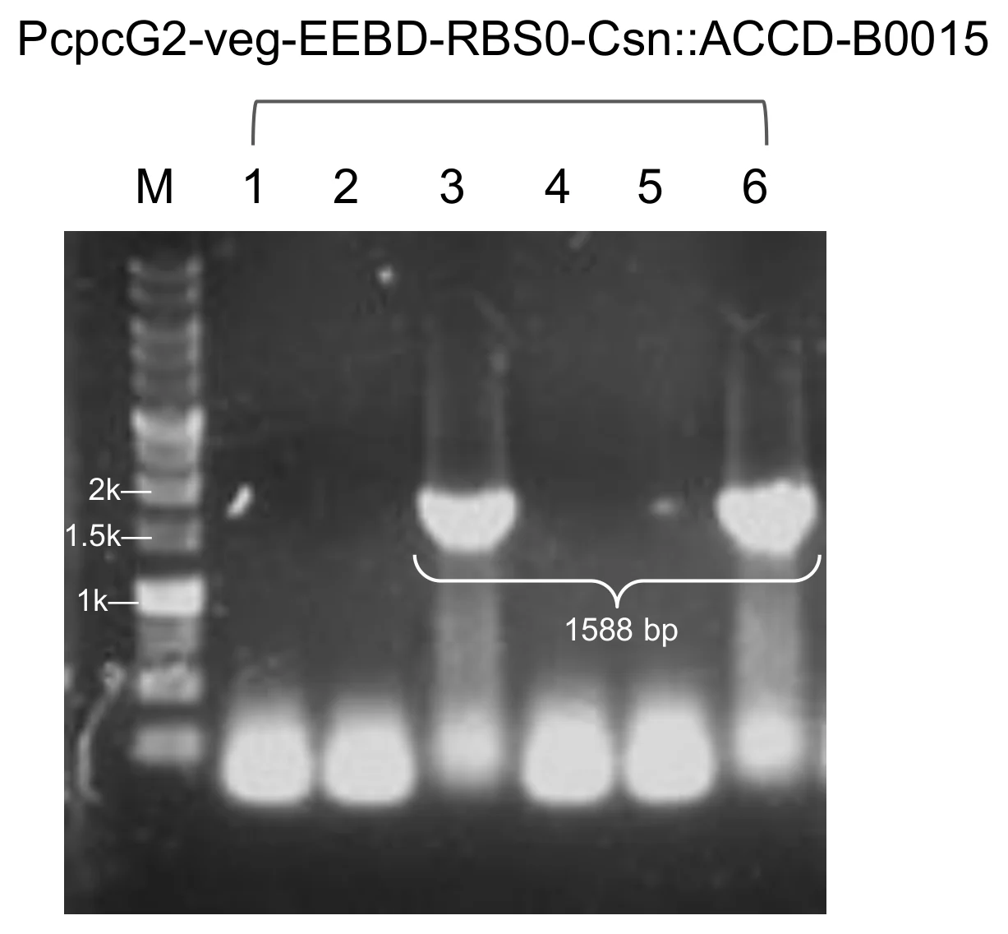
Figure 1. Module 4, P cpcG2-veg –EEBD–RBS0–Csn–AcdS–Histag–B0015. Two of six colonies gave a band at 1,588 bp. Clone 3 was selected for sequencing.
upload/12_BBa_26Q3LKZU_EXPE_fig1_pp-gel-m4-csn.png (1227x1136, 187 KB)

Application
This part was designed for the GEMS-Taiwan 2026 iGEM team’s work on a Stress-Responsive Optogenetic Bioreactor for Precision Plant Protection:

* **ccaSR-Csn-AcdS-Histag** ([<u>**BBa\_2654HAF3**</u>](https://registry.igem.org/parts/bba-2654haf3)): the system is an engineered construct that produces and secretes plant-protective proteins under green/red light control.
* **ccaSR-SamyQ-AcdS 2.1-Histag** ([<u>**BBa\_26U8UTMH**</u>](https://registry.igem.org/parts/bba-26u8utmh)): the system is an engineered construct that produces and secretes plant-protective proteins under green/red light control.

BBa_26SG0NQQ — Pveg-EEBD-RBS0-Csn-LEA14-Histag-B0015
protectant · tier A · published · 1111 bp · registry.igem.org/parts/bba-26sg0nqq

Design
## Overview

This part encodes a Late Embryogenesis Abundant 14 protein (LEA14) (LEA: [BBa\_26LTB0W1](https://registry.igem.org/parts/bba-26ltb0w1)) from *Arabidopsis thaliana* gene *At1g01470.1*, which belongs to LEA\_2 subgroup.

The part is a composite transcription unit with four elements, in this order:

· Pveg (BBa\_K143012): a constitutive bacterial promoter originally derived from *Bacillus subtilis* that drives continuous gene transcription without requiring external induction.

· EEBD-RBS0 ([BBa\_26V6CPEV](https://registry.igem.org/parts/bba-26v6cpev)): a composite ribosome binding site element containing a synthetic RBS sequence and expression-enhancing nucleotide context to improve translation initiation efficiency. EEBD is a blocking device, consisting of a B0015 terminator between two recombination sites to prevent unwanted gene expression or the production of toxic proteins while cloning DNA constructs inside *Escherichia coli*.

· Csn-LEA14-Histag ([BBa\_26ZQ1T72](https://registry.igem.org/parts/bba-26zq1t72)): a translational fusion of three elements:

1. **Csn signal peptide:** the N-terminal Sec-dependent signal peptide of *B. subtilis* chitosanase (gene *csn*), which directs the protein to the secretion pathway and is cleaved off during export. Csn and SamyQ were selected as candidates to determine which signal peptide offers higher secretion efficiency.
2. **LEA14 (**[<u>BBa\_26LTB0W1</u>](https://registry.igem.org/parts/bba-26ltb0w1)**):** This part encodes a Late Embryogenesis Abundant 14 protein (LEA14) from [<u>*Arabidopsis thaliana*</u>](https://www.uniprot.org/uniprotkb/O03983/entry) with its native start codon and stop codon removed.
3. **6x Histag:** This allows protein purification and identification after successful assembly and electroporation. Fused at the C-terminus followed by a stop codon.

· B0015 (BBa\_B0015): a high-efficiency double transcriptional terminator that stops RNA polymerase from continuing transcription past the CDS protectant, preventing transcriptional read-through into downstream modules.

The complete module was assembled by Golden gate assembly with BsaI-HFv2.

## About

* **Biosafety level:** S1
* **Target organism:** *Bacillus subtilis* (168 / WB800)
* **Main purpose of use:** Constitutive expression and secretion of LEA14
* **Potential application:** Protecting cellular structures and maintaining cellular stability under environmental stress conditions.

## Literature

**Rationale.** LEA proteins are small, partially folded, hydrophilic proteins that stabilise membranes and isolate ions to prevent water loss, and they keep other proteins from aggregating when water is withdrawn (Goyal et al., 2005; Hundertmark et al., 2008; Mertens et al., 2018). LEA14 from *Arabidopsis thaliana* is an intrinsically disordered protein of this family (Singh et al., 2005), and its overexpression raises salt-stress tolerance in *A. thaliana* (Jia et al., 2014). We selected it as a protectant cargo on the expectation that a secreted copy can help stabilise plant cell membranes under drought, salinity, heat and osmotic stress. This cassette carries the wild-type LEA14 coding sequence behind the Csn signal peptide, which exports the protein from the cell, and a C-terminal 6x Histag for detection and purification.

**Why a constitutive version.** We used the constitutive Pveg version in addition to the whole light-sensing construct because it lets us see the maximal secretion and protein production rate without the light switch. This version can be applied to plants and characterized directly by Western blot, which shows whether our constructs work under the most optimal conditions.

**Why Pveg and EEBD-RBS0.** Pveg gives high, continuous expression at a fixed level, so differences between protectants and signal peptides reflect the cargo. RBS0 sets translation initiation, and the EEBD protects *Escherichia coli* during cloning. These are standard SubtiToolKit (STK) parts (Caro-Astorga et al., 2025), so they assemble with the other protectant cassettes in the same format.

## References

1\. Goyal, K., Walton, L. J., & Tunnacliffe, A. (2005). LEA proteins prevent protein aggregation due to water stress. Biochemical Journal, 388(1), 151–157. [https://doi.org/10.1042/bj20041931](https://doi.org/10.1042/bj20041931)

2\. Hundertmark, M., Hincha, D. K., & Thalhammer, A. (2008). LEA (late embryogenesis abundant) proteins and their encoding genes in *Arabidopsis thaliana*. BMC Genomics, 9, Article 118. [https://doi.org/10.1186/1471-2164-9-118](https://doi.org/10.1186/1471-2164-9-118)

3\. Jia, F., Qi, S., Li, H., Liu, P., Li, P., Wu, C., Zheng, C., & Huang, J. (2014). Overexpression of late embryogenesis abundant 14 enhances *Arabidopsis* salt stress tolerance. Biochemical and Biophysical Research Communications, 454(4), 505–511. [https://doi.org/10.1016/j.bbrc.2014.10.136](https://doi.org/10.1016/j.bbrc.2014.10.136)

4\. Mertens, J., Aliyu, H., & Cowan, D. A. (2018). LEA proteins and the evolution of the WHy domain. Applied and Environmental Microbiology, 84(15), Article e00539-18. [https://doi.org/10.1128/AEM.00539-18](https://doi.org/10.1128/AEM.00539-18)

5\. Singh, S., Cornilescu, C. C., Tyler, R. C., Cornilescu, G., Tonelli, M., Lee, M. S., & Markley, J. L. (2005). Solution structure of a late embryogenesis abundant protein (LEA14) from *Arabidopsis thaliana*, a cellular stress-related protein. Protein Science, 14(10), 2601–2609. [https://doi.org/10.1110/ps.051579205](https://doi.org/10.1110/ps.051579205)

6\. Wang, J. W., Squire, H. J., Goh, N. S., Ni, H. M., Lien, E., Wong, C., González-Grandío, E., & Landry, M. P. (2023). Delivered complementation in planta (DCIP) enables measurement of peptide-mediated protein delivery efficiency in plants. Communications Biology, 6(1), Article 829. [https://doi.org/10.1038/s42003-023-05191-5](https://doi.org/10.1038/s42003-023-05191-5)

7\. Caro-Astorga, J., Rogan, M., Malcı, K., Ming, H., Debenedictis, E., James, P., & Ellis, T. (2025). SubtiToolKit: A bioengineering kit for *Bacillus subtilis* and Gram-positive bacteria. Trends in Biotechnology, 43(6), 1446–1469. [https://doi.org/10.1016/j.tibtech.2025.02.004](https://doi.org/10.1016/j.tibtech.2025.02.004)

Experiment
## Construction/assembly (wet lab)

* Composite insert: Pveg – EEBD-RBS0 – Csn-LEA14-Histag – B0015, \[1302 bp]
* Level 1 vector: pSTK-EXP1 expression shuttle vector (STK), \[ampicillin]
* Template: synthesized fragments assembled together
* Annealing temperature (Level 0 amplification): 60 °C
* Assembly method (Level 1): Golden Gate, BsaI-HFv2 enzyme
* Thermal cycle:

| Temperature | Time | Cycles |
| ----------- | ------ | --------- |
| 37 °C | 5 min | 45 cycles |
| 16 °C | 5 min | |
| 37 °C | 10 min | 1 cycle |
| 80 °C | 20 min | 1 cycle |

The full CDS was PCR-amplified as a single amplicon from the synthesized fragment using primers Csn F and ACCD R. Each primer carries a 5′ ATATAT spacer, a BpiI site (GAAGAC) for level 0 vector entry cloning, and a BsaI site (GGTCTC) for Level 1 assembly. The inner BsaI overhangs are TATG (incorporating the Csn start codon) at the 5′ end and TGTC at the 3′ end, which sets the CDS position and allows fusion to the downstream terminator. The amplicon was cloned into pGEM-T Easy and sequence-verified.

The Level 0 parts Pveg (BBa\_K143012), EEBD-RBS0 ([BBa\_26V6CPEV](https://registry.igem.org/parts/bba-26v6cpev)), Csn-LEA14-Histag ([BBa\_26ZQ1T72](https://registry.igem.org/parts/bba-26zq1t72)) and B0015 (BBa\_B0015) were then combined in a single Golden Gate reaction (BsaI, T4 DNA ligase buffer, and T4 DNA ligase) into the pSTK-EXP1 expression shuttle vector, a Level 1 vector, in the order promoter, RBS, CDS, terminator. The reaction was transformed into *E. coli* DH5α, and positive clones were identified by colony PCR and sent for sequencing before electroporation into *B. subtilis*.

| Primer name | Primer sequence (5′ to 3′) |
| -------------- | ------------------------------------------------------------------ |
| pSTK-EXP-seq F | atagtcgatcggttcatcattcaccaaatca |
| Csn F | ATA TAT GAA GAC ATC TGA GGT CTC ATA TGA AAA TCA GTA TGC AAA AAG CA |
| LEA R | ATA TAT GAA GAC ATG AGG GGT CTC ATG TCT TAA TGA TGA TGA TGA TGA T |
| pSTK-EXP-seq R | ctcactcattaggcaccccagg |

## Verification (wet lab)

Colonies from the pSTK-EXP1-sfGFP transformation were screened by colony PCR with Csn F and pSTK-EXP-seq R primers, and the products were run on an agarose gel alongside a DNA ladder. A correct band runs at the expected size 735 bp. Colonies producing a single, clean band at this size were considered positive candidates.

Positive candidates were then sequenced to confirm that the promoter, RBS, CDS and terminator are free of mutations and correctly ordered. Clones with a verified sequence were used for further experiments.

## Results

![](https://registry.igem.wiki/documentation/230c92c1-9633-4bc5-bcce-b77e115c013e/a2f980ff8969210f1161786da8f1adad96e9d7efeb22feeaa7d96a1e1d81fe23.avif)

**Figure 1. Colony PCR of pSTK-EXP1-Pveg-EEBD-RBS0-Csn-LEA14-Histag-B0015.** 1 of 1 colony gave a band at the expected size (735 bp).

**Figure 2. Clone \[X] was sequence-verified and used downstream.**

Resolved: [BsaI-HFv2 enzyme] → BsaI-HFv2 enzyme (stated unbracketed elsewhere on this part); [735 bp] → 735 bp (matches the wiki caption); [735 bp] → 735 bp (matches the wiki caption)
Open questions: [1302 bp] — no wiki caption confirms this band size; [ampicillin] — not corroborated anywhere; [X] — clone number not stated in the wiki caption

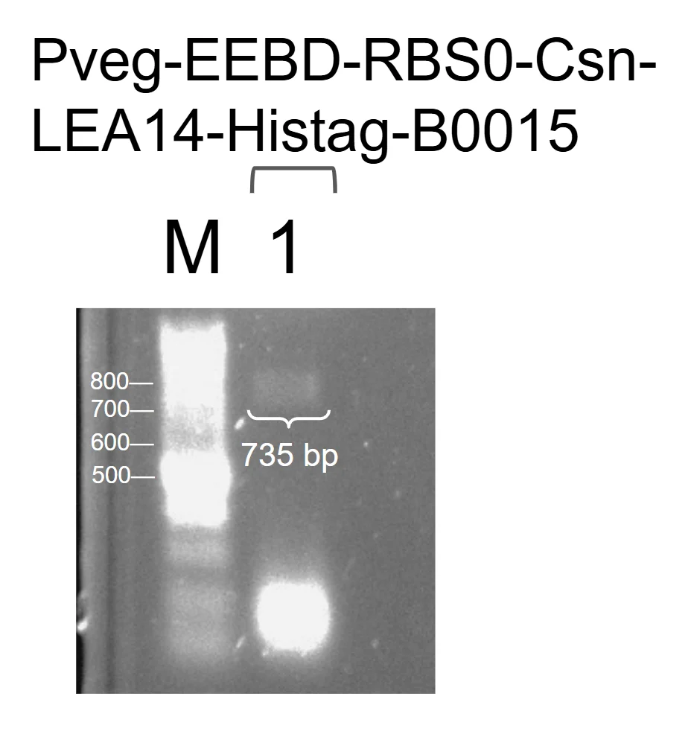
Figure 1. P veg –EEBD–RBS0–Csn–LEA14–Histag–B0015. One colony at 735 bp, sequenced.
upload/13_BBa_26SG0NQQ_EXPE_fig1_pp-gel-prod-csn-lea14.png (928x994, 199 KB)

Application
A full ccaSR construct with LEA14 as Module 4 was not built. The constitutive LEA14 version lets us assess its behavior in the system, and it also helped plants under salinity stress, without duplicating the work, because ccaSR-Csn-AcdS-Histag ([BBa\_2654HAF3](https://registry.igem.org/parts/bba-2654haf3)) and ccaSR-SamyQ-AcdS 2.1-Histag ([BBa\_26U8UTMH](https://registry.igem.org/parts/bba-26u8utmh)) already serves as proof of concept for the circuit.

BBa_26XVQ3FS — Pveg-EEBD-RBS0-SamyQ-AcdS 2.1-Histag-B0015
protectant · tier A · published · 1654 bp · registry.igem.org/parts/bba-26xvq3fs

Design
## Overview

This part encodes 1-aminocyclopropane-1-carboxylate (ACC) deaminase (AcdS: [BBa\_26MA70QI](https://registry.igem.org/parts/bba-26ma70qi)) from *Pseudomonas putida* (Arthrobacter siderocapsulatus) strain UW4.

The part is a composite transcription unit with three elements, in this order:

* **Pveg (**&#x42;ba\_K14301&#x32;**):** a constitutive bacterial promoter originally derived from *Bacillus subtilis* that drives continuous gene transcription without requiring external induction.
* **EEBD-RBS0 (**[BBa\_26V6CPEV](https://registry.igem.org/parts/bba-26v6cpev)**):** A composite ribosome binding site element containing a synthetic RBS sequence and expression-enhancing nucleotide context to improve translation initiation efficiency. EEBD is a blocking device, consisting of a B0015 terminator between two recombination sites to prevent unwanted gene expression or the production of toxic proteins while cloning DNA constructs inside *Escherichia coli*
* **SamyQ-AcdS 2.1-Histag (**[BBa\_26NXOP7S](https://registry.igem.org/parts/bba-26nxop7s)**):** a translational fusion of three elements:
1. **SamyQ signal peptide (**[<u>BBa\_K1074014</u>](https://registry.igem.org/parts/bba-k1074014)**):** N-terminal signal peptide of the *amyQ* gene, which encodes a highly efficient α-amylase natively found in *Bacillus subtilis* (and related lineages like *Bacillus amyloliquefaciens*). Csn and SamyQ were selected as candidates to determine which signal peptide offers higher secretion efficiency.
2. **AcdS 2.1 (**[<u>**BBa\_262YYNPV**</u>](https://registry.igem.org/parts/bba-262yynpv)**):** the ACC deaminase coding sequence from [*Pseudomonas putida(Arthrobacter siderocapsulatus)*](https://www.uniprot.org/taxonomy/303) , with its native start codon and stop codon removed In this variant, the first 15 codons of the coding sequence from AcdS wild-type ([<u>**BBa\_26MA70QI**</u>](https://registry.igem.org/parts/bba-26ma70qi)) were optimized to improve the mRNA secondary structure of the translation start site.
3. **6x Histag:** Fused at the C-terminus followed by a stop codon.This allows protein purification and identification after successful assembly and electroporation.
* **B0015** (BBa\_B0015): A high-efficiency double transcriptional terminator that stops RNA polymerase from continuing transcription past the CDS protectant, preventing transcriptional read-through into downstream modules.

The complete module was assembled by Golden gate assembly with BsaI-HFv2.

## About

* **Biosafety level:** S1
* **Target organism:** *Bacillus subtilis* (168 / WB800)
* **Main purpose of use:** Constitutive expression and secretion of ACC deaminase
* **Potential application:** Lowering plant ethylene levels under stress, as a component of plant-growth-promoting bioprotectants.

## Literature

**Rationale.** ACC deaminase degrades ACC, the precursor of ethylene, and so can lower the ethylene levels that inhibit plant growth under stress (Hontzeas et al., 2004; Shah et al., 1998). The Csn signal peptide exports the enzyme from the cell, and the C-terminal 6x Histag allows detection and purification. The AcdS sequence comes from Q5PWZ8 (UniProt Consortium, n.d.; GenBank CP053102.1).

**Why a constitutive version.** We used the constitutive Pveg version in addition to the whole light-sensing construct because it lets us see the maximal secretion and protein production rate without the light switch. This version can be applied to plants and characterized directly by Western blot, which shows whether our constructs work under the most optimal conditions.

**Why Pveg and EEBD-RBS0.** Pveg gives high, continuous expression, so differences between protectants and signal peptides reflect the cargo rather than promoter strength. RBS0 sets translation initiation, and the EEBD protects *E. coli* during cloning. These are standard SubtiToolKit (STK) parts, so they assemble with the other protectant cassettes in the same format.

## References

1\. UniProt Consortium. (n.d.). Q5PWZ8. UniProt. Retrieved October 18, 2026, from UniProt entry Q5PWZ8

2\. Hontzeas, N., Zoidakis, J., Glick, B. R., & Abu-Omar, M. M. (2004). Expression and characterization of 1-aminocyclopropane-1-carboxylate deaminase from the rhizobacterium *Pseudomonas putida* UW4: A key enzyme in bacterial plant growth promotion. Biochimica et Biophysica Acta, 1703(1), 11–19. PubMed. [https://doi.org/10.1016/j.bbapap.2004.09.015](https://doi.org/10.1016/j.bbapap.2004.09.015)

3\. Shah, S., Li, J., Moffatt, B. A., & Glick, B. R. (1998). Isolation and characterization of ACC deaminase genes from two different plant growth-promoting rhizobacteria. Canadian Journal of Microbiology, 44(9), 833–843. [https://doi.org/10.1139/w98-074](https://doi.org/10.1139/w98-074)

4\. Glick, B. R., Penrose, D. M., & Li, J. (1998). A model for the lowering of plant ethylene concentrations by plant growth-promoting bacteria. Journal of Theoretical Biology, 190(1), 63–68. [https://doi.org/10.1006/jtbi.1997.0532](https://doi.org/10.1006/jtbi.1997.0532)

5\. Castillo-Hair, S. M., Baerman, E. A., Fujita, M., Igoshin, O. A., & Voigt, C. A. (2019). Optogenetic control of *Bacillus subtilis* gene expression. Nature Communications, 10, Article 3099. [https://doi.org/10.1038/s41467-019-10906-6](https://doi.org/10.1038/s41467-019-10906-6)

6\. Lorenz, R., Bernhart, S. H., Höner zu Siederdissen, C., Tafer, H., Flamm, C., Stadler, P. F., & Hofacker, I. L. (2011). ViennaRNA Package 2.0. Algorithms for Molecular Biology, 6, Article 26. [https://doi.org/10.1186/1748-7188-6-26](https://doi.org/10.1186/1748-7188-6-26)

7\. Kazusa DNA Research Institute. (n.d.). Codon usage database: *Bacillus subtilis* subsp. *subtilis* str. 168 (taxid:1423). [https://www.kazusa.or.jp/codon/](https://www.kazusa.or.jp/codon/)

8\. Caro-Astorga, J., Rogan, M., Malcı, K., Ming, H., Debenedictis, E., James, P., & Ellis, T. (2025). SubtiToolKit: A bioengineering kit for *Bacillus subtilis* and Gram-positive bacteria. Trends in Biotechnology, 43(6), 1446–1469. [https://doi.org/10.1016/j.tibtech.2025.02.004](https://doi.org/10.1016/j.tibtech.2025.02.004)

Experiment
## Construction/assembly (wet lab)

* **Composite insert:** Pveg – EEBD-RBS0 – SamyQ-AcdS 2.1-Histag – B0015, \[1848 bp]
* **Level 1 vector:** pSTK-EXP1 expression shuttle vector (STK), \[ampicillin]
* **Template:** synthesized fragments assembled together
* **Annealing temperature (Level 0 amplification):** 60 °C
* **Assembly method (Level 1):** Golden Gate, BsaI-HFv2 enzyme
* **Thermal cycle:**

| Temperature | Time | Cycles |
| ----------- | ------ | --------- |
| 37 °C | 5 min | 45 cycles |
| 16 °C | 5 min | |
| 37 °C | 10 min | 1 cycle |
| 80 °C | 20 min | 1 cycle |

The full CDS was PCR-amplified as a single amplicon from the synthesized fragment using primers SamyQ F and ACCD R. Each primer carries a 5′ ATATAT spacer, a BpiI site (GAAGAC) for level 0 vector entry cloning, and a BsaI site (GGTCTC) for Level 1 assembly. The inner BsaI overhangs are TATG (incorporating the SamyQ start codon) at the 5′ end and TGTC at the 3′ end, which sets the CDS position and allows fusion to the downstream terminator. The amplicon was cloned into pSTK-0C-sfGFP and sequence-verified.

The Level 0 parts Pveg (BBa\_K143012), EEBD-RBS0 ([BBa\_26V6CPEV](https://registry.igem.org/parts/bba-26v6cpev)), SamyQ-AcdS 2.1-Histag ([BBa\_26TOGLX3](https://registry.igem.org/parts/bba-26toglx3)) and B0015 (BBa\_B0015) were then combined in a single Golden Gate reaction (BsaI, T4 DNA ligase buffer, and T4 DNA ligase) into the pSTK-EXP1 expression shuttle vector, a Level 1 vector, in the order promoter, RBS, CDS, terminator. The reaction was transformed into *E. coli* DH5α, and positive clones were identified by colony PCR and sent for sequencing before electroporation into *B. subtilis*.

| Primer name | Primer sequence (5′ to 3′) |
| -------------- | -------------------------------------------------- |
| pSTK-EXP-seq F | atagtcgatcggttcatcattcaccaaatca |
| SamyQ F | ATATATGAAGACATCTGAGGTCTCATATGATTC AAAAACGAAAGCGGAC |
| ACCD R | ATATATGAAGACATGAGGGGTCTCATGTCTTAATGATGATGATGATGAT |
| pSTK-EXP-seq R | ctcactcattaggcaccccagg |

## Verification (wet lab)

Colonies from the pSTK-EXP1-sfGFP transformation were screened by colony PCR with backbone primers primers flanking the CDS insertion site, and the products were run on an agarose gel alongside a DNA ladder. A correct band runs at the expected size 1984 bp. Colonies producing a single, clean band at this size were considered positive candidates.

Positive candidates were then sequenced to confirm that the promoter, RBS, CDS and terminator are free of mutations and correctly ordered. Clones with a verified sequence were used for further experiments.

## Results

***Figure 1.*** **Colony PCR of pSTK-EXP1-Pveg-EEBD-RBS0-SamyQ-AcdS 2.1-Histag-B0015.** 1 of 1 colonies gave a band at the expected size (1984 bp).

***Figure 2.*** **Clone 1 was sequence-verified and used downstream.**

Resolved: [BsaI-HFv2 enzyme] → BsaI-HFv2 enzyme (stated unbracketed elsewhere on this part); [1984 bp] → 1984 bp (matches the wiki caption); [1984 bp] → 1984 bp (matches the wiki caption)
Open questions: [1848 bp] — no wiki caption confirms this band size; [ampicillin] — not corroborated anywhere

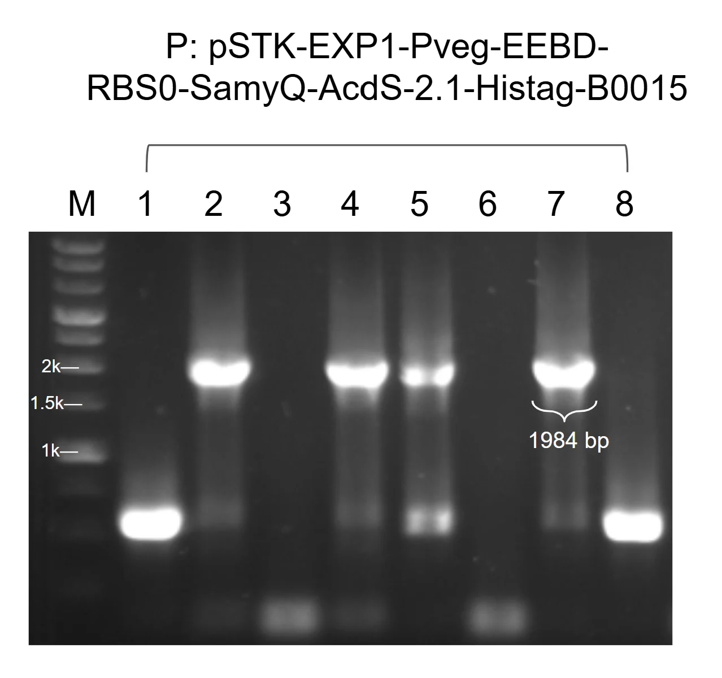
Figure 1. P veg –EEBD–RBS0–SamyQ–AcdS–Histag 2.1–B0015. Four of eight colonies at 1,984 bp; clone 2 sequenced.
upload/17_BBa_26XVQ3FS_EXPE_fig1_pp-gel-prod-samyq-accd.png (1278x1200, 226 KB)

Characterisation
**Fig. X. Western blot analysis of constitutive ACC deaminase-2.1-Histag expression in *Bacillus subtilis*.** Detection was performed using a mouse monoclonal anti-Histag antibody. Immunodetection verified successful expression and secretion of ACC deaminase from the constitutive P<sub>veg</sub> promoter construct. Lane ACCD represents the culture supernatant in which a clear band was detected at approximately 37 kDa, consistent with the predicted size of the secreted ACCD.

Application
This construct is the constitutive counterpart of the Light Responsive Expression Module in ccaSR-Csn-AcdS-Histag. It gives the maximal output of the same cassette, which the light-controlled version can be compared against. It was run in our bioreactor to monitor production and secretion, and its protein can be applied to plants for functional testing.

BBa_26XZYM10 — PtagC+RBS-Ho1:pcyA-L3S2P21
light-sensing · tier A · published · 1655 bp · registry.igem.org/parts/bba-26xzym10

Design
## Overview

The PCB Production Module supplies the chromophore required for light sensing.

The part is a composite transcription unit with three elements, in this order:

* **PtagC+RBS (**[<u>**BBa\_26A4MT29**</u>](https://registry.igem.org/parts/bba-26a4mt29)**):** a promoter and ribosome binding site that controls both transcription and translation of the downstream coding sequence.
* **Ho1-pcyA (**[<u>**BBa\_K4354012**</u>](https://registry.igem.org/parts/bba-k4354012) **):** a fusion CDS of heme oxygenase-1 (Ho1) and phycocyanobilin:ferredoxin oxidoreductase (PcyA). Ho1 converts endogenous heme to biliverdin IXα, and PcyA reduces biliverdin IXα to PCB.
* **L3S2P21 (**[<u>**BBa\_K2675031**</u>](https://share.google/pocPiJukHq9mm39e5)**):** a strong synthetic intrinsic (Rho-independent) terminator from the synthetic terminator library of Chen et al. (2013), which ends transcription and limits read-through into neighboring units.

The complete module was assembled by Golden gate assembly with BsaI-HFv2.

**Design considerations:**

*Why PCB must be supplied:* CcaS is a cyanobacteriochrome that senses green and red light only when it binds PCB. *B. subtilis* does not naturally make PCB, so without this module the CcaSR system cannot respond to light. Fusing Ho1 and pcyA into a single CDS allows both biosynthetic steps from one gene, which keeps the module compact and the two enzymes stoichiometrically matched. PtagC+RBS presented a shorter length in base pairs, therefore allowing easier cloning into a level 2 transcriptional unit. Because there was an ambiguity on homologous recombination, it was used as an alternative to Pveg and RBS0, as the plasmid was already amplified in our collection.

*Expression context:* Heme is an endogenous substrate in *B. subtilis*, so the module needs no added precursor. Ferredoxin is required as the electron donor for PcyA.

*Design:* The full CDS was PCR-amplified as a single amplicon from the synthesized fragment using primers Csn F and ACCD R. Each primer carries a 5′ ATATAT spacer, a BpiI site (GAAGAC) for Level 0 entry cloning, and a BsaI site (GGTCTC) for Level 1 assembly. The inner BsaI overhangs are TATG (incorporating the Csn start codon) at the 5′ end and TGTC at the 3′ end, which sets the CDS position and allows fusion to the downstream terminator. The amplicon was cloned into pGEM-T Easy and sequence-verified.

The Level 0 parts Pveg (BBa\_K143012), EEBD-RBS0 (BBa\_26V6CPEV), Csn-AcdS-Histag (BBa\_26NXOP7S) and B0015 (BBa\_B0015) were then combined in a single Golden Gate reaction (BsaI, T4 DNA ligase buffer, and T4 DNA ligase) into the pSTK-EXP1 expression shuttle vector (Caro-Astorga et al., 2025), a Level 1 vector, in the order promoter, RBS, CDS, terminator. The reaction was transformed into *E. coli* DH5α, and positive clones were identified by colony PCR and sent for sequencing before electroporation into *B. subtilis*.

## About

* **Biosafety level:** S1
* **Target organism:** *Bacillus subtilis* WB800
* **Main purpose of use:** Intracellular biosynthesis of phycocyanobilin (PCB), the chromophore required for CcaS photoreceptor activity, in the host *B. subtilis*.
* **Potential application:** Enabling green/red light-responsive gene expression through the CcaSR system, as the light-sensing component of a stress-responsive optogenetic bioreactor for plant-growth-promoting bioprotectants.

### **References**

1. CcaSR green red light-responsive system for transcriptional control in B. subtilis (Haller et al., 2025; 10.1007/978-1-0716-40)\*\*
2. Chen, Y.-J., Liu, P., Nielsen, A. A. K., et al. (2013). Characterization of 582 natural and synthetic terminators and quantification of their design constraints. *Nature Methods*, 10(7), 659–664.
3. [<u>**BBa\_K4354012**</u>](https://registry.igem.org/parts/bba-k4354012)
4. [<u>**BBa\_K2675031**</u>](https://share.google/pocPiJukHq9mm39e5)
5. Caro-Astorga, J., Rogan, M., Malcı, K., Ming, H., Debenedictis, E., James, P., & Ellis, T. (2025). SubtiToolKit: A bioengineering kit for *Bacillus subtilis* and Gram-positive bacteria. *Trends in Biotechnology, 43*(6), 1446–1469.[ <u>https://doi.org/10.1016/j.tibtech.2025.02.004</u>](https://doi.org/10.1016/j.tibtech.2025.02.004)

Resolved: [168 / WB800] → WB800 (strain settled 7 Oct)

Experiment
## Construction/assembly (wet lab)

* **Composite insert:** PtagC+RBS – Ho1-pcyA – L3S2P21, \[1660 bp]
* **Vector:** pSTK-1A-sfGFP (Level 1 cloning vector) \[ampicillin]
* **Assembly method:** Golden Gate, BsaI-HFv2 enzyme
* Thermal cycle:

| 37°C | 5 min | 45cycles (37+16°C) |
| ----- | ------ | ------------------ |
| 16°C | 5 min | |
| 37°C | 10 min | 1 cycle |
| 80°C | 20 min | 1 cycle |

## Verification (wet lab)

Colonies from the pSTK-1A-sfGFP transformation were screened by colony PCR with Ho1 F and pSTK-seq R flanking the insertion site, and the products were run on an agarose gel alongside a DNA ladder. A correct band runs at the expected size, which is the length of the insert \[1660 bp] plus the vector sequence between the priming sites, for a total of \[1721 bp]. Colonies producing a single, clean band at this size were considered positive candidates.

Positive candidates were then sequenced to confirm that the promoter, RBS, Ho1-pcyA CDS and terminator are free of mutations and correctly ordered. Clones with a verified sequence were used for the level 2 Optogenics system constructed in pSTK- EXP 2 vector.

| Primer name | Primer sequence |
| ----------- | ----------------------------------------------- |
| Ho1 F | ATATATGAAGACATCTGAGGTCTCATATGTCAGTAAATTTAGCATCA |
| pcyA R | ATATATGAAGACATGAGGGGTCTCATGTCTTACTGGATGACATCAAA |
| pSTK-seq R | tctttcctgcgttatcccctgattc |

## Results

![](https://registry.igem.wiki/documentation/262c8605-6299-459e-839e-85c1e8c74039/43e883f568b333188b583311d70de2255e41e4e66f1cfa850ac0bdf03658737f.avif)

***Figure 1.*** **Colony PCR of pSTK-1A-PtagC+RBS-Ho1-pcyA-L3S2P21.** All colonies gave a band at the expected size (\[1721 bp]).

***Figure 2.*** **Clone 1 was sequence-verified and used for downstream experiments.**

Resolved: [BsaI-HFv2 enzyme] → BsaI-HFv2 enzyme (stated unbracketed elsewhere on this part)
Open questions: [1660 bp] — no wiki caption confirms this band size; [ampicillin] — not corroborated anywhere; [1660 bp] — no wiki caption confirms this band size; [1721 bp] — no wiki caption confirms this band size; [1721 bp] — no wiki caption confirms this band size

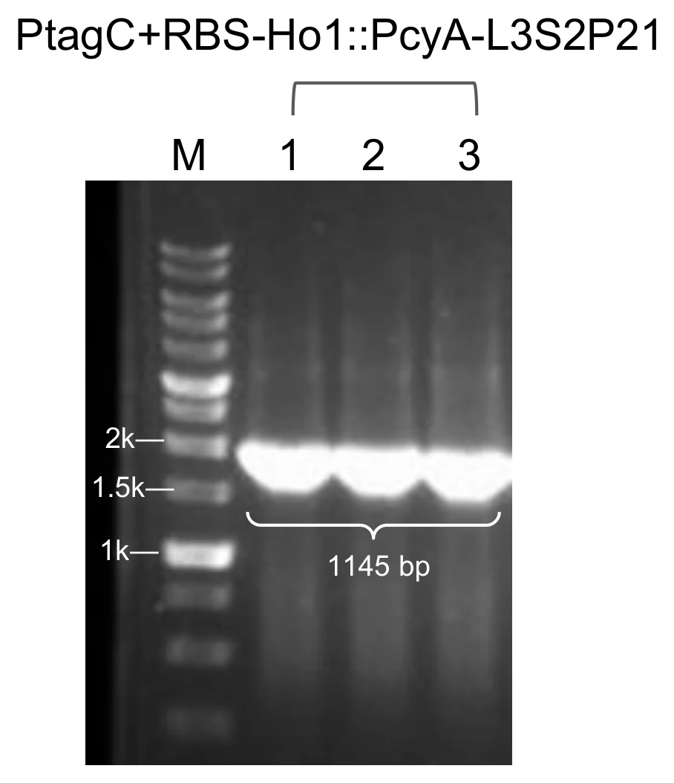
Figure 1. Module 1, P tagC +RBS–Ho1::pcyA–L3S2P21. Three of three colonies gave a band at the expected size, 1,145 bp. Clone 1 was selected for sequencing.
upload/18_BBa_26XZYM10_EXPE_fig1_pp-gel-m1.png (908x1054, 107 KB)

Application
This part was designed for the GEMS-Taiwan 2026 iGEM team’s work on a Stress-Responsive Optogenetic Bioreactor for Precision Plant Protection:

* **ccaSR-Csn-AcdS-Histag** ([<u>**BBa\_2654HAF3**</u>](https://registry.igem.org/parts/bba-2654haf3)): the system is an engineered construct that produces and secretes plant-protective proteins under green/red light control.
* **ccaSR-SamyQ-AcdS 2.1-Histag** ([<u>**BBa\_26U8UTMH**</u>](https://registry.igem.org/parts/bba-26u8utmh)): the system is an engineered construct that produces and secretes plant-protective proteins under green/red light control.

BBa_262YYNPV — AcdS 2.1
protectant · tier B · published · 1011 bp · registry.igem.org/parts/bba-262yynpv

Design
## **About**

* **Biosafety level:** S1
* **Target organism:** *Bacillus subtilis* WB800
* In this variant, the first 15 codons of the coding sequence were optimized to improve the mRNA secondary structure of the translation start site.

## **Literature**

The cloned ACC deaminase gene can be expressed in *Escherichia coli*, which enables this bacterium to grow on ACC as its sole nitrogen source. Both *E. coli* and *Pseudomonas* spp. strains transformed with this gene gain the ability to promote root elongation in canola seedlings (Hontzeas et al., 2004).

A soluble recombinant ACC deaminase from *Pseudomonas putida* UW4 was cloned, expressed and purified. It has a molecular weight of 41 kDa and shows selectivity and high activity towards ACC, with a K(M)\=3.4+/-0.2 mM and k(cat)\=146+/-5 min(-1) at pH 8.0 and 22 °C. Activity is optimal at pH 8.0 and declines sharply to essentially nothing below pH 6.5. It tapers off more gradually at higher pH, and activity is lost above pH 10. (Hontzeas et al., 2004).

## **References**

1\. UniProt Consortium. (n.d.). *Q5PWZ8*. UniProt. Retrieved October 18, 2026, from[<u>UniProt entry Q5PWZ8</u>](https://www.uniprot.org/uniprotkb/Q5PWZ8/entry?utm_source=chatgpt.com)

2\. Hontzeas, N., Zoidakis, J., Glick, B. R., & Abu-Omar, M. M. (2004). Expression and characterization of 1-aminocyclopropane-1-carboxylate deaminase from the rhizobacterium pseudomonas putida UW4: A key enzyme in bacterial plant growth promotion. *Biochimica et Biophysica Acta, 1703(1)*, 11–19. PubMed.[<u>https://doi.org/10.1016/j.bbapap.2004.09.015</u>](https://doi.org/10.1016/j.bbapap.2004.09.015)

3\. Shah, S., Li, J., Moffatt, B. A., & Glick, B. R. (1998). Isolation and characterization of ACC deaminase genes from two different plant growth-promoting rhizobacteria. *Canadian Journal of Microbiology, 44*(9), 833–843.[<u>https://doi.org/10.1139/w98-074</u>](https://doi.org/10.1139/w98-074)

4\. Castillo-Hair, S. M., Baerman, E. A., Fujita, M., Igoshin, O. A., & Voigt, C. A. (2019). Optogenetic control of Bacillus subtilis gene expression. Nature Communications, 10, Article 3099.[ <u>https://doi.org/10.1038/s41467-019-10906-6</u>](https://doi.org/10.1038/s41467-019-10906-6)

5\. Kazusa DNA Research Institute. (n.d.). Codon usage database: Bacillus subtilis subsp. subtilis str. 168 (taxid:1423).[ <u>https://www.kazusa.or.jp/codon/</u>](https://www.kazusa.or.jp/codon/)

6\. Glick, B. R., Penrose, D. M., & Li, J. (1998). A model for the lowering of plant ethylene concentrations by plant growth-promoting bacteria. *Journal of Theoretical Biology*, *190*(1), 63–68. [<u>https://doi.org/10.1006/jtbi.1997.0532</u>](https://doi.org/10.1006/jtbi.1997.0532)

Resolved: [168 / WB800] → WB800 (strain settled 7 Oct)

Application
This part was designed for the GEMS-Taiwan 2026 iGEM team’s work on a Stress-Responsive Optogenetic Bioreactor for Precision Plant Protection and is used in the construction of composite parts:

* **SamyQ-AcdS 2.1-Histag** ([<u>**BBa\_26TOGLX3**</u>](https://registry.igem.org/parts/bba-26toglx3))**:** The ACC deaminase protein is fused to the alpha-amylase signal peptide (SamyQ) at the N-terminus and a 6x Histag at the C-terminus.****
* **Pveg-EEBD-RBS0-SamyQ-AcdS 2.1-Histag-B0015** ([<u>**BBa\_26XVQ3FS**</u>](https://registry.igem.org/parts/bba-26xvq3fs)): this **Protectant Module** constitutively expresses potential stress-mitigation proteins and enables evaluation of their secretion and detection, with its constitutive promoter Pveg, RBS EEBD-RBS, and terminator B0015.
* **PcpcG2-veg-EEBD-RBS0-SamyQ-AcdS 2.1-Histag-B0015** ([<u>**BBa\_26DE5E2Q**</u>](https://registry.igem.org/parts/bba-26de5e2q)): this module includes the light-responsive promoter P*cpcG2*-veg, the RBS EEBD-RBS0, a protectant CDS, and the terminator B0015, which together drive the expression of downstream genes in response to green-light signaling in *Bacillus Subtilis* after[<u>BBa\_26XZYM10</u>](https://registry.igem.org/parts/bba-26xzym10),[<u>BBa\_261XH2RS</u>](https://registry.igem.org/parts/bba-261xh2rs), and[<u>BBa\_26BDO8AQ</u>](https://registry.igem.org/parts/bba-26bdo8aq).
* **ccaSR-SamyQ-AcdS 2.1-Histag** ([<u>**BBa\_26U8UTMH**</u>](https://registry.igem.org/parts/bba-26u8utmh)): the system is an engineered construct that produces and secretes plant-protective proteins under green/red light control.

BBa_265CD14Z — BoPep4
protectant · tier B · published · 69 bp · registry.igem.org/parts/bba-265cd14z

Design
## **About**

* **Biosafety level:** S1
* **Target organism:** *Bacillus subtilis* WB800

## **References**

1. Wang, A., Guo, J., Wang, S., Zhang, Y., Lu, F., Duan, J., Liu, Z., & Ji, W. (2022). BoPEP4, a C-Terminally Encoded Plant Elicitor Peptide from Broccoli, Plays a Role in Salinity Stress Tolerance. International Journal of Molecular Sciences, 23(6), 3090–3090. [<u>https://doi.org/10.3390/ijms23063090</u>](https://doi.org/10.3390/ijms23063090)
2. Li, R., Liu, M., Hu, X., Li, J., Pang, Q., Yan, X., Li, J., & Ji, W. (2026). Broccoli plant elicitor peptide BoPep4 enhances plant salt tolerance by improving glucosinolate metabolism. Plant Science, 364, 112954.

Resolved: [168 / WB800] → WB800 (strain settled 7 Oct)

Application
This part was designed for the GEMS-Taiwan 2026 iGEM team’s work on a Stress-Responsive Optogenetic Bioreactor for Precision Plant Protection and is used in the construction of composite parts:

* **BoPep4 2.1 (**[<u>BBa\_26LYCBW0</u>](https://registry.igem.org/parts/bba-26lycbw0)): In this variant, the first 15 codons of the BoPep4 coding sequence were optimized to improve the mRNA secondary structure of the translation start site.
* **BoPep4 2.2 (**[<u>BBa\_26ERHWWI</u>](https://registry.igem.org/parts/bba-26erhwwi)): This is a second optimized variant of the first 15 codons of the BoPep4 coding sequence, designed with the same aim of improving the mRNA secondary structure of the translation start site.
* **SamyQ-BoPep4-Histag** ([<u>BBa\_26ILD3SO</u>](https://registry.igem.org/parts/bba-26ild3so)): The BoPep4 protein, a C-terminally encoded plant elicitor peptide derived from broccoli, is fused to the SamyQ signal peptide at the N-terminus and a 6x Histag at the C-terminus.
* **Pveg-EEBD-RBS0-SamyQ-BoPep4-Histag-B0015** ([<u>BBa\_26FSZTWM</u>](https://registry.igem.org/parts/bba-26fsztwm)): this Protectant Module constitutively expresses potential stress-mitigation proteins and enables evaluation of their secretion and detection, with its constitutive promoter Pveg, RBS EEBD-RBS0, and terminator B0015.

BBa_267B69E3 — SamyQ-BoPep4 2.2-Histag
protectant · tier B · published · 183 bp · registry.igem.org/parts/bba-267b69e3

Design
## Overview

This part encodes BoPep4, a 23-residue plant elicitor peptide (PEP) from broccoli (*Brassica oleracea var. italica).*

The part is a translational fusion with three elements, in this order:

1. **SamyQ signal peptide (BBa\_K1074014):** N-terminal signal peptide of the amyQ gene, which encodes a highly efficient α-amylase natively found in Bacillus subtilis (and related lineages like Bacillus amyloliquefaciens). Csn and SamyQ were selected as candidates to determine which signal peptide offers higher secretion efficiency.
2. **BoPep4 2.2 (**[<u>**BBa\_26ERHWWI**</u>](https://registry.igem.org/parts/bba-26erhwwi) **):** encodes BoPep4, a 23-residue plant elicitor peptide (PEP) from broccoli (*Brassica oleracea var. italica),* with its native start codon removed, followed by a stop codon. In this variant, the first 15 codons of the coding sequence were optimized to improve the mRNA secondary structure of the translation start site.
3. **6x Histag:** fused N-terminally to the peptide. This allows detection and quantification of the short peptide after successful assembly and electroporation.

The complete part was obtained by de novo gene synthesis.

## About

* **Biosafety Level:** S1
* **Target organism:** Bacillus subtilis WB800
* **Main purpose of use:** Expression and secretion of BoPep4 in the host B. subtilis
* **Potential application:** Enhancing plant salt-stress tolerance as a component of plant-protecting bioprotectants

## Dry lab / computational analysis

The mRNA secondary structure around the ribosome binding site and start codon influences translation-initiation efficiency inside bacteria, independent of the encoded protein sequence. Following the concept suggested by Castillo-Hair (2019), the design pipeline treated the first 15 codons of the BoPep4 CDS as an editable region. ViennaRNA 2.7.2 was used to generate and fold tens of thousands of synonymous variants in the RS-inclusive 236-nt 5′ window (residual recombination site + MF001 RBS + spacer + SamyQ ORF + first 90 nt of CDS), determining the mean base-pair unpaired probability across the 15 nt following the ATG and across the MF001 Shine-Dalgarno core (AAGGAGG), and combining these into a balance score.

Wild-type BoPep4 was the weakest starting point of the whole construct series: start+15 accessibility was only 0.396 and SD-core accessibility only 0.067, both below the \~0.50 usability threshold and the Ho1 reference baseline (0.681). SamyQ-BoPep4 2.2-Histag was determined to be the best candidate from the run: 9 of the first 15 BoPep4 codons were changed (c2 ATT→ATC, c5 GGA→GGT, c6 TCA→AGT, c7 AAA→AAG, c10 CCG→CCT, c11 AGA→AGG, c13 CCG→CCT, c14 CAT→CAC, c15 TCA→TCC). The predicted start+15 accessibility improved from 0.396 to 0.497, and SD-core accessibility rose sharply from 0.067 to 0.634 (roughly a 9.5-fold gain), resulting in an overall balance score gain of 0.462 to 1.131. The codon adaptation index in B. subtilis 168 dropped from 0.87 to 0.77. We verified this variant against a Castillo-rule-applied control (low GC content, A over U): the control reached a start+15 of 0.677 and an SD-core of 0.425 (balance 1.102) an improvement over wild type, but still below the balance achieved by individually folding and verifying each candidate.

## References

1. Wang, A., Guo, J., Wang, S., Zhang, Y., Lu, F., Duan, J., Liu, Z., & Ji, W. (2022). BoPEP4, a C-Terminally Encoded Plant Elicitor Peptide from Broccoli, Plays a Role in Salinity Stress Tolerance. International Journal of Molecular Sciences, 23(6), 3090–3090. [<u>https://doi.org/10.3390/ijms23063090</u>](https://doi.org/10.3390/ijms23063090)
2. Li, R., Liu, M., Hu, X., Li, J., Pang, Q., Yan, X., Li, J., & Ji, W. (2026). Broccoli plant elicitor peptide BoPep4 enhances plant salt tolerance by improving glucosinolate metabolism. Plant Science, 364, 112954.

Resolved: [168 / WB800] → WB800 (strain settled 7 Oct)

Experiment
## Construction/assembly (wet lab)

The SamyQ-Bopep4 2.2-Histag coding sequence was amplified by PCR and cloned into a pSTK-0C-sfGFP vector from the SubtiToolKit provided by [<u>**Dr. Joaquín Caro-Astorga**</u>](https://www.google.com/search?kgmid=%2Fg%2F11jg8gn6cr\&q=Dr.+Joaqu%C3%ADn+Caro-Astorga), giving pSTK-0C-SamyQ-Bopep4 2.2-Histag. The ligation was transformed into *E. coli* strain DH5α, and positive clones carrying the SamyQ-Bopep4 2.1-Histag coding sequence were identified by colony PCR and sent for sequencing to confirm the insert before use in subsequent Golden Gate reactions.

Construct details:

* **Insert:** SamyQ signal peptide – Bopep4 2.2 – 6x Histag, \[177 bp]
* **Amplification primers:**

| Primer name | Primer sequence (5’ to 3’) |
| ----------- | ---------------------------------------------------------------- |
| SamyQ F | ATATAT GAA GAC ATC TGA GGT CTC ATA TGA TTC AAA AAC GAA AGC GGA C |
| BoPep R | ATA TAT GAA GAC ATG AGG GGT CTC ATG TCA TGA TGA TGA TGA TGA TG |

* **Annealing temperature:** 60°C
* **Template:** synthetized fragment
* **Vector:** pSTK-0C-sfGFP (chloramphenicol resistance) The plasmid contains a superfolder green fluorescent protein (sfGFP) cassette, flanked by Type IIS restriction sites, that serves as a visual selection marker; cells containing the empty vector therefore become fluoresce green, while successful insertion of the target DNA fragment replaces the sfGFP sequence, resulting in white/non-fluorescent colonies.

## Verification (wet lab)

Colonies from the pSTK-0C-SamyQ-BoPep4 2.2-Histag transformation were screened by colony PCR with the SamyQ and STK R primers, which flank the insertion site. The products were run on an agarose gel alongside a DNA ladder to assess cloning success. A correct band runs at the expected size, which is the length of the SamyQ-BoPep4 2.2-Histag insert \[177 bp] plus the vector sequence between the Histag and STK R priming site, for a total of \[536 bp]. A band at this size confirms that a fragment of the correct length was ligated into the vector at the expected position. Colonies producing a single, clean band at this size were considered positive candidates for the correct insert.

Positive candidates were then sequenced to confirm that the insert is free of mutations and that the signal peptide, BoPep4 2.2 coding sequence, and Histag. Clones with a verified sequence were used for the Level 1 Golden Gate reactions.

## Results

![](https://registry.igem.wiki/documentation/b566a2c3-8f38-4553-99a0-7f84e388a866/c99753738e9199f0b8df03c2cd933ef5b4924dd02a1b503b646bb6101bbfd98d.avif)

**Figure 1. Colony PCR of pSTK-0C-SamyQ-BoPep4 2.2-Histag**. The figure indicates that 4 of 4 colonies gave a band at the expected size (\[536 bp])

**Figure 2. Clone 1 was sequence-verified and used downstream.**

Open questions: [177 bp] — no wiki caption confirms this band size; [177 bp] — no wiki caption confirms this band size; [536 bp] — no wiki caption confirms this band size; [536 bp] — no wiki caption confirms this band size

Application
This part was designed for the GEMS-Taiwan 2026 iGEM team’s work on a Stress-Responsive Optogenetic Bioreactor for Precision Plant Protection and is used in the construction of the composite part:

* **Pveg-EEBD-RBS0-SamyQ-BoPep4 2.2-Histag-B0015** ([BBa\_26IA55UY](https://registry.igem.org/parts/bba-26ia55uy)): this Protectant Module constitutively expresses potential stress-mitigation proteins and enables evaluation of their secretion and detection, with its constitutive promoter Pveg, RBS EEBD-RBS0, and terminator B0015.

BBa_26ERHWWI — Bopep4 2.2
protectant · tier B · published · 69 bp · registry.igem.org/parts/bba-26erhwwi

Design
## **About**

* **Biosafety level:** S1
* **Target organism:** *Bacillus subtilis* WB800
* In this variant, the first 15 codons of the BoPep4 coding sequence were optimized to improve the mRNA secondary structure of the translation start site.

## **References**

1. Wang, A., Guo, J., Wang, S., Zhang, Y., Lu, F., Duan, J., Liu, Z., & Ji, W. (2022). BoPEP4, a C-Terminally Encoded Plant Elicitor Peptide from Broccoli, Plays a Role in Salinity Stress Tolerance. International Journal of Molecular Sciences, 23(6), 3090–3090. [<u>https://doi.org/10.3390/ijms23063090</u>](https://doi.org/10.3390/ijms23063090)
2. Li, R., Liu, M., Hu, X., Li, J., Pang, Q., Yan, X., Li, J., & Ji, W. (2026). Broccoli plant elicitor peptide BoPep4 enhances plant salt tolerance by improving glucosinolate metabolism. Plant Science, 364, 112954.

Resolved: [168 / WB800] → WB800 (strain settled 7 Oct)

Application
This part was designed for the GEMS-Taiwan 2026 iGEM team’s work on a Stress-Responsive Optogenetic Bioreactor for Precision Plant Protection and is used in the construction of composite parts:

* **SamyQ-BoPep4 2.2-Histag** ([<u>BBa\_267B69E3</u>](https://registry.igem.org/parts/bba-267b69e3) ): The BoPep4 protein, a C-terminally encoded plant elicitor peptide derived from broccoli, is fused to the SamyQ signal peptide at the N-terminus and a 6x Histag at the C-terminus.
* **Pveg-EEBD-RBS0-SamyQ-BoPep4 2.2-Histag-B0015** ([<u>BBa\_26IA55UY</u>](https://registry.igem.org/parts/bba-26ia55uy) ): this Protectant Module constitutively expresses potential stress-mitigation proteins and enables evaluation of their secretion and detection, with its constitutive promoter Pveg, RBS EEBD-RBS0, and terminator B0015.

BBa_26FSZTWM — Pveg-EEBD-RBS0-SamyQ-BoPep4-Histag-B0015
protectant · tier B · published · 712 bp · registry.igem.org/parts/bba-26fsztwm

Design
## Overview

This part encodes BoPep4, a 23-residue plant elicitor peptide (PEP) from broccoli (*Brassica oleracea var. italica).*

The part is a composite transcription unit with four elements, in this order:

· Pveg (BBa\_K143012): a constitutive bacterial promoter originally derived from *Bacillus subtilis* that drives continuous gene transcription without requiring external induction.

· EEBD-RBS0 ([BBa\_26V6CPEV](https://registry.igem.org/parts/bba-26v6cpev)): a composite ribosome binding site element containing a synthetic RBS sequence and expression-enhancing nucleotide context to improve translation initiation efficiency. EEBD is a blocking device, consisting of a B0015 terminator between two recombination sites to prevent unwanted gene expression or the production of toxic proteins while cloning DNA constructs inside *Escherichia coli*.

· SamyQ-BoPep4-Histag ([BBa\_26ILD3SO](https://registry.igem.org/parts/bba-26ild3so))

· B0015 (BBa\_B0015): a high-efficiency double transcriptional terminator that stops RNA polymerase from continuing transcription past the CDS protectant, preventing transcriptional read-through into downstream modules.

The complete cassette was obtained by de novo gene synthesis.

## About

* **Biosafety level:** S1
* **Target organism:** *Bacillus subtilis* (168 / WB800)
* **Main purpose of use:** Constitutive expression and secretion of BoPep4
* **Potential application:** Enhancing plant salt-stress tolerance as a component of plant-protecting bioprotectants

## Literature

**Rationale.** BoPep4 is a 23-residue mature plant elicitor peptide from broccoli (*Brassica oleracea* var. *italica*), sequence GILIGSKKRPREPHSSGKPGGHN. It works through auxin and abscisic acid signalling crosstalk to raise salt-stress tolerance in broccoli, lowering the Na⁺/K⁺ ratio and promoting leaf wax and cutin accumulation (Wang, A., et al., 2022). The peptide is 23 residues, short enough that it cannot be detected without the tag. This cassette carries the wild-type BoPep4 coding sequence behind the SamyQ signal peptide, which directs it into the Sec-dependent secretion pathway. The 6x Histag is fused N-terminally to the peptide, which allows detection and quantification of the short peptide.

**Why the wild-type coding sequence.** Wild-type BoPep4 was the weakest starting point of our whole construct series for predicted translation initiation. Start+15 accessibility was 0.396 and Shine-Dalgarno core accessibility 0.067, both below the roughly 0.50 usability threshold we worked to and below the Ho1 reference baseline of 0.681. We kept an untouched copy in the set as the baseline for the BoPep4 variants, both the two recoded versions and the mutant and truncated peptides. Our BoPep4 cassettes, this one and the ones carrying BoPep4 2.1 and BoPep4 2.2, all use the SamyQ signal peptide and differ only in the first 15 codons of the coding sequence. They are the one place in our part set where the effect of 5′ recoding can be read on its own, with everything else held fixed.

**Why a constitutive version.** We used the constitutive Pveg version in addition to the whole light-sensing construct because it lets us see the maximal secretion and protein production rate without the light switch. This version can be applied to plants and characterized directly by Western blot, which shows whether our constructs work under the most optimal conditions.

**Why Pveg and EEBD-RBS0.** Pveg gives high, continuous expression at a fixed level, so differences between protectants and signal peptides reflect the cargo. RBS0 sets translation initiation, and the EEBD protects *Escherichia coli* during cloning. These are standard SubtiToolKit (STK) parts (Caro-Astorga et al., 2025), so they assemble with the other protectant cassettes in the same format.

## References

1\. Wang, A., Guo, J., Wang, S., Zhang, Y., Lu, F., Duan, J., Liu, Z., & Ji, W. (2022). BoPEP4, a C-terminally encoded plant elicitor peptide from broccoli, plays a role in salinity stress tolerance. International Journal of Molecular Sciences, 23(6), Article 3090. [https://doi.org/10.3390/ijms23063090](https://doi.org/10.3390/ijms23063090)

2\. Caro-Astorga, J., Rogan, M., Malcı, K., Ming, H., Debenedictis, E., James, P., & Ellis, T. (2025). SubtiToolKit: A bioengineering kit for *Bacillus subtilis* and Gram-positive bacteria. Trends in Biotechnology, 43(6), 1446–1469. [https://doi.org/10.1016/j.tibtech.2025.02.004](https://doi.org/10.1016/j.tibtech.2025.02.004)

Experiment
## Construction/assembly (wet lab)

This cassette was built differently from the others. The whole construct was obtained by de novo gene synthesis, so there is no Level 0 entry-cloning step and no amplification of the coding-sequence fusion for it.

* Composite insert: Pveg – EEBD-RBS0 – SamyQ-BoPep4-Histag – B0015, \[910 bp]
* Level 1 vector: pSTK-EXP1 expression shuttle vector (STK), \[ampicillin]
* Template: de novo synthesised cassette
* Level 0 entry step: none&#x20;
* Assembly method (Level 1): Golden gate assembly with BsaI-HFv2 enzyme
* Thermal cycle:

| Temperature | Time | Cycles |
| ----------- | ------ | --------- |
| 37 °C | 5 min | 45 cycles |
| 16 °C | 5 min | |
| 37 °C | 10 min | 1 cycle |
| 80 °C | 20 min | 1 cycle |

*

The coding sequence was incorporated into Pveg-EEBD-RBS0-SamyQ-BoPep4-B0015 by de novo gene synthesis. Our six other constitutive protectant cassettes were assembled from separate Level 0 parts in a Golden Gate reaction with BsaI-HFv2, and that narrative does not apply here. The construct was assembled into pSTK-EXP1-sfGFP. The amplification primers used on the other cassettes, SamyQ F and BoPep R, were not needed for this one.&#x20;

## Verification (wet lab)

Colonies from the pSTK-EXP1-sfGFP transformation were screened by colony PCR with SamyQ F and pSTK-EXP-seq R primers, and the products were run on an agarose gel alongside a DNA ladder. A correct band runs at the expected size. Colonies producing a single, clean band at this size were considered positive candidates.

## Results

Although the gel image for Pveg-EEBD-RBS0-SamyQ-Bopep4-Histag-B0015 is unavailable, the construct was successfully assembled and verified by gel electrophoresis.

**Figure 1. Sequencing of pSTK-EXP1-Pveg-EEBD-RBS0-SamyQ-BoPep4-Histag-B0015.**&#x20;

Open questions: [910 bp] — no wiki caption confirms this band size; [ampicillin] — not corroborated anywhere

Application
A full ccaSR construct with BoPep4 as Module 4 was not built. The constitutive BoPep4 version lets us assess its behavior in the system, and it also helped plants under salinity stress, without duplicating the work, because ccaSR-Csn-AcdS-Histag ([BBa\_2654HAF3](https://registry.igem.org/parts/bba-2654haf3)) and ccaSR-SamyQ-AcdS 2.1-Histag ([BBa\_26U8UTMH](https://registry.igem.org/parts/bba-26u8utmh)) already serves as proof of concept for the circuit.

BBa_26ILD3SO — SamyQ-BoPep4-Histag
protectant · tier B · published · 183 bp · registry.igem.org/parts/bba-26ild3so

Design
## Overview

This part encodes BoPep4, a 23-residue plant elicitor peptide (PEP) from broccoli (*Brassica oleracea var. italica).*

The part is a translational fusion with three elements, in this order:

1. **SamyQ signal peptide (BBa\_K1074014):** N-terminal signal peptide of the amyQ gene, which encodes a highly efficient α-amylase natively found in Bacillus subtilis (and related lineages like Bacillus amyloliquefaciens). Csn and SamyQ were selected as candidates to determine which signal peptide offers higher secretion efficiency.
2. **BoPep4 (**[<u>**BBa\_265CD14Z**</u>](https://registry.igem.org/parts/bba-265cd14z)**):** encodes BoPep4, a 23-residue plant elicitor peptide (PEP) from broccoli (*Brassica oleracea var. italica),* with its native start codon removed, followed by a stop codon.
3. **6x Histag:** fused N-terminally to the peptide. This allows detection and quantification of the short peptide after successful assembly and electroporation.

The complete part was obtained by de novo gene synthesis.

## About

* **Biosafety Level:** S1
* **Target organism:** Bacillus subtilis WB800
* **Main purpose of use:** Expression and secretion of BoPep4 in the host B. subtilis
* **Potential application:** Enhancing plant salt-stress tolerance as a component of plant-protecting bioprotectants

## References

1. Wang, A., Guo, J., Wang, S., Zhang, Y., Lu, F., Duan, J., Liu, Z., & Ji, W. (2022). BoPEP4, a C-Terminally Encoded Plant Elicitor Peptide from Broccoli, Plays a Role in Salinity Stress Tolerance. International Journal of Molecular Sciences, 23(6), 3090–3090. [<u>https://doi.org/10.3390/ijms23063090</u>](https://doi.org/10.3390/ijms23063090)
2. Li, R., Liu, M., Hu, X., Li, J., Pang, Q., Yan, X., Li, J., & Ji, W. (2026). Broccoli plant elicitor peptide BoPep4 enhances plant salt tolerance by improving glucosinolate metabolism. Plant Science, 364, 112954.

Resolved: [168 / WB800] → WB800 (strain settled 7 Oct)

Experiment
This CDS was incorporated in Pveg-EEBD-RBS0-SamyQ-BoPep4-B0015 by de novo gene synthesis.

Application
This part was designed for the GEMS-Taiwan 2026 iGEM team’s work on a Stress-Responsive Optogenetic Bioreactor for Precision Plant Protection and is used in the construction of the composite part:

* **Pveg-EEBD-RBS0-SamyQ-BoPep4-Histag-B0015** ([BBa\_26FSZTWM](https://registry.igem.org/parts/bba-26fsztwm)): this Protectant Module constitutively expresses potential stress-mitigation proteins and enables evaluation of their secretion and detection, with its constitutive promoter Pveg, RBS EEBD-RBS0, and terminator B0015.

BBa_26IN6G1D — LEA14 2.1
protectant · tier B · published · 450 bp · registry.igem.org/parts/bba-26in6g1d

Design
## **About**

* **Biosafety level:** S1
* **Target organism:** *Bacillus subtilis* WB800
* In this variant, the first 15 codons of the coding sequence were optimized to improve the mRNA secondary structure of the translation start site.

## **Literature**

The cloned ACC deaminase gene can be expressed in *Escherichia coli*, which enables this bacterium to grow on ACC as its sole nitrogen source. Both *E. coli* and *Pseudomonas* spp. strains transformed with this gene gain the ability to promote root elongation in canola seedlings (Hontzeas et al., 2004).

A soluble recombinant ACC deaminase from *Pseudomonas putida* UW4 was cloned, expressed and purified. It has a molecular weight of 41 kDa and shows selectivity and high activity towards ACC, with a K(M)\=3.4+/-0.2 mM and k(cat)\=146+/-5 min(-1) at pH 8.0 and 22 °C. Activity is optimal at pH 8.0 and declines sharply to essentially nothing below pH 6.5. It tapers off more gradually at higher pH, and activity is lost above pH 10. (Hontzeas et al., 2004).

## **References**

1. Goyal, K., Walton, L. J., & Tunnacliffe, A. (2005). LEA proteins prevent protein aggregation due to water stress. *Biochemical Journal, 388(1)*, 151–157. [<u>https://doi.org/10.1042/bj20041931</u>](https://doi.org/10.1042/bj20041931)
2. Hundertmark, M., Hincha, D. K., & Thalhammer, A. (2008). LEA (late embryogenesis abundant) proteins and their encoding genes in *Arabidopsis thaliana*. *BMC Genomics, 9*, Article 118. [<u>https://doi.org/10.1186/1471-2164-9-118</u>](https://doi.org/10.1186/1471-2164-9-118)
3. Jia, F., Qi, S., Li, H., Liu, P., Li, P., Wu, C., Zheng, C., & Huang, J. (2014). Overexpression of late embryogenesis abundant 14 enhances *Arabidopsis* salt stress tolerance. *Biochemical and Biophysical Research Communications, 454(4)*, 505–511. [<u>https://doi.org/10.1016/j.bbrc.2014.10.136</u>](https://doi.org/10.1016/j.bbrc.2014.10.136)
4. Mertens, J., Aliyu, H., & Cowan, D. A. (2018). LEA proteins and the evolution of the WHy domain. *Applied and Environmental Microbiology, 84(15)*, Article e00539-18. [<u>https://doi.org/10.1128/AEM.00539-18</u>](https://doi.org/10.1128/AEM.00539-18)
5. Singh, S., Cornilescu, C. C., Tyler, R. C., Cornilescu, G., Tonelli, M., Lee, M. S., & Markley, J. L. (2005). Solution structure of a late embryogenesis abundant protein (LEA14) from *Arabidopsis thaliana*, a cellular stress-related protein. *Protein Science, 14(10)*, 2601–2609. [<u>https://doi.org/10.1110/ps.051579205</u>](https://doi.org/10.1110/ps.051579205)
6. Wang, J. W., Squire, H. J., Goh, N. S., Ni, H. M., Lien, E., Wong, C., González-Grandío, E., & Landry, M. P. (2023). Delivered complementation in planta (DCIP) enables measurement of peptide-mediated protein delivery efficiency in plants. *Communications Biology, 6(1)*, Article 829. [<u>https://doi.org/10.1038/s42003-023-05191-5</u>](https://doi.org/10.1038/s42003-023-05191-5)

Resolved: [168 / WB800] → WB800 (strain settled 7 Oct)

Application
This part was designed for the GEMS-Taiwan 2026 iGEM team’s work on a Stress-Responsive Optogenetic Bioreactor for Precision Plant Protection and is used in the construction of composite parts:

* **SamyQ-LEA14 2.1-Histag** ([<u>BBa\_26J0GJGZ</u>](https://registry.igem.org/parts/bba-26j0gjgz)): The Late Embryogenesis Abundant (LEA14) 2.1 protein is fused to the SamyQ signal peptide at the N-terminus and a 6x Histag at the C-terminus.
* **Pveg-EEBD-RBS0-SamyQ-LEA14-Histag 2.1-B0015** ([<u>BBa\_26D5AX7S</u>](https://registry.igem.org/parts/bba-26d5ax7s)): this Protectant Module constitutively expresses potential stress-mitigation proteins and enables evaluation of their secretion and detection, with its constitutive promoter Pveg, RBS EEBD-RBS0, and terminator B0015.

BBa_26J0GJGZ — SamyQ-LEA14 2.1-Histag
protectant · tier B · published · 564 bp · registry.igem.org/parts/bba-26j0gjgz

Design
## Overview

This part encodes a Late Embryogenesis Abundant 14 protein (LEA14)from *Arabidopsis thaliana* gene *At1g01470.1*, which belongs to LEA\_2 subgroup.

The part is a translational fusion with three elements, in this order:

1. **SamyQ signal peptide (**[<u>BBa\_K1074014</u>](https://registry.igem.org/parts/bba-k1074014)**):** N-terminal signal peptide of the *amyQ* gene, which encodes a highly efficient α-amylase natively found in *Bacillus subtilis* (and related lineages like *Bacillus amyloliquefaciens*). Csn and SamyQ were selected as candidates to determine which signal peptide offers higher secretion efficiency.
2. **LEA14 2.1 (**[<u>BBa\_26IN6G1D</u>](https://registry.igem.org/parts/bba-26in6g1d)**):** This part encodes a Late Embryogenesis Abundant 14 protein (LEA14) from [<u>*Arabidopsis thaliana*</u>](https://www.uniprot.org/uniprotkb/O03983/entry) with its native start codon and stop codon removed. In this variant, the first 15 codons of the coding sequence from LEA14 wild-type ([<u>BBa\_26LTB0W1</u>](https://registry.igem.org/parts/bba-26ltb0w1)) were optimized to improve the mRNA secondary structure of the translation start site.
3. **6x Histag:** Fused at the C-terminus followed by a stop codon. This allows protein purification and identification after successful assembly and electroporation.

The complete part was obtained by de novo gene synthesis.

## About

* **Biosafety level:** S1
* **Target organism:** *Bacillus subtilis* WB800
* **Main purpose of use:** Expression and secretion of LEA 14 in the host *B. subtilis*
* **Potential application:** Lowering plant ethylene levels under stress, as a component of plant-growth-promoting bioprotectants

## Dry lab / computational analysis

The mRNA secondary structure around the ribosome binding site and start codon heavily influences the translation-initiation efficiency inside bacteria. Synonymous codons, meaning codons that result in the same amino acids, in the 5’ end of a CDS can impact how the mRNA folds near the binding site. The folding can either hide or expose the Shine Dalgarno sequence and start codon, impacting the efficiency of ribosome binding and translation initiation. Following this concept suggested by Castillo-Hair (2019), the design pipeline treated the first 15 codons of the LEA14 CDS as an editable region. ViennaRNA 2.7.2 was used to generate and fold tens of thousands of synonymous variants in the RS-inclusive 236-nt 5’ window (residual recombination site + MF001 RBS + spacer + SamyQ ORF + first 90 nt of cds), determining the mean base-pair unpaired probability across the 15 nt following the ATG and across the MF001 Shine-Dalgarno core (AAGGAGG) and creating a balance score.

SamyQ-LEA 2.1-Histag was determined to be the best candidate from the run: 6 of the first 15 LEA14 codons were changed (c1 GCG→GCA, c2 TCT→AGT, c3 TTA→CTC, c4 TTA→CTC, c10 TTT→TTC, c11 GTA→GTC). The predicted start+15 accessibility improved from 0.538 to 0.669 and SD-core accessibility decreased from 0.357 to 0.307 when compared to the wild type, resulting in an overall balance score gain of 0.895 to 0.976. The codon adaptation index against B. subtilis 168 usage dropped from 0.85 to 0.81. Instead of following Castillo’s rule, which prioritizes low GC content and A over U, the program individually folded and verified every candidate to verify improved accessibility, as the Castillo-rule-applied control produced a start+15 score of only 0.669 and an SD-core score of 0.078 (balance 0.748), which was lower than wild type.

## References

1. Goyal, K., Walton, L. J., & Tunnacliffe, A. (2005). LEA proteins prevent protein aggregation due to water stress. *Biochemical Journal, 388(1)*, 151–157. [<u>https://doi.org/10.1042/bj20041931</u>](https://doi.org/10.1042/bj20041931)
2. Hundertmark, M., Hincha, D. K., & Thalhammer, A. (2008). LEA (late embryogenesis abundant) proteins and their encoding genes in *Arabidopsis thaliana*. *BMC Genomics, 9*, Article 118. [<u>https://doi.org/10.1186/1471-2164-9-118</u>](https://doi.org/10.1186/1471-2164-9-118)
3. Jia, F., Qi, S., Li, H., Liu, P., Li, P., Wu, C., Zheng, C., & Huang, J. (2014). Overexpression of late embryogenesis abundant 14 enhances *Arabidopsis* salt stress tolerance. *Biochemical and Biophysical Research Communications, 454(4)*, 505–511. [<u>https://doi.org/10.1016/j.bbrc.2014.10.136</u>](https://doi.org/10.1016/j.bbrc.2014.10.136)
4. Mertens, J., Aliyu, H., & Cowan, D. A. (2018). LEA proteins and the evolution of the WHy domain. *Applied and Environmental Microbiology, 84(15)*, Article e00539-18. [<u>https://doi.org/10.1128/AEM.00539-18</u>](https://doi.org/10.1128/AEM.00539-18)
5. Singh, S., Cornilescu, C. C., Tyler, R. C., Cornilescu, G., Tonelli, M., Lee, M. S., & Markley, J. L. (2005). Solution structure of a late embryogenesis abundant protein (LEA14) from *Arabidopsis thaliana*, a cellular stress-related protein. *Protein Science, 14(10)*, 2601–2609. [<u>https://doi.org/10.1110/ps.051579205</u>](https://doi.org/10.1110/ps.051579205)
6. Wang, J. W., Squire, H. J., Goh, N. S., Ni, H. M., Lien, E., Wong, C., González-Grandío, E., & Landry, M. P. (2023). Delivered complementation in planta (DCIP) enables measurement of peptide-mediated protein delivery efficiency in plants. *Communications Biology, 6(1)*, Article 829. [<u>https://doi.org/10.1038/s42003-023-05191-5</u>](https://doi.org/10.1038/s42003-023-05191-5)

Resolved: [168 / WB800] → WB800 (strain settled 7 Oct)

Experiment
## Construction/assembly (wet lab)

The SamyQ-LEA14 2.1-Histag coding sequence was amplified by PCR and cloned into a pSTK-0C-sfGFP vector from the SubtiToolKit provided by [<u>**Dr. Joaquín Caro-Astorga**</u>](https://www.google.com/search?kgmid=%2Fg%2F11jg8gn6cr\&q=Dr.+Joaqu%C3%ADn+Caro-Astorga), giving pSTK-0C-SamyQ-LEA14 2.1-Histag. The ligation was transformed into *E. coli* strain DH5α, and positive clones carrying the SamyQ-LEA14 2.1-Histag coding sequence were identified by colony PCR and sent for sequencing to confirm the insert before use in subsequent Golden Gate reactions.

Construct details:

* **Insert:** SamyQ signal peptide – LEA14 2.1 – 6x Histag, \[561 bp]
* **Amplification primers:**

| Primer name | Primer sequence (5’ to 3’) |
| ----------- | ----------------------------------------------------------------- |
| SamyQ F | ATATAT GAA GAC ATC TGA GGT CTC ATA TGA TTC AAA AAC GAA AGC GGA C |
| LEA14 R | ATA TAT GAA GAC ATG AGG GGT CTC ATG TCT TAA TGA TGA TGA TGA TGA T |

* **Annealing temperature:** 60°C
* **Template:** synthetic fragment
* **Vector:** pSTK-0C-sfGFP (chloramphenicol resistance) The plasmid contains a superfolder green fluorescent protein (sfGFP) cassette, flanked by Type IIS restriction sites, that serves as a visual selection marker; cells containing the empty vector therefore become fluoresce green, while successful insertion of the target DNA fragment replaces the sfGFP sequence, resulting in white/non-fluorescent colonies.

## Verification (wet lab)

Colonies from the pSTK-0C-SamyQ-LEA14 2.1-Histag transformation were screened by colony PCR with the SamyQ and STK R primers, which flank the insertion site. The products were run on an agarose gel alongside a DNA ladder to assess cloning success. A correct band runs at the expected size, which is the length of the SamyQ-LEA14 2.1-Histag insert \[561 bp] plus the vector sequence between the His Tag and STK R priming site, for a total of \[770 bp]. A band at this size confirms that a fragment of the correct length was ligated into the vector at the expected position. Colonies producing a single, clean band at this size were considered positive candidates for the correct insert.

Positive candidates were then sequenced to confirm that the insert is free of mutations and that the signal peptide, LEA14 2.1 coding sequence, and Histag. Clones with a verified sequence were used for the Level 1 Golden Gate reactions.

## Result

![](https://registry.igem.wiki/documentation/da1b3de3-ebd2-4a73-bb4e-2ef6dc8e8ec8/2463682d514cfc7eaa3e7c9162c24cb2fde222c8a612aefb787f00e93d58e3a9.avif)

**Figure 1. Colony PCR of pSTK-0C-SamyQ-LEA14 2.1-Histag**. The figure indicates that 2 of 2 colonies gave a band at the expected size (\[770 bp])

**Figure 2. Clone 1 was sequence-verified and used downstream.**

Open questions: [561 bp] — no wiki caption confirms this band size; [561 bp] — no wiki caption confirms this band size; [770 bp] — no wiki caption confirms this band size; [770 bp] — no wiki caption confirms this band size

Application
This part was designed for the GEMS-Taiwan 2026 iGEM team’s work on a Stress-Responsive Optogenetic Bioreactor for Precision Plant Protection and is used in the construction of the composite part:

* **Pveg-EEBD-RBS0-SamyQ-LEA14-Histag 2.1-B0015** ([<u>BBa\_26D5AX7S</u>](https://registry.igem.org/parts/bba-26d5ax7s)): this Protectant Module constitutively expresses potential stress-mitigation proteins and enables evaluation of their secretion and detection, with its constitutive promoter Pveg, RBS EEBD-RBS0, and terminator B0015.

BBa_26LTB0W1 — LEA14
protectant · tier B · published · 450 bp · registry.igem.org/parts/bba-26ltb0w1

Design
## **About**

* **Biosafety level:** S1
* **Target organism:** *Bacillus subtilis* WB800

## **References**

1. Goyal, K., Walton, L. J., & Tunnacliffe, A. (2005). LEA proteins prevent protein aggregation due to water stress. *Biochemical Journal, 388(1)*, 151–157. [<u>https://doi.org/10.1042/bj20041931</u>](https://doi.org/10.1042/bj20041931)
2. Hundertmark, M., Hincha, D. K., & Thalhammer, A. (2008). LEA (late embryogenesis abundant) proteins and their encoding genes in *Arabidopsis thaliana*. *BMC Genomics, 9*, Article 118. [<u>https://doi.org/10.1186/1471-2164-9-118</u>](https://doi.org/10.1186/1471-2164-9-118)
3. Jia, F., Qi, S., Li, H., Liu, P., Li, P., Wu, C., Zheng, C., & Huang, J. (2014). Overexpression of late embryogenesis abundant 14 enhances *Arabidopsis* salt stress tolerance. *Biochemical and Biophysical Research Communications, 454(4)*, 505–511. [<u>https://doi.org/10.1016/j.bbrc.2014.10.136</u>](https://doi.org/10.1016/j.bbrc.2014.10.136)
4. Mertens, J., Aliyu, H., & Cowan, D. A. (2018). LEA proteins and the evolution of the WHy domain. *Applied and Environmental Microbiology, 84(15)*, Article e00539-18. [<u>https://doi.org/10.1128/AEM.00539-18</u>](https://doi.org/10.1128/AEM.00539-18)
5. Singh, S., Cornilescu, C. C., Tyler, R. C., Cornilescu, G., Tonelli, M., Lee, M. S., & Markley, J. L. (2005). Solution structure of a late embryogenesis abundant protein (LEA14) from *Arabidopsis thaliana*, a cellular stress-related protein. *Protein Science, 14(10)*, 2601–2609. [<u>https://doi.org/10.1110/ps.051579205</u>](https://doi.org/10.1110/ps.051579205)
6. Wang, J. W., Squire, H. J., Goh, N. S., Ni, H. M., Lien, E., Wong, C., González-Grandío, E., & Landry, M. P. (2023). Delivered complementation in planta (DCIP) enables measurement of peptide-mediated protein delivery efficiency in plants. *Communications Biology, 6(1)*, Article 829. [<u>https://doi.org/10.1038/s42003-023-05191-5</u>](https://doi.org/10.1038/s42003-023-05191-5)

Resolved: [168 / WB800] → WB800 (strain settled 7 Oct)

Application
This part was designed for the GEMS-Taiwan 2026 iGEM team’s work on a Stress-Responsive Optogenetic Bioreactor for Precision Plant Protection and is used in the construction of composite parts:

* **LEA14 2.1** ([<u>BBa\_26IN6G1D</u>](https://registry.igem.org/parts/bba-26in6g1d)): In this variant, the first 15 codons of the LEA14 coding sequence were optimized to improve the mRNA secondary structure of the translation start site.
* **Csn-LEA14-Histag** ([<u>BBa\_26ZQ1T72</u>](https://registry.igem.org/parts/bba-26zq1t72)): The Late Embryogenesis Abundant (LEA14) protein is fused to the chitosanase signal (Csn) peptide at the N-terminus and a 6x Histag at the C-terminus.
* **Pveg-EEBD-RBS0-Csn-LEA14-Histag-B0015** ([<u>BBa\_26SG0NQQ</u>](https://registry.igem.org/parts/bba-26sg0nqq)): this Protectant Module constitutively expresses potential stress-mitigation proteins and enables evaluation of their secretion and detection, with its constitutive promoter Pveg, RBS EEBD-RBS0, and terminator B0015.

BBa_26LYCBW0 — BoPep4 2.1
protectant · tier B · published · 69 bp · registry.igem.org/parts/bba-26lycbw0

Design
## **About**

* **Biosafety level:** S1
* **Target organism:** *Bacillus subtilis* WB800
* In this variant, the first 15 codons of the BoPep4 coding sequence were optimized to improve the mRNA secondary structure of the translation start site.

## **References**

1. Wang, A., Guo, J., Wang, S., Zhang, Y., Lu, F., Duan, J., Liu, Z., & Ji, W. (2022). BoPEP4, a C-Terminally Encoded Plant Elicitor Peptide from Broccoli, Plays a Role in Salinity Stress Tolerance. International Journal of Molecular Sciences, 23(6), 3090–3090. [<u>https://doi.org/10.3390/ijms23063090</u>](https://doi.org/10.3390/ijms23063090)
2. Li, R., Liu, M., Hu, X., Li, J., Pang, Q., Yan, X., Li, J., & Ji, W. (2026). Broccoli plant elicitor peptide BoPep4 enhances plant salt tolerance by improving glucosinolate metabolism. Plant Science, 364, 112954.

Resolved: [168 / WB800] → WB800 (strain settled 7 Oct)

Application
This part was designed for the GEMS-Taiwan 2026 iGEM team’s work on a Stress-Responsive Optogenetic Bioreactor for Precision Plant Protection and is used in the construction of composite parts:

* **SamyQ-BoPep4 2.1-Histag** ([<u>BBa\_26PX0UGH</u>](https://registry.igem.org/parts/bba-26px0ugh)): The BoPep4 protein, a C-terminally encoded plant elicitor peptide derived from broccoli, is fused to the SamyQ signal peptide at the N-terminus and a 6x Histag at the C-terminus.
* **Pveg-EEBD-RBS0-SamyQ-BoPep4 2.1-Histag-B0015** ([<u>BBa\_269A97I7</u>](https://registry.igem.org/parts/bba-269a97i7)): this Protectant Module constitutively expresses potential stress-mitigation proteins and enables evaluation of their secretion and detection, with its constitutive promoter Pveg, RBS EEBD-RBS0, and terminator B0015.

BBa_26MA70QI — AcdS
protectant · tier B · published · 1011 bp · registry.igem.org/parts/bba-26ma70qi

Design
## About

* **Biosafety level:** S1
* **Target organism:** *Bacillus subtilis* WB800

## Literature

The cloned ACC deaminase gene can be expressed in *Escherichia coli*, which enables this bacterium to grow on ACC as its sole nitrogen source. Both *E. coli* and *Pseudomonas* spp. strains transformed with this gene gain the ability to promote root elongation in canola seedlings (Hontzeas et al., 2004).

A soluble recombinant ACC deaminase from *Pseudomonas putida* UW4 was cloned, expressed and purified. It has a molecular weight of 41 kDa and shows selectivity and high activity towards ACC, with a K(M)\=3.4+/-0.2 mM and k(cat)\=146+/-5 min(-1) at pH 8.0 and 22 °C. Activity is optimal at pH 8.0 and declines sharply to essentially nothing below pH 6.5. It tapers off more gradually at higher pH, and activity is lost above pH 10. (Hontzeas et al., 2004).

## References

1\. UniProt Consortium. (n.d.). *Q5PWZ8*. UniProt. Retrieved October 18, 2026, from[ <u>UniProt entry Q5PWZ8</u>](https://www.uniprot.org/uniprotkb/Q5PWZ8/entry?utm_source=chatgpt.com)

2\. Hontzeas, N., Zoidakis, J., Glick, B. R., & Abu-Omar, M. M. (2004). Expression and characterization of 1-aminocyclopropane-1-carboxylate deaminase from the rhizobacterium pseudomonas putida UW4: A key enzyme in bacterial plant growth promotion. *Biochimica et Biophysica Acta, 1703(1)*, 11–19. PubMed.[ <u>https://doi.org/10.1016/j.bbapap.2004.09.015</u>](https://doi.org/10.1016/j.bbapap.2004.09.015)

3\. Shah, S., Li, J., Moffatt, B. A., & Glick, B. R. (1998). Isolation and characterization of ACC deaminase genes from two different plant growth-promoting rhizobacteria. *Canadian Journal of Microbiology, 44*(9), 833–843.[ <u>https://doi.org/10.1139/w98-074</u>](https://doi.org/10.1139/w98-074)

4\. Deng, L. (2022). *Bacillus subtilis subsp. subtilis str. 168 chromosome, complete genome* \[GenBank sequence CP103783.1]. GenBank. National Center for Biotechnology Information.[ ](https://www.ncbi.nlm.nih.gov/nucleotide/CP103783.1?utm_source=chatgpt.com)[<u>https://www.ncbi.nlm.nih.gov/nucleotide/CP103783.1</u>](https://www.ncbi.nlm.nih.gov/nucleotide/CP103783.1)

Resolved: [168 / WB800] → WB800 (strain settled 7 Oct)
Open questions: [GenBank sequence CP103783.1] — not corroborated anywhere

Application
This part was designed for the GEMS-Taiwan 2026 iGEM team’s work on a Stress-Responsive Optogenetic Bioreactor for Precision Plant Protection and is used in the construction of composite parts:

* **AcdS 2.1** ([<u>BBa\_262YYNPV</u>](https://registry.igem.org/parts/bba-262yynpv)): In this variant, the first 15 codons of the ACC deaminasecoding sequence were optimized to improve the mRNA secondary structure of the translation start site.
* **Csn-AcdS-Histag** ([BBa\_26NXOP7S](https://registry.igem.org/parts/bba-26nxop7s)): The ACC deaminase protein is fused to the chitosanase signal (Csn) peptide at the N-terminus and a 6x Histag at the C-terminus.
* **Pveg-EEBD-RBS0-Csn-AcdS-Histag-B0015** ([<u>BBa\_26CXI09X</u>](https://registry.igem.org/parts/bba-26cxi09x)): this **Protectant Module** constitutively expresses potential stress-mitigation proteins and enables evaluation of their secretion and detection, with its constitutive promoter Pveg, RBS EEBD-RBS, and terminator B0015.
* **PcpcG2-veg-EEBD-RBS0-Csn-AcdS-Histag-B0015** ([<u>BBa\_26Q3LKZU</u>](https://registry.igem.org/parts/bba-26q3lkzu)): this module includes the light-responsive promoter P*cpcG2*-veg, the RBS EEBD-RBS0, a protectant CDS, and the terminator B0015, which together drive the expression of downstream genes in response to green-light signaling in *Bacillus Subtilis* after[ <u>BBa\_26XZYM10</u>](https://registry.igem.org/parts/bba-26xzym10),[ <u>BBa\_261XH2RS</u>](https://registry.igem.org/parts/bba-261xh2rs), and[ <u>BBa\_26BDO8AQ</u>](https://registry.igem.org/parts/bba-26bdo8aq).
* **ccaSR-Csn-AcdS-Histag** ([<u>BBa\_2654HAF3</u>](https://registry.igem.org/parts/bba-2654haf3)): the system is an engineered construct that produces and secretes plant-protective proteins under green/red light control.

BBa_26NXOP7S — Csn-AcdS-Histag
protectant · tier B · published · 1140 bp · registry.igem.org/parts/bba-26nxop7s

Design
## Overview

This part encodes 1-aminocyclopropane-1-carboxylate (ACC) deaminase (AcdS: [BBa\_26MA70QI](https://registry.igem.org/parts/bba-26ma70qi)) from *Pseudomonas putida* (Arthrobacter siderocapsulatus) strain UW4.

The part is a translational fusion with three elements, in this order:

1. **Csn signal peptide:** the N-terminal Sec-dependent signal peptide of *B. subtilis* chitosanase (gene *csn*), which directs the protein to the secretion pathway and is cleaved off during export. Csn and SamyQ were selected as candidates to determine which signal peptide offers higher secretion efficiency.
2. **AcdS (**[<u>**BBa\_26MA70QI**</u>](https://registry.igem.org/parts/bba-26ma70qi)**):** the ACC deaminase coding sequence from [*Pseudomonas putida* *(Arthrobacter siderocapsulatus)*](https://www.uniprot.org/taxonomy/303), with its native start codon and stop codon removed
3. **6x Histag:** Fused at the C-terminus followed by a stop codon.This allows protein purification and identification after successful assembly and electroporation.

The complete part was obtained by de novo gene synthesis.

## About

* **Biosafety level:** S1
* **Target organism:** *Bacillus subtilis* WB800
* **Main purpose of use:** Expression and secretion of ACC deaminase in the host *B. subtilis*
* **Potential application:** Lowering plant ethylene levels under stress, as a component of plant-growth-promoting bioprotectants

## Literature

The cloned ACC deaminase gene can be expressed in *Escherichia coli*, which enables this bacterium to grow on ACC as its sole nitrogen source. Both *E. coli* and *Pseudomonas* spp. strains transformed with this gene gain the ability to promote root elongation in canola seedlings (Hontzeas et al., 2004).

A soluble recombinant ACC deaminase from *Pseudomonas putida* UW4 was cloned, expressed and purified. It has a molecular weight of 41 kDa and shows selectivity and high activity towards ACC, with a K(M)\=3.4+/-0.2 mM and k(cat)\=146+/-5 min(-1) at pH 8.0 and 22 °C. Activity is optimal at pH 8.0 and declines sharply to essentially nothing below pH 6.5. It tapers off more gradually at higher pH, and activity is lost above pH 10.

## References

1\. UniProt Consortium. (n.d.). *Q5PWZ8*. UniProt. Retrieved October 18, 2026, from[ <u>UniProt entry Q5PWZ8</u>](https://www.uniprot.org/uniprotkb/Q5PWZ8/entry?utm_source=chatgpt.com)

2\. Hontzeas, N., Zoidakis, J., Glick, B. R., & Abu-Omar, M. M. (2004). Expression and characterization of 1-aminocyclopropane-1-carboxylate deaminase from the rhizobacterium pseudomonas putida UW4: A key enzyme in bacterial plant growth promotion. *Biochimica et Biophysica Acta, 1703(1)*, 11–19. PubMed.[ <u>https://doi.org/10.1016/j.bbapap.2004.09.015</u>](https://doi.org/10.1016/j.bbapap.2004.09.015)

3\. Shah, S., Li, J., Moffatt, B. A., & Glick, B. R. (1998). Isolation and characterization of ACC deaminase genes from two different plant growth-promoting rhizobacteria. *Canadian Journal of Microbiology, 44*(9), 833–843.[ <u>https://doi.org/10.1139/w98-074</u>](https://doi.org/10.1139/w98-074)

4\. Deng, L. (2022). *Bacillus subtilis subsp. subtilis str. 168 chromosome, complete genome* \[GenBank sequence CP103783.1]. GenBank. National Center for Biotechnology Information.[ <u>https://www.ncbi.nlm.nih.gov/nucleotide/CP103783.1</u>](https://www.ncbi.nlm.nih.gov/nucleotide/CP103783.1?utm_source=chatgpt.com)

## Dry lab / computational analysis

Resolved: [168 / WB800] → WB800 (strain settled 7 Oct)
Open questions: [GenBank sequence CP103783.1] — not corroborated anywhere

Experiment
## Construction/assembly (wetlab)

To improve the reliability of our Level 0 entry step, the Csn-AcdS-Histag coding sequence was amplified by PCR and cloned into a pGEM-T Easy vector, giving pGEM-T Easy-Csn-AcdS. The ligation was transformed into *E. coli* strain DH5α, and positive clones carrying the Csn-AcdS-Histag coding sequence were identified by colony PCR and sent for sequencing to confirm the insert before use in subsequent Golden Gate reactions.

* **Construct details:**
* **Insert:** Csn signal peptide – AcdS – 6x Histag, \[1122 bp]
* **Amplification primers:**

| Primer name | Primer sequence (5’ to 3’) |
| ----------- | ------------------------------------------------------------------ |
| Csn F | ATA TAT GAA GAC ATC TGA GGT CTC ATA TGA AAA TCA GTA TGC AAA AAG CA |
| ACCD R | ATA TAT GAA GAC ATG AGG GGT CTC ATG TCT TAA TGA TGA TGA TGA TGA T |

* **Annealing temperature:** 60°C
* **Template:** synthetized fragment
* **Vector:** pGEM-T Easy (ampicillin resistance, blue/white screening)

## Verification (wetlab)

Colonies from the pGEM-T Easy-Csn:ACCD transformation were screened by colony PCR with the T7 and SP6 primers, which flank the insertion site. The products were run on an agarose gel alongside a DNA ladder to assess cloning success. A correct band runs at the expected size, which is the length of the Csn-AcdS-Histag insert \[1122 bp] plus the vector sequence between the T7 and SP6 priming sites, for a total of \[1372 bp]. A band at this size confirms that a fragment of the correct length was ligated into the vector at the expected position. Colonies producing a single, clean band at this size were considered positive candidates for the correct insert.

Positive candidates were then sequenced to confirm that the insert is free of mutations and that the signal peptide, AcdS coding sequence, and Histag. Clones with a verified sequence were used for the Level 1 Golden Gate reactions.

## **Results**

![](https://registry.igem.wiki/documentation/2e0c7969-989e-4d77-8537-5ad723e0e269/54aa2f3c3988069d3a6b4b20e1990c3faf3ab9d4bb5bbc882c5adef17adcce74.avif)

**Figure 1.** **Colony PCR of pGEM-T Easy-Csn-AcdS-Histag.** The figure indicates that 2 of 4 colonies gave a band at the expected size (\[1372 bp])

**Figure 2. Clone 3 was sequence-verified and used downstream.**

Open questions: [1122 bp] — no wiki caption confirms this band size; [1122 bp] — no wiki caption confirms this band size; [1372 bp] — no wiki caption confirms this band size; [1372 bp] — no wiki caption confirms this band size

Application
This part was designed for the GEMS-Taiwan 2026 iGEM team’s work on a Stress-Responsive Optogenetic Bioreactor for Precision Plant Protection and is used in the construction of composite parts:

* **Pveg-EEBD-RBS0-Csn-AcdS-Histag-B0015** ([BBa\_26CXI09X](https://registry.igem.org/parts/bba-26cxi09x)): this **Protectant Module** constitutively expresses potential stress-mitigation proteins and enables evaluation of their secretion and detection, with its constitutive promoter Pveg, RBS EEBD-RBS, and terminator B0015.
* **PcpcG2-veg-EEBD-RBS0-Csn-AcdS-Histag-B0015** ([BBa\_26Q3LKZU](https://registry.igem.org/parts/bba-26q3lkzu)): this module includes the light-responsive promoter P*cpcG2*-veg, the RBS EEBD-RBS0, a protectant CDS, and the terminator B0015, which together drive the expression of downstream genes in response to green-light signaling in *Bacillus Subtilis* after [BBa\_26XZYM10](https://registry.igem.org/parts/bba-26xzym10), [BBa\_261XH2RS](https://registry.igem.org/parts/bba-261xh2rs), and [BBa\_26BDO8AQ](https://registry.igem.org/parts/bba-26bdo8aq).
* **ccaSR-Csn-AcdS-Histag** ([BBa\_2654HAF3](https://registry.igem.org/parts/bba-2654haf3)): the system is an engineered construct that produces and secretes plant-protective proteins under green/red light control.

BBa_26PX0UGH — SamyQ-BoPep4 2.1-Histag
protectant · tier B · published · 183 bp · registry.igem.org/parts/bba-26px0ugh

Design
## Overview

This part encodes BoPep4, a 23-residue plant elicitor peptide (PEP) from broccoli (*Brassica oleracea var. italica).*

The part is a translational fusion with three elements, in this order:

1. **SamyQ signal peptide (BBa\_K1074014):** N-terminal signal peptide of the amyQ gene, which encodes a highly efficient α-amylase natively found in Bacillus subtilis (and related lineages like Bacillus amyloliquefaciens). Csn and SamyQ were selected as candidates to determine which signal peptide offers higher secretion efficiency.
2. **BoPep4 2.1 (**[<u>**BBa\_26LYCBW0**</u>](https://registry.igem.org/parts/bba-26lycbw0)**):** encodes BoPep4, a 23-residue plant elicitor peptide (PEP) from broccoli (*Brassica oleracea var. italica),* with its native start codon removed, followed by a stop codon. In this variant, the first 15 codons of the coding sequence were optimized to improve the mRNA secondary structure of the translation start site.
3. **6x Histag:** fused N-terminally to the peptide. This allows detection and quantification of the short peptide after successful assembly and electroporation.

The complete part was obtained by de novo gene synthesis.

## About

* **Biosafety Level:** S1
* **Target organism:** Bacillus subtilis WB800
* **Main purpose of use:** Expression and secretion of BoPep4 in the host B. subtilis
* **Potential application:** Enhancing plant salt-stress tolerance as a component of plant-protecting bioprotectants

## Dry lab / computational analysis

The mRNA secondary structure around the ribosome binding site and start codon influences translation-initiation efficiency inside bacteria, independent of the encoded protein sequence. Following the concept suggested by Castillo-Hair (2019), the design pipeline treated the first 15 codons of the BoPep4 CDS as an editable region. ViennaRNA 2.7.2 was used to generate and fold tens of thousands of synonymous variants in the RS-inclusive 236-nt 5′ window (residual recombination site + MF001 RBS + spacer + SamyQ ORF + first 90 nt of CDS), determining the mean base-pair unpaired probability across the 15 nt following the ATG and across the MF001 Shine-Dalgarno core (AAGGAGG), and combining these into a balance score.

Wild-type BoPep4 was the weakest starting point of the whole construct series: start+15 accessibility was only 0.396 and SD-core accessibility only 0.067, both below the \~0.50 usability threshold and the Ho1 reference baseline (0.681). SamyQ-BoPep4 2.1-Histag was determined to be the best candidate from the run: 9 of the first 15 BoPep4 codons were changed (c2 ATT→ATC, c5 GGA→GGT, c6 TCA→AGT, c7 AAA→AAG, c10 CCG→CCT, c11 AGA→AGG, c13 CCG→CCT, c14 CAT→CAC, c15 TCA→TCC). The predicted start+15 accessibility improved from 0.396 to 0.497, and SD-core accessibility rose sharply from 0.067 to 0.634 (roughly a 9.5-fold gain), resulting in an overall balance score gain of 0.462 to 1.131. The codon adaptation index in B. subtilis 168 dropped from 0.87 to 0.77. We verified this variant against a Castillo-rule-applied control (low GC content, A over U): the control reached a start+15 of 0.677 and an SD-core of 0.425 (balance 1.102) an improvement over wild type, but still below the balance achieved by individually folding and verifying each candidate.

## References

1. Wang, A., Guo, J., Wang, S., Zhang, Y., Lu, F., Duan, J., Liu, Z., & Ji, W. (2022). BoPEP4, a C-Terminally Encoded Plant Elicitor Peptide from Broccoli, Plays a Role in Salinity Stress Tolerance. International Journal of Molecular Sciences, 23(6), 3090–3090. [<u>https://doi.org/10.3390/ijms23063090</u>](https://doi.org/10.3390/ijms23063090)
2. Li, R., Liu, M., Hu, X., Li, J., Pang, Q., Yan, X., Li, J., & Ji, W. (2026). Broccoli plant elicitor peptide BoPep4 enhances plant salt tolerance by improving glucosinolate metabolism. Plant Science, 364, 112954.

Resolved: [168 / WB800] → WB800 (strain settled 7 Oct)

Experiment
## Construction/assembly (wet lab)

The SamyQ-Bopep4 2.1-Histag coding sequence was amplified by PCR and cloned into a pSTK-0C-sfGFP vector from the SubtiToolKit provided by [<u>**Dr. Joaquín Caro-Astorga**</u>](https://www.google.com/search?kgmid=%2Fg%2F11jg8gn6cr\&q=Dr.+Joaqu%C3%ADn+Caro-Astorga), giving pSTK-0C-SamyQ-Bopep4 2.1-Histag. The ligation was transformed into *E. coli* strain DH5α, and positive clones carrying the SamyQ-Bopep4 2.1-Histag coding sequence were identified by colony PCR and sent for sequencing to confirm the insert before use in subsequent Golden Gate reactions.

Construct details:

* **Insert:** SamyQ signal peptide – Bopep4 2.1 – 6x Histag, \[177 bp]
* **Amplification primers:**

| Primer name | Primer sequence (5’ to 3’) |
| ----------- | ---------------------------------------------------------------- |
| SamyQ F | ATATAT GAA GAC ATC TGA GGT CTC ATA TGA TTC AAA AAC GAA AGC GGA C |
| BoPep R | ATA TAT GAA GAC ATG AGG GGT CTC ATG TCA TGA TGA TGA TGA TGA TG |

* **Annealing temperature:** 60°C
* **Template:** synthetic fragment
* **Vector:** pSTK-0C-sfGFP (chloramphenicol resistance) The plasmid contains a superfolder green fluorescent protein (sfGFP) cassette, flanked by Type IIS restriction sites, that serves as a visual selection marker; cells containing the empty vector therefore become fluoresce green, while successful insertion of the target DNA fragment replaces the sfGFP sequence, resulting in white/non-fluorescent colonies.

## Verification (wet lab)

Colonies from the pSTK-0C-SamyQ-BoPep4 2.1-Histag transformation were screened by colony PCR with the SamyQ and STK R primers, which flank the insertion site. The products were run on an agarose gel alongside a DNA ladder to assess cloning success. A correct band runs at the expected size, which is the length of the SamyQ-BoPep4 2.1-Histag insert \[177 bp] plus the vector sequence between the Histag and STK R priming site, for a total of \[536 bp]. A band at this size confirms that a fragment of the correct length was ligated into the vector at the expected position. Colonies producing a single, clean band at this size were considered positive candidates for the correct insert.

Positive candidates were then sequenced to confirm that the insert is free of mutations and that the signal peptide, BoPep4 2.1 coding sequence, and Histag. Clones with a verified sequence were used for the Level 1 Golden Gate reactions.

## Results

![](https://registry.igem.wiki/documentation/603279c2-8482-45a5-9c9a-d23fd0bfc8dd/8834ba1b94f0d101c311b9adae10aa4cea38616e5f61a5f90a8e5450d5de15d1.avif)

**Figure 1. Colony PCR of pSTK-0C-SamyQ-BoPep4 2.1-Histag**. The figure indicates that 18 of 19 colonies gave a band at the expected size (\[536 bp])

**Figure 2. Clone 1 was sequence-verified and used downstream.**

Open questions: [177 bp] — no wiki caption confirms this band size; [177 bp] — no wiki caption confirms this band size; [536 bp] — no wiki caption confirms this band size; [536 bp] — no wiki caption confirms this band size

Application
This part was designed for the GEMS-Taiwan 2026 iGEM team’s work on a Stress-Responsive Optogenetic Bioreactor for Precision Plant Protection and is used in the construction of the composite part:

* **Pveg-EEBD-RBS0-SamyQ-BoPep4 2.1-Histag-B0015** ([<u>BBa\_269A97I7</u>](https://registry.igem.org/parts/bba-269a97i7)): this Protectant Module constitutively expresses potential stress-mitigation proteins and enables evaluation of their secretion and detection, with its constitutive promoter Pveg, RBS EEBD-RBS0, and terminator B0015.

BBa_26TOGLX3 — SamyQ-AcdS 2.1-Histag
protectant · tier B · published · 1125 bp · registry.igem.org/parts/bba-26toglx3

Design
## Overview

This part encodes 1-aminocyclopropane-1-carboxylate (ACC) deaminase (AcdS:[ <u>BBa\_26MA70QI</u>](https://registry.igem.org/parts/bba-26ma70qi)) from *Pseudomonas putida* (Arthrobacter siderocapsulatus) strain UW4.

The part is a translational fusion with three elements, in this order:

1. **SamyQ signal peptide (**[<u>BBa\_K1074014</u>](https://registry.igem.org/parts/bba-k1074014)**):** N-terminal signal peptide of the *amyQ* gene, which encodes a highly efficient α-amylase natively found in *Bacillus subtilis* (and related lineages like *Bacillus amyloliquefaciens*). Csn and SamyQ were selected as candidates to determine which signal peptide offers higher secretion efficiency.
2. **AcdS 2.1 (**[<u>**BBa\_262YYNPV**</u>](https://registry.igem.org/parts/bba-262yynpv)**):** the ACC deaminase coding sequence from [*Pseudomonas putida* *(Arthrobacter siderocapsulatus)*](https://www.uniprot.org/taxonomy/303) , with its native start codon and stop codon removed In this variant, the first 15 codons of the coding sequence from AcdS wild-type ([<u>**BBa\_26MA70QI**</u>](https://registry.igem.org/parts/bba-26ma70qi)) were optimized to improve the mRNA secondary structure of the translation start site.
3. **6x Histag:** Fused at the C-terminus followed by a stop codon.This allows protein purification and identification after successful assembly and electroporation.

The complete part was obtained by de novo gene synthesis.

## About

* **Biosafety level:** S1
* **Target organism:** *Bacillus subtilis* WB800
* **Main purpose of use:** Expression and secretion of ACC deaminase in the host *B. subtilis*
* **Potential application:** Lowering plant ethylene levels under stress, as a component of plant-growth-promoting bioprotectants

## Dry lab / computational analysis

The mRNA secondary structure around the ribosome binding site and start codon heavily influences the translation-initiation efficiency inside bacteria. Synonymous codons, meaning codons that result in the same amino acids, in the 5' end of a CDS can impact how the mRNA folds near the binding site. The folding can either hide or expose the Shine Dalgarno sequence and start codon, impacting the efficiency of ribosome binding and translation initiation. Following this concept suggested by Castillo-Hair (2019), the design pipeline treated the first 15 codons of the acdS CDS as an editable region. ViennaRNA 2.7.2 was used to generate and fold tens of thousands of synonymous variants in the RS-inclusive 236-nt 5' window (residual recombination site + MF001 RBS + spacer + SamyQ ORF + first 90 nt of cds), determining the mean base-pair unpaired probability across the 15 nt following the ATG and across the MF001 Shine-Dalgarno core (AAGGAGG) and creating a balance score.

SamyQ-AcdS 2.1-Histag was determined to be the best candidate from the run: 12 of the first 15 acdS codons were changed (c2 TTA→TTG, c3 AAT→AAC, c4 AGA→CGC, c7 AGA→CGC, c8 TAT→TAC, c9 CCG→CCC, c10 TTA→CTT, c11 ACA→ACT, c12 TTC→TTT, c13 GGA→GGG, c14 CCG→CCA, c15 AGC→AGT). The predicted start+15 accessibility improved from 0.563 to 0.773 and SD-core accessibility improved from 0.088 to 0.203 when compared to the wild type, resulting in an overall balance score gain of 0.651 to 0.976. The codon adaptation index against B. subtilis 168 usage dropped from 0.85 to 0.75. Instead of following Castillo's rule, which prioritizes low GC content and A over U, the program individually folded and verified every candidate to verify improved accessibility, as the Castillo-rule-applied control produced a start+15 score of only 0.698 and an SD-core score of 0.186 (balance 0.884), which, although still an improvement over wild type, remained lower than the balance achieved through individual verification of every candidate.

## Literature

The cloned ACC deaminase gene can be expressed in *Escherichia coli*, which enables this bacterium to grow on ACC as its sole nitrogen source. Both *E. coli* and *Pseudomonas* spp. strains transformed with this gene gain the ability to promote root elongation in canola seedlings (Hontzeas et al., 2004).

A soluble recombinant ACC deaminase from *Pseudomonas putida* UW4 was cloned, expressed and purified. It has a molecular weight of 41 kDa and shows selectivity and high activity towards ACC, with a K(M)\=3.4+/-0.2 mM and k(cat)\=146+/-5 min(-1) at pH 8.0 and 22 °C. Activity is optimal at pH 8.0 and declines sharply to essentially nothing below pH 6.5. It tapers off more gradually at higher pH, and activity is lost above pH 10. (Hontzeas et al., 2004).

## References

1\. UniProt Consortium. (n.d.). *Q5PWZ8*. UniProt. Retrieved October 18, 2026, from[<u>UniProt entry Q5PWZ8</u>](https://www.uniprot.org/uniprotkb/Q5PWZ8/entry?utm_source=chatgpt.com)

2\. Hontzeas, N., Zoidakis, J., Glick, B. R., & Abu-Omar, M. M. (2004). Expression and characterization of 1-aminocyclopropane-1-carboxylate deaminase from the rhizobacterium pseudomonas putida UW4: A key enzyme in bacterial plant growth promotion. *Biochimica et Biophysica Acta, 1703(1)*, 11–19. PubMed.[<u>https://doi.org/10.1016/j.bbapap.2004.09.015</u>](https://doi.org/10.1016/j.bbapap.2004.09.015)

3\. Shah, S., Li, J., Moffatt, B. A., & Glick, B. R. (1998). Isolation and characterization of ACC deaminase genes from two different plant growth-promoting rhizobacteria. *Canadian Journal of Microbiology, 44*(9), 833–843.[<u>https://doi.org/10.1139/w98-074</u>](https://doi.org/10.1139/w98-074)

4\. Castillo-Hair, S. M., Baerman, E. A., Fujita, M., Igoshin, O. A., & Voigt, C. A. (2019). Optogenetic control of Bacillus subtilis gene expression. Nature Communications, 10, Article 3099. [<u>https://doi.org/10.1038/s41467-019-10906-6</u>](https://doi.org/10.1038/s41467-019-10906-6)

5\. Kazusa DNA Research Institute. (n.d.). Codon usage database: Bacillus subtilis subsp. subtilis str. 168 (taxid:1423). [<u>https://www.kazusa.or.jp/codon/</u>](https://www.kazusa.or.jp/codon/)

6\. Glick, B. R., Penrose, D. M., & Li, J. (1998). A model for the lowering of plant ethylene concentrations by plant growth-promoting bacteria. *Journal of Theoretical Biology*, *190*(1), 63–68.[ <u>https://doi.org/10.1006/jtbi.1997.0532</u>](https://doi.org/10.1006/jtbi.1997.0532)

Resolved: [168 / WB800] → WB800 (strain settled 7 Oct)

Experiment
## Construction/assembly (wet lab)

The SamyQ-AcdS 2.1-Histag coding sequence was amplified by PCR and cloned into a pSTK-0C-sfGFP vector from the SubtiToolKit provided by [<u>**Dr. Joaquín Caro-Astorga**</u>](https://www.google.com/search?kgmid=%2Fg%2F11jg8gn6cr\&q=Dr.+Joaqu%C3%ADn+Caro-Astorga), giving pSTK-0C-SamyQ-AcdS 2.1. The ligation was transformed into *E. coli* strain DH5α, and positive clones carrying the SamyQ-AcdS 2.1-Histag coding sequence were identified by colony PCR and sent for sequencing to confirm the insert before use in subsequent Golden Gate reactions.

* **Insert:** SamyQ signal peptide – AcdS 2.1 – 6x Histag, \[1122 bp]
* **Amplification primers:**

| Primer name | Primer sequence (5’ to 3’) |
| ----------- | -------------------------------------------------- |
| SamyQ F | ATATATGAAGACATCTGAGGTCTCATATGA TTCAAAAACGAAAGCGGAC |
| ACCD R | ATATATGAAGACATGAGGGGTCTCATG TCTTAATGATGATGATGATGAT |

* **Annealing temperature:** 60°C
* **Template:** synthetized fragment
* **Vector:** pSTK-0C-sfGFP (chloramphenicol resistance) The plasmid contains a superfolder green fluorescent protein (sfGFP) cassette, flanked by Type IIS restriction sites, that serves as a visual selection marker; cells containing the empty vector therefore become fluoresce green, while successful insertion of the target DNA fragment replaces the sfGFP sequence, resulting in white/non-fluorescent colonies.

## Verification (wet lab)

Colonies from the pSTK-0C-SamyQ-AcdS 2.1-Histag transformation were screened by colony PCR with the SamyQ and STK primers, which flank the insertion site. The products were run on an agarose gel alongside a DNA ladder to assess cloning success. A correct band runs at the expected size, which is the length of the SamyQ-AcdS-Histag insert \[1122 bp] plus the vector sequence between the Histag and STK R priming site, for a total of \[1331 bp]. A band at this size confirms that a fragment of the correct length was ligated into the vector at the expected position. Colonies producing a single, clean band at this size were considered positive candidates for the correct insert.

Positive candidates were then sequenced to confirm that the insert is free of mutations and that the signal peptide, AcdS coding sequence, and Histag. Clones with a verified sequence were used for the Level 1 Golden Gate reactions.

## Results

![](https://registry.igem.wiki/documentation/ac216f11-0619-4f9d-bde3-95eaddb96dac/0b523a149a6f3fe081a164343b3fcb40b83b8a65e393e3a440278ae7b424bccc.avif)

**Figure 1. Colony PCR of pSTK-0C-SamyQ-AcdS-Histag 2.1.** The figure indicates that 2 of 2 colonies gave a band at the expected size (\[1331 bp])

**Figure 2. Clone 2 was sequence-verified and used downstream.**

Open questions: [1122 bp] — no wiki caption confirms this band size; [1122 bp] — no wiki caption confirms this band size; [1331 bp] — no wiki caption confirms this band size; [1331 bp] — no wiki caption confirms this band size

Application
This part was designed for the GEMS-Taiwan 2026 iGEM team’s work on a Stress-Responsive Optogenetic Bioreactor for Precision Plant Protection and is used in the construction of composite parts:

* **Pveg-EEBD-RBS0-SamyQ-AcdS 2.1-Histag-B0015** ([<u>**BBa\_26XVQ3FS**</u>](https://registry.igem.org/parts/bba-26xvq3fs)): this **Protectant Module** constitutively expresses potential stress-mitigation proteins and enables evaluation of their secretion and detection, with its constitutive promoter Pveg, RBS EEBD-RBS, and terminator B0015.
* **PcpcG2-veg-EEBD-RBS0-SamyQ-AcdS 2.1-Histag-B0015** ([<u>**BBa\_26DE5E2Q**</u>](https://registry.igem.org/parts/bba-26de5e2q)): this module includes the light-responsive promoter P*cpcG2*-veg, the RBS EEBD-RBS0, a protectant CDS, and the terminator B0015, which together drive the expression of downstream genes in response to green-light signaling in *Bacillus Subtilis* after[ <u>BBa\_26XZYM10</u>](https://registry.igem.org/parts/bba-26xzym10),[ <u>BBa\_261XH2RS</u>](https://registry.igem.org/parts/bba-261xh2rs), and[ <u>BBa\_26BDO8AQ</u>](https://registry.igem.org/parts/bba-26bdo8aq).
* **ccaSR-SamyQ-AcdS 2.1-Histag** ([<u>**BBa\_26U8UTMH**</u>](https://registry.igem.org/parts/bba-26u8utmh)): the system is an engineered construct that produces and secretes plant-protective proteins under green/red light control.

BBa_26ZQ1T72 — Csn-LEA14-Histag
protectant · tier B · published · 582 bp · registry.igem.org/parts/bba-26zq1t72

Design
## Overview

This part encodes a Late Embryogenesis Abundant 14 protein (LEA14)from *Arabidopsis thaliana* gene *At1g01470.1*, which belongs to LEA\_2 subgroup.

The part is a translational fusion with three elements, in this order:

1. **Csn signal peptide:** the N-terminal Sec-dependent signal peptide of *B. subtilis* chitosanase (gene *csn*), which directs the protein to the secretion pathway and is cleaved off during export. Csn and SamyQ were selected as candidates to determine which signal peptide offers higher secretion efficiency.
2. **LEA14 (**[<u>BBa\_26LTB0W1</u>](https://registry.igem.org/parts/bba-26ltb0w1)**):** This part encodes a Late Embryogenesis Abundant 14 protein (LEA14) from [<u>*Arabidopsis thaliana*</u>](https://www.uniprot.org/uniprotkb/O03983/entry) with its native start codon and stop codon removed.
3. **6x Histag:** This allows protein purification and identification after successful assembly and electroporation. Fused at the C-terminus followed by a stop codon.

The complete part was obtained by de novo gene synthesis.

## About

* **Biosafety level:** S1
* **Target organism:** *Bacillus subtilis* WB800
* **Main purpose of use:** Expression and secretion of LEA14 in the host *B. subtilis*
* **Potential application:** Protecting cellular structures and maintaining cellular stability under environmental stress conditions.

## References

1. Goyal, K., Walton, L. J., & Tunnacliffe, A. (2005). LEA proteins prevent protein aggregation due to water stress. *Biochemical Journal, 388(1)*, 151–157. [<u>https://doi.org/10.1042/bj20041931</u>](https://doi.org/10.1042/bj20041931)
2. Hundertmark, M., Hincha, D. K., & Thalhammer, A. (2008). LEA (late embryogenesis abundant) proteins and their encoding genes in *Arabidopsis thaliana*. *BMC Genomics, 9*, Article 118. [<u>https://doi.org/10.1186/1471-2164-9-118</u>](https://doi.org/10.1186/1471-2164-9-118)
3. Jia, F., Qi, S., Li, H., Liu, P., Li, P., Wu, C., Zheng, C., & Huang, J. (2014). Overexpression of late embryogenesis abundant 14 enhances *Arabidopsis* salt stress tolerance. *Biochemical and Biophysical Research Communications, 454(4)*, 505–511. [<u>https://doi.org/10.1016/j.bbrc.2014.10.136</u>](https://doi.org/10.1016/j.bbrc.2014.10.136)
4. Mertens, J., Aliyu, H., & Cowan, D. A. (2018). LEA proteins and the evolution of the WHy domain. *Applied and Environmental Microbiology, 84(15)*, Article e00539-18. [<u>https://doi.org/10.1128/AEM.00539-18</u>](https://doi.org/10.1128/AEM.00539-18)
5. Singh, S., Cornilescu, C. C., Tyler, R. C., Cornilescu, G., Tonelli, M., Lee, M. S., & Markley, J. L. (2005). Solution structure of a late embryogenesis abundant protein (LEA14) from *Arabidopsis thaliana*, a cellular stress-related protein. *Protein Science, 14(10)*, 2601–2609. [<u>https://doi.org/10.1110/ps.051579205</u>](https://doi.org/10.1110/ps.051579205)
6. Wang, J. W., Squire, H. J., Goh, N. S., Ni, H. M., Lien, E., Wong, C., González-Grandío, E., & Landry, M. P. (2023). Delivered complementation in planta (DCIP) enables measurement of peptide-mediated protein delivery efficiency in plants. *Communications Biology, 6(1)*, Article 829. [<u>https://doi.org/10.1038/s42003-023-05191-5</u>](https://doi.org/10.1038/s42003-023-05191-5)&#x20;

Resolved: [168 / WB800] → WB800 (strain settled 7 Oct)

Experiment
## Construction/assembly (wet lab)

The Csn-LEA14-Histag coding sequence was amplified by PCR and cloned into a pSTK-0C-sfGFP vector from the SubtiToolKit provided by [<u>**Dr. Joaquín Caro-Astorga**</u>](https://www.google.com/search?kgmid=%2Fg%2F11jg8gn6cr\&q=Dr.+Joaqu%C3%ADn+Caro-Astorga), giving pSTK-0C-Csn-LEA14-Histag. The ligation was transformed into *E. coli* strain DH5α, and positive clones carrying the Csn-LEA14-Histag coding sequence were identified by colony PCR and sent for sequencing to confirm the insert before use in subsequent Golden Gate reactions.

Construct details:

* **Insert:** Csn signal peptide – LEA14 – 6x Histag, \[576 bp]
* **Amplification primers:**

| Primer name | Primer sequence (5’ to 3’) |
| ----------- | --------------------------------------------------- |
| Csn F | ATATATGAAGACATCTGAGGTCTCATATGAAAA TCAGTATGCAAAAAGCA |
| LEA R | ATATATGAAGACATGAGGGGTCTCATGTCTTAA TGATGATGATGATGAT |

* **Template:** synthetized fragment
* **Vector:** pSTK-0C-sfGFP (chloramphenicol resistance) The plasmid contains a superfolder green fluorescent protein (sfGFP) cassette, flanked by Type IIS restriction sites, that serves as a visual selection marker; cells containing the empty vector therefore become fluoresce green, while successful insertion of the target DNA fragment replaces the sfGFP sequence, resulting in white/non-fluorescent colonies.

## Verification (wet lab)

Colonies from the pSTK-0C-Csn-LEA14-Histag transformation were screened by colony PCR with the Csn and STK primers, which flank the insertion site. The products were run on an agarose gel alongside a DNA ladder to assess cloning success. A correct band runs at the expected size, which is the length of the Csn-LEA14-Histag insert \[576 bp] plus the vector sequence between the Histag and STK R priming site, for a total of \[811 bp]. A band at this size confirms that a fragment of the correct length was ligated into the vector at the expected position. Colonies producing a single, clean band at this size were considered positive candidates for the correct insert.

Positive candidates were then sequenced to confirm that the insert is free of mutations and that the signal peptide, LEA14 coding sequence, and Histag. Clones with a verified sequence were used for the Level 1 Golden Gate reactions.

## Results

![](https://registry.igem.wiki/documentation/6e46f42a-045c-4116-9c2a-6146c4330d7d/2438a0dda56a65c53ee6b971ee84ca082b5adaef14b4777a95a1194d2cd9c618.avif)

Figure 1. **Colony PCR of pSTK-0C-Csn-LEA14-Histag.** The figure indicates that 16 of 16 colonies gave a band at the expected size (\[811 bp])

Figure 2. **Clone 2 was sent for sequencing with a silent mutation (G381A)**

Figure 3. **Clone 10 was sent for sequencing, but had a point mutation at 299.**

Figure 4. **Clone 16 was sequence-verified and used for downstream experiments.**

Open questions: [576 bp] — no wiki caption confirms this band size; [576 bp] — no wiki caption confirms this band size; [811 bp] — no wiki caption confirms this band size; [811 bp] — no wiki caption confirms this band size

Application
This part was designed for the GEMS-Taiwan 2026 iGEM team’s work on a Stress-Responsive Optogenetic Bioreactor for Precision Plant Protection and is used in the construction of the composite part:

* **Pveg-EEBD-RBS0-Csn-LEA14-Histag-B0015** ([<u>BBa\_26SG0NQQ</u>](https://registry.igem.org/parts/bba-26sg0nqq)): this Protectant Module constitutively expresses potential stress-mitigation proteins and enables evaluation of their secretion and detection, with its constitutive promoter Pveg, RBS EEBD-RBS0, and terminator B0015.

BBa_26A4MT29 — PtagC+RBS
light-sensing · tier C · published · 100 bp · registry.igem.org/parts/bba-26a4mt29
No documentation exists for this part. Nothing is staged — this one has to be written from scratch.

BBa_26OSLRE4 — RBS0
shared infrastructure · tier C · published · 33 bp · registry.igem.org/parts/bba-26oslre4
No documentation exists for this part. Nothing is staged — this one has to be written from scratch.

BBa_26V6CPEV — EEBD-RBS0
shared infrastructure · tier C · published · 303 bp · registry.igem.org/parts/bba-26v6cpev
No documentation exists for this part. Nothing is staged — this one has to be written from scratch.

BBa_26YHOQCL — Bopep4 (15-23)
protectant · tier C · draft · 0 bp · registry.igem.org/parts/bba-26yhoqcl
No documentation exists for this part. Nothing is staged — this one has to be written from scratch.

BBa_26Z8FHTR — Pveg-EEBD-RBS0-SamyQ-Bopep4-Histag (9-23)-B0015
protectant · tier C · draft · 0 bp · registry.igem.org/parts/bba-26z8fhtr
No documentation exists for this part. Nothing is staged — this one has to be written from scratch.

